

MaxiSys MS909S2
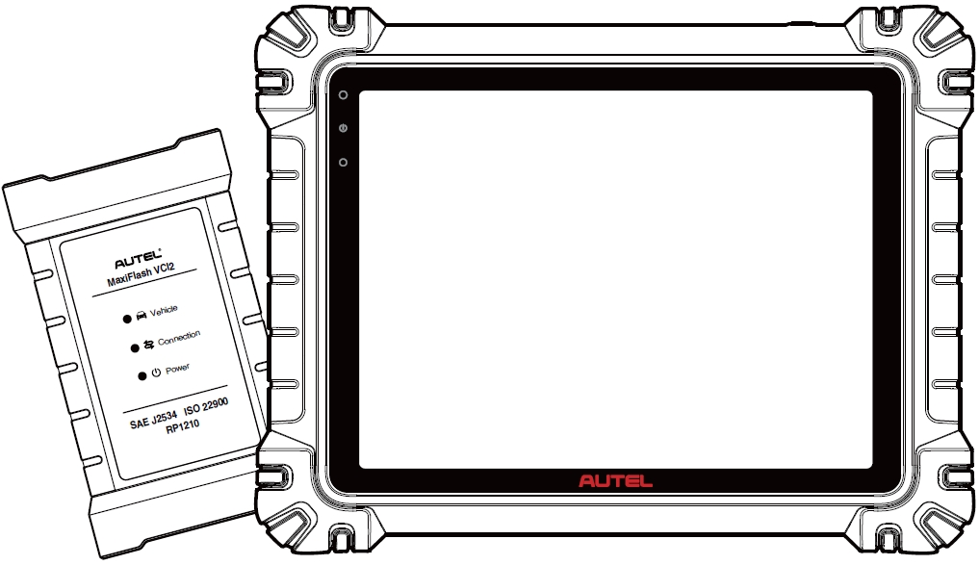

USER MANUAL

Trademarks
Autel®, MaxiSys®, MaxiDAS®, MaxiScan®, MaxiTPMS®, MaxiRecorder®, and MaxiCheck® are trademarks of Autel Intelligent Technology Corp., Ltd., registered in China, the United States, and other countries. All other marks are trademarks or registered trademarks of their respective holders.
Copyright Information
No part of this manual may be reproduced, stored in a retrieval system or transmitted in any form or by any means electronic, mechanical, photocopying, recording, or otherwise without the prior written permission of Autel.
Disclaimer of Warranties and Limitation of Liabilities
All information, specifications and illustrations in this manual are based on the latest information available at the time of printing.
Autel reserves the right to make changes at any time without notice. While information of this manual has been carefully checked for accuracy, no guarantee is given for the completeness and correctness of the contents, including but not limited to the product specifications, functions, and illustrations.
Autel will not be liable for any direct, special, incidental, or indirect damages, or for any economic consequential damages (including the loss of profits) as a result of using this product.

IMPORTANT
Before operating or maintaining this unit, please read this manual carefully, paying extra attention to the safety warnings and precautions.
For Services and Support

pro.autel.com
www.autel.com

1-855-288-3587 (North America)

+86 (0755) 8614-7779 (China)
support@autel.com
For technical assistance in all other markets, please refer to Technical Support in this manual.

Safety Information
For your own safety and the safety of others, and to prevent damage to the device and vehicles upon which it is used, it is important that the safety instructions presented throughout this manual be read and understood by all persons operating or coming into contact with the device.
There are numerous procedures, techniques, tools, and parts required for servicing vehicles, as well as the skills of the person doing the work. Because of the vast number of test applications and variations in the products that can be tested with this equipment, we cannot possibly anticipate or provide advice or safety messages to cover every circumstance. It is the automotive technician’s responsibility to be knowledgeable of the system being tested. It is crucial to use proper service methods and test procedures. It is essential to perform tests in an appropriate and acceptable manner that does not endanger your safety, the safety of others in the work area, the device being used, or the vehicle being tested.
Before using the device, always refer to and follow the safety messages and applicable test procedures provided by the manufacturer of the vehicle or equipment being tested. Use the device only as described in this manual. Be sure to read, understand, and follow all safety messages and instructions in this manual.
Safety Messages
Safety messages are provided to help prevent personal injury and equipment damage. All safety messages are introduced by a signal word indicating the hazard level.

DANGER
Indicates an imminently hazardous situation which, if not avoided, could result in death or serious injury to the operator or to bystanders.

WARNING
Indicates a potentially hazardous situation which, if not avoided, could result in death or serious injury to the operator or to bystanders.
Safety Instructions
The safety messages herein cover situations Autel is aware of at the time of publication. Autel cannot know, evaluate or advise you as to all of the possible hazards. You must be certain that any condition or service procedure encountered does not jeopardize your personal safety.
DANGER
When an engine is operating, keep the service area WELL VENTILATED or attach a building exhaust removal system to the engine exhaust system. Engines produce carbon monoxide, an odorless, poisonous gas that causes slower reaction time and can lead to serious personal injury or loss of life.

It is not advised to use headphones at a high volume
Listening at high volumes for long periods of time may result in loss of hearing.
Safety Warnings
- Always perform automotive testing in a safe environment.
- Wear safety eye protection that meets ANSI standards.
- Keep clothing, hair, hands, tools, test equipment, etc. away from all moving or hot engine parts.
- Operate the vehicle in a well-ventilated work area, for exhaust gases are poisonous.
- Put the transmission in PARK (for automatic transmission) or NEUTRAL (for manual transmission) and make sure the parking brake is engaged.
- Put blocks in front of the drive wheels and never leave the vehicle unattended while testing.
- Be extra cautious when working around the ignition coil, distributor cap, ignition wires and spark plugs. These components create hazardous voltages when the engine is running.
- Keep a fire extinguisher suitable for gasoline, chemical, and electrical fires nearby.
- Do not connect or disconnect any test equipment while the ignition is on or the engine is running.
- Keep the test equipment dry, clean, free from oil, water or grease. Use a clean cloth dampened with mild detergent to clean the outside of the equipment as necessary.
- Do not drive the vehicle and operate the test equipment at the same time. Any distraction may cause an accident.
- Refer to the service manual for the vehicle being serviced and adhere to all diagnostic procedures and precautions. Failure to do so may result in personal injury or damage to the test equipment.
- To avoid damaging the test equipment or generating false data, make sure the vehicle battery is fully charged and the connection to the vehicle DLC is clean and secure.
- Do not place the test equipment on the distributor of the vehicle. Strong electro-magnetic interference can damage the equipment.

CONTENTS
1 Using This Manual 1
1.1 Conventions 1
2 General Introduction 3
2.1 MaxiSys Tablet 3
2.2 MaxiFlash VCI2 8
2.3 Accessories Kit 11
2.4 Other Accessories 13
3 Getting Started 15
3.1 Power Up 15
3.2 Power Down 20
4 AI Technician Assistant 21
5 Digital Vehicle Inspection 23
6 Diagnostics 27
6.1 Establish Vehicle Communication 27
6.2 Getting Started 32
6.3 Vehicle Identification 34
6.4 Navigation 38
6.5 Diagnostics Menu 41
6.6 Diagnostics Functions 41
6.7 Graphical Diagnostics 59
6.8 Live Data Fusion 60
6.9 Programming and Coding 61
6.10 Generic OBDII Operations 64
6.11 Diagnostic Report 68
6.12 Exit Diagnostics 72
7 Service 74
7.1 Oil Reset Service 74
7.2 Electric Parking Brake (EPB) Service 75
7.3 Tire Pressure Monitoring System (TPMS) Service 75
7.4 Battery Management System (BMS) Service 76
7.5 Diesel Particulate Filter (DPF) Service 76
7.6 Steering Angle Sensor (SAS) Service 77
8 ADAS 79
9 Data Manager 80
9.1 Vehicle History 82
9.2 Workshop Information 84
9.3 Customer 85
9.4 Image 86
9.5 Cloud Report 87
9.6 PDF Files 87
9.7 Review Data 88
9.8 Reference Value 88
9.9 Data Logging 90
9.10 Uninstall Apps 90
9.11 Backup & Restore 90
10 Autel Cloud 92
10.1 Registration and Login 93
10.2 Device Management 93
10.3 File Management 97
10.4 Customer Management 101
10.5 Workshop Information 102
10.6 Data Backup 103
11 Battery Test 105
11.1 MaxiBAS BT506 Battery Tester 106
11.2 Test Preparation 108
11.3 In-vehicle Test 109
11.4 Out-vehicle Test 114
12 Settings 116
12.1 Unit 116
12.2 Language 117
12.3 Printing Settings 117
12.4 Report Settings 118
12.5 Push Notification 119
12.6 Auto Update 119
12.7 ADAS Settings 120
12.8 OBFCM Upload 120
12.9 Vehicle List 121
12.10 App Sorting 121
12.11 Battery Test 121
12.12 Country/Region Code 121
12.13 Laws and Regulations 122
12.14 System Settings 122
12.15 About 122
13 Update 123
14 VCI Manager 124
14.1 Wi-Fi Connection 125
14.2 VCI Bluetooth Pairing 125
14.3 BAS Bluetooth Pairing 126
14.4 VCI Update 126
14.5 BAS Update 127
15 Hand-held Inclinometer 128
16 Support 130
16.1 Support Screen Layout 130
16.2 My Account 130
16.3 Training 131
16.4 Data Logging 131
16.5 FAQ 131
17 MaxiViewer 132
18 MaxiVideo 134
19 Quick Link 135
20 Remote Desktop 136
21 User Feedback 138
22 Autel User Center 139
23 Maintenance and Service 141
23.1 Maintenance Instructions 141
23.2 Troubleshooting Checklist 142
23.3 About Battery Usage 142
23.4 Service Procedures 143
24 Compliance Information 147
25 Warranty 150

Using This Manual
This manual contains device usage instructions.
Some illustrations shown in this manual may contain modules and optional equipment that are not included in your system.

Conventions
The following conventions are used:

Bold Text
Bold text is used to highlight selectable items such as buttons and menu options.
Example:
- Tap OK.

Notes and Important Messages

Notes
A NOTE provides helpful information such as additional explanations, tips, and comments.

Important
IMPORTANT indicates a situation that if not avoided may result in damage to the tablet or vehicle.

Hyperlinks
Hyperlinks are available in electronic documents. Blue italic text indicates a selectable hyperlink; blue underlined text indicates a website link or an email address link.

Illustrations
Illustrations used in this manual are samples, the actual testing screen may vary for each vehicle being tested. Observe the menu titles and on-screen instructions to make correct option selection.

Procedures
An arrow icon indicates a procedure. Example:
- To power down the MaxiSys tablet
- Long press (press and hold) the Power/Lock button.
- Tap the Power Off option.
- Tap OK.

General Introduction
There are two main components to the MaxiSys system:
- MaxiSys Tablet — the central processor and monitor for the system.
- MaxiFlash VCI2 — Vehicle Communication Interface 2.
This manual describes the construction and operation of these devices and how they work together to deliver diagnostic solutions.

MaxiSys Tablet

Function Description
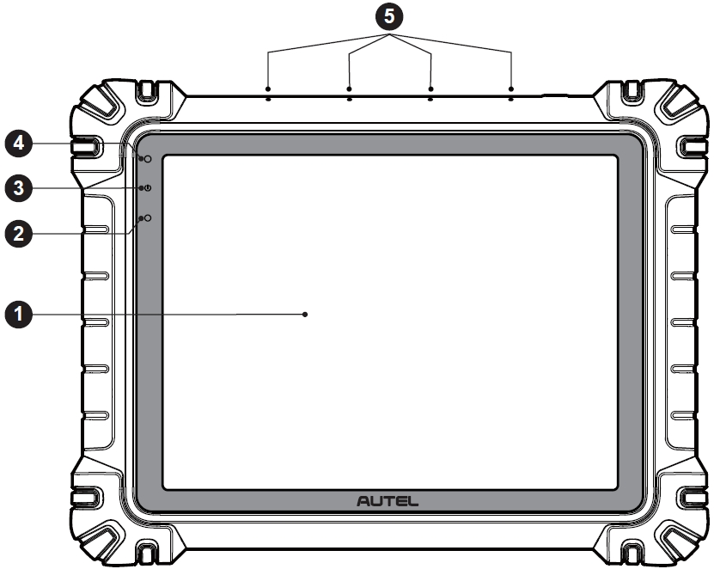
Figure 2-1 MaxiSys Tablet, Front View
- 11” TFT-LCD Capacitive Touchscreen
- Ambient Light Sensor — detects ambient brightness
- Power LED — refer to Table 2-1 Power LED Description for details
- Front Camera
- Built-in Microphone

Table 2-1 Power LED Description
LED | Color | Description
Power | Green | - Lights green when the tablet is charging and the battery level is above 90%.  - Lights green when the tablet is powered on and the battery level is above 20%.
Power | Yellow | Lights yellow when the tablet is charging and the battery level is below 90%.
Power | Red | - Lights red when the tablet is powered on and the battery level is below 20%.  - Lights red when the tablet shows abnormality after being powered on or during charging.
Camera
Function Description: Used for vehicle information identification, such as VIN scanning and vehicle photography.
Privacy Impact: Collects vehicle VIN data and uploads it to the cloud platform to identify the vehicle model, year, engine type, etc.
Permission Control: Camera access permissions can be disabled in system settings (Path: Settings > System Settings > Privacy > Permission Manager > Camera).

Microphone
Function Description:
1. Used for AI technician assistant.
2. Used for audio and video recording through the device and its camera.
Privacy Impact:
1. Collects user voice data for speech recognition and speech-to-text conversion; stores the data locally or uploads it to the cloud platform.
2. Stores recorded voice data from the recorder and camera locally.
Permission Control: Microphone access permissions can be disabled in system settings (Path: Settings > System Settings > Privacy > Permission Manager > Microphone).

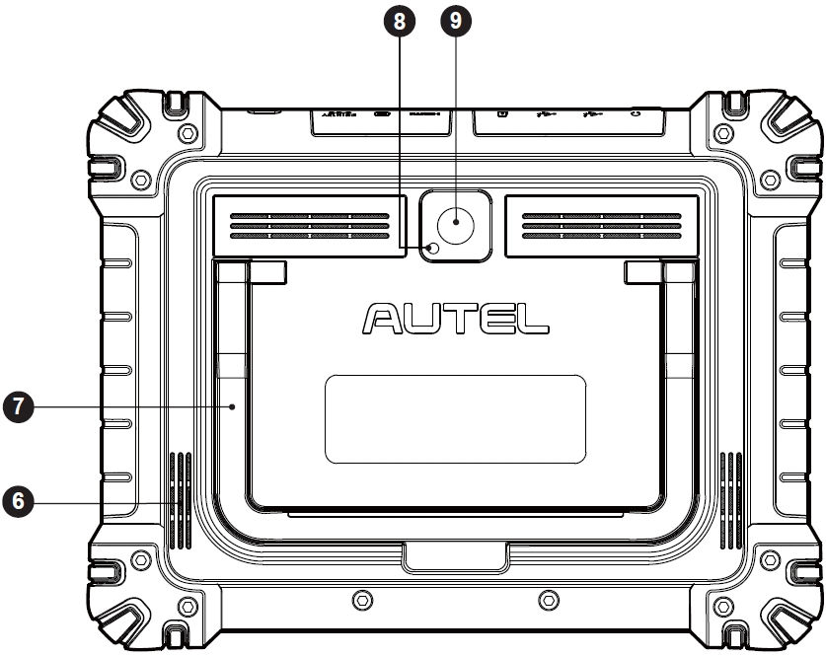
Figure 2-2 MaxiSys Tablet, Back View
- Speaker
- Collapsible Stand — extends from the back to allow hands-free viewing of the tablet
- Camera Flash
- Rear Camera
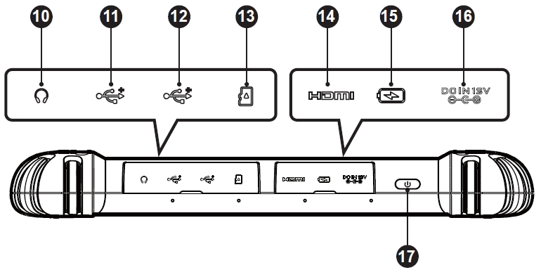
Figure 2-3 MaxiSys Tablet, Top View
- Headphone Jack
- USB Port
- USB Port
- Mini SD Card Slot
- HDMI (High-Definition Multimedia Interface) Port
- Type-C Charging Port
- DC Power Supply Input Port
- Power/Lock Button — long press to turn on/off the tablet; short press to lock the screen

Power Sources
The tablet can receive power from any of the following sources:
- Internal Battery Pack
- AC/DC Power Supply
- Vehicle Power
- Type-C Power Supply
IMPORTANT
Do not charge the battery when the temperature is lower than 0 °C (32 °F) or higher than 45 °C (113 °F).

Internal Battery Pack
The tablet can be powered with its internal rechargeable battery, which if fully charged can provide sufficient power for about 10 hours of continuous operation.

AC/DC Power Supply
The tablet can be powered from an electrical outlet using the AC/DC power adapter. The AC/DC power supply also charges the internal battery pack.

Vehicle Power
The tablet can be powered from the auxiliary power outlet adapter or other DC power port on the test vehicle through a direct cable connection. The vehicle power cable connects to the DC power supply port on the top side of the tablet.

Type-C Power Supply
This tablet can be powered using the supplied USB Type-C cable. It supports USB Type-C 45W (15V/3A) PD (power delivery) fast charging if your power adapter supports the PD protocol.

Technical Specifications
Table 2-2 Tablet Specifications
Item | Description
Operating System | Android 13
Processor | Octa-core processor
Memory | 12 GB RAM & 256 GB on-board memory
Display | 11-inch anti-glare screen (2176 x 1600)
Connectivity | - Wi-Fi x 2 (802.11 a/b/g/n/ac/ax 2x2 MIMO)  - BT V5.2 + EDR  - GPS  - USB 2.0 (Two USB host Type A)  - USB Type C (used to charge the tablet or connect to a PC for data transfer)  - HDMI 2.0  - SD Card (support up to 256 GB)
Camera | - Rear: 16 Megapixel, autofocus with flashlight  - Front: 16 Megapixel
Sensors | - Gravity Accelerometer  - Ambient Light Sensor (ALS)
Audio  Input / Output | - Microphone  - Dual speakers  - 3-band or 4-band 3.5 mm headset jack
Power and Battery | - Charging via 12V 6A DC power adapter  - USB Type-C 45W (15V/3A) PD (Power Delivery) fast charging. Ensure the power adapter supports the PD protocol.  - 15000 mAh 3.85V lithium-polymer battery
Input Voltage | - DC input: 12V/6A  - USB-C input: 15V/3A max. (also support 9V/3A or 5V/3A)
Operating Temp. | 0 °C to 50 °C (32 °F to 122 °F)
Storage Temp. | -10 °C to 60 °C (14 °F to 140 °F)
Dimensions  (W x H x D) | 315.4 mm (12.42”) x 240.3 mm (9.46”) x 39 mm (1.54”)
Weight | 1656.5 g (3.65 lbs.)
Protocols | PLC J2497, ISO-15765, SAE-J1939, ISO-14229 UDS, SAE-J2411 Single Wire Can (GMLAN), ISO-11898-2, ISO-11898-3, SAE-J2819 (TP20), TP16, ISO-9141, ISO-14230, SAE-J2610 (Chrysler SCI), UART Echo Byte, SAE-J2809 (Honda Diag-H), SAE-J2740 (GM ALDL), SAE-J1567 (CCD BUS), Ford UBP, Nissan DDL UART with Clock, BMW DS2, BMW DS1, SAE J2819 (VAG KW81), KW82, SAE J1708, SAE-J1850 PWM (Ford SCP), SAE-J1850 VPW (GM Class2), ISO 13400, CAN FD

MaxiFlash VCI2

Function Description
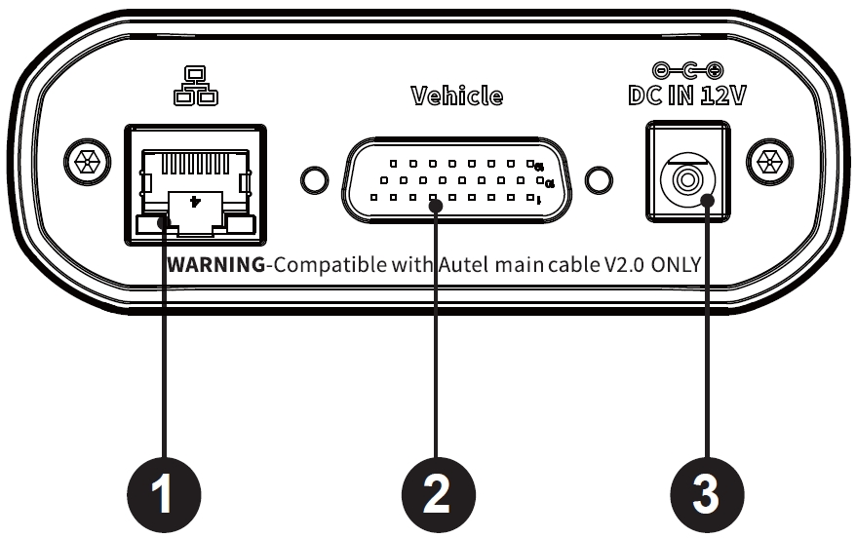
Figure 2-4 VCI2 Top View
- Ethernet Port
- Vehicle Data Connector
- DC Power Supply Input Port
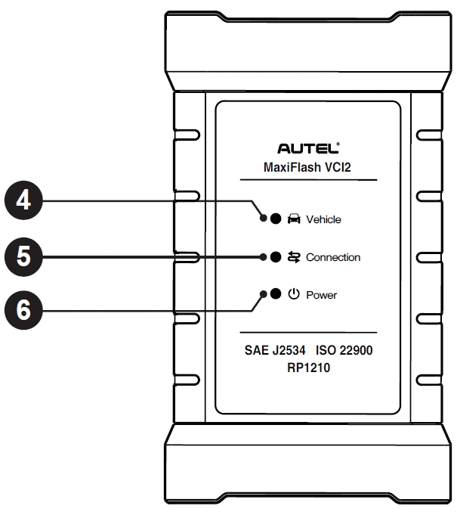
Figure 2-5 VCI2 Front View
- Vehicle LED — flashes green when the device is communicating with the vehicle
- Connection LED — refer to Table 2-3 Connection LED Description for details
- Power LED — refer to Table 2-4 Power LED Description for details
IMPORTANT
Do not disconnect this programming device while the vehicle LED status light is on. If programming is interrupted while the vehicle's ECU is blank or only partially programmed, the module may be unrecoverable.
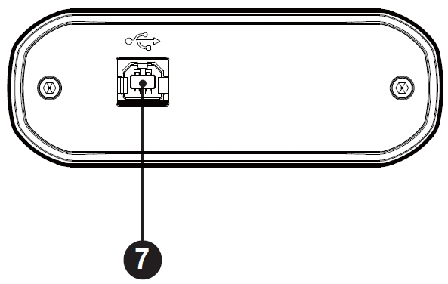
Figure 2-6 VCI2 Bottom View
- USB Port
Table 2-3 Connection LED Description
LED | Color | Description
Connection | Green | Lights solid green when connected with the tablet via the USB cable.
Connection | Cyan | Lights solid cyan (blue/green) when connected via Wi-Fi.
Connection | Blue | Lights solid blue when connected via wireless Bluetooth connection.
Table 2-4 Power LED Description
LED | Color | Description
Power | Yellow | Lights yellow automatically at power up when VCI2 is self-testing.
Power | Green | Lights solid green when powered on.
Power | Red | - Lights solid red when system failure occurs.  - Flashes red when the VCI2 is upgrading.

Communication Capability
The VCI2 supports Bluetooth (BT), Wi-Fi and USB communications. It can transmit vehicle data to the tablet with or without a cable connection. In open areas, the working range of the transmitter through BT communication is up to 328 feet (100 m). The working range of 5G communication Wi-Fi is up to 328 feet (100 m). If the signal is lost due to being taken out of range, communication will be restored once the tablet is within range.

Programming Capability
The VCI2 is a D-PDU, SAE J2534 & RP1210 compliant PassThru programming interface device. Using the updated OEM software, it is capable of replacing the existing software/firmware in the Electronic Control Units (ECUs), programming new ECUs and fixing software-controlled drivability issues and emission issues.

Power Sources
The VCI2 can receive power from the following sources:
- Vehicle Power
- AC/DC Power Supply

Vehicle Power
The VCI2 operates on 12/24 V vehicle power, which receives power via the vehicle data connection port. The device powers on whenever it is connected to an OBD II/EOBD compliant Data Link Connector (DLC). For non-OBDII/EOBD compliant vehicles, the device can be powered from an auxiliary power outlet adapter or other suitable power port on the test vehicle using the auxiliary power cable.

AC/DC Power Supply
The VCI2 can be powered from a wall socket using the AC/DC power adapter.

Technical Specifications
Table 2-5 VCI2 Specifications
Item | Description
Communications | - BT V5.0 + EDR  - USB 2.0  - Wi-Fi 5G  - Ethernet
Wireless Frequency | 5 GHz
Power | 12 V DC power supply
Operating Temp. | 0 °C to 50 °C (32 °F to 122 °F)
Storage Temp. | -10 °C to 60 °C (14 °F to 140 °F)
Dimensions  (W x H x D) | 168.4 mm (6.63") x 98 mm (3.86") x 35 mm (1.38")
Weight | 379.7 g (0.84 lbs.)

Accessories Kit

Main Cable
The VCI2 can be powered through the Autel main cable V2.0 (the V2.0 icon can be seen on the cable) when connected to an OBDII/EOBD compliant vehicle. The main cable connects the VCI2 to the vehicle’s Data Link Connector (DLC), through which the VCI2 can transmit vehicle data to the tablet.
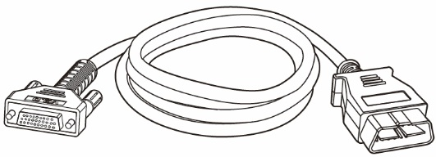
Figure 2-7 Main Cable V2.0

NOTE
The MaxiFlash VCI2 can only be connected by the Autel main cable V2.0. DO NOT use other Autel main cables to connect the MaxiFlash VCI2.

OBDI-Type Adapters (Optional)
The optional OBDI-type adapters are for non-OBDII vehicles. The adapter used depends on the type of vehicle being tested. The most common adapters are shown below. (Adapters are sold separately. Please contact your distributor for details.)
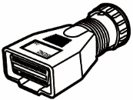  Benz-14 | 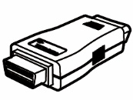  Chrysler-16 | 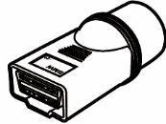  BMW-20 | 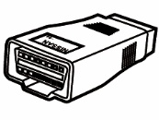  Nissan-14
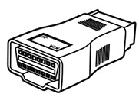 Kia-20 | 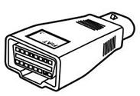 Fiat-3 | 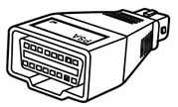 PSA-2 | 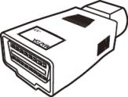 Mazda-17
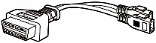  Volkswagen/  Audi-2+2 |   Benz-38 | 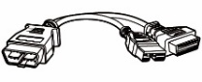  Mitsubishi/  Hyundai-12+16

Other Accessories
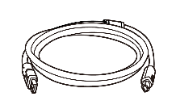 | USB 2.0 Cable V2 (the V2 icon can be seen on the cable)  Connects the tablet to the VCI2.
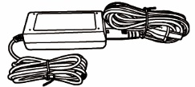 | AC/DC Adapter (12V)  Connects the tablet to the external AC/DC power port for power supply.  (Note: For environmental reasons, the product package does not include a charger in the European market. This device can be powered with most USB power adapters and a cable with USB Type-C plug.)
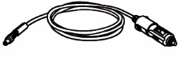 | Auxiliary Power Outlet Adapter  Provides power to the tablet or the VCI2 through connection to the vehicle’s auxiliary power outlet adapter receptacle, as some non-OBDII vehicles cannot provide power via the DLC connection.
 | Clamp Cable  Provides power to the tablet or the VCI2 through connection to the vehicle’s battery.
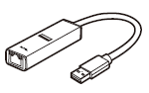 | USB to Ethernet Adapter  Network connection function can be realized through this device.
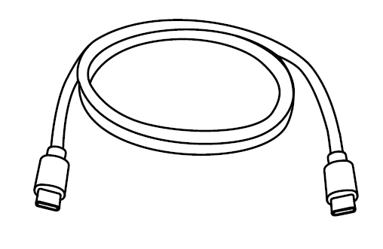 | USB Type-C Cable  Supports charging.
 | Spare Fuse x2  A safety device for the auxiliary power outlet adapter.

Getting Started
Make sure that the tablet has sufficient power or is connected to the external power supply (see Power Sources).

Power Up
Long press (press and hold) the Power/Lock button on the top-right side of the tablet to switch the unit on. Swipe up from the bottom of the Lock screen to enter the MaxiSys Job Menu screen.
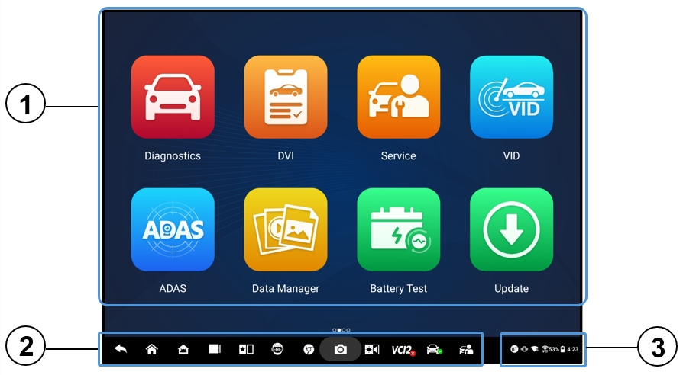
Figure 3-1 MaxiSys Job Menu
- Application Buttons
- Locator and Navigation Buttons
- Status Icons
NOTE
It is recommended that you lock the screen when not in use to protect information in the system and conserve power.
Almost all operations on the tablet are controlled through the touchscreen. The touchscreen navigation is menu-driven, allowing for quick access to the test procedure or the data that you need, through a series of questions and options. Detailed descriptions of the menu structures are found in the chapters for each application.

Application Buttons
The table below briefly describes each of the applications in the MaxiSys system.
Table 3-1 Applications
Button | Name | Description
 | Diagnostics | Accesses the diagnostics functions. See Diagnostics.
 | DVI | Before diagnosing, the technicians perform an overall inspection with their eyes and record the results. See Digital Vehicle Inspection.
 | Service | Accesses Service functions menu. See Service.
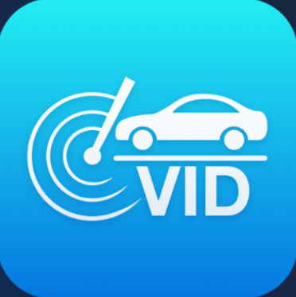 | VID | Accesses the Enter VIN screen or Vehicle Information Confirmation screen. See Vehicle Identification.
 | ADAS | Accesses ADAS systems menu. See ADAS.
 | Data Manager | Accesses the saved repair shop, customer, and vehicle data, including detailed vehicle diagnostics and test records. See Data Manager.
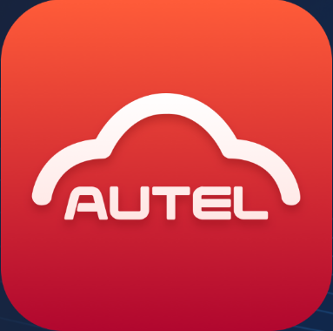 | Autel Cloud | Accesses the Autel Cloud platform. See Autel Cloud.
 | Battery Test | Accesses the Battery Test menu with two functions, including in-vehicle test and out-vehicle test. See Battery Test.
 | Settings | Accesses the system settings menu and general tablet menu. See Settings.
 | Update | Accesses system software update menu. See Update.
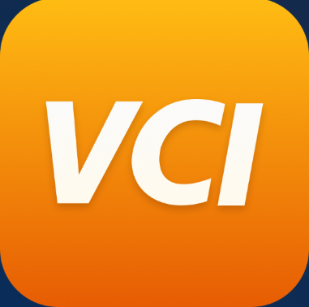 | VCI Manager | Accesses VCI connection menu. See VCI Manager.
 | Hand-held Inclinometer | Connects your tablet to a hand-held inclinometer to measure the ride height of Mercedes-Benz vehicles. See Hand-held Inclinometer.
 | MaxiTools | Includes Log collection and Factory data reset two parts.
 | Support | Synchronizes Autel's online service database with the MaxiSys tablet. See Support.
 | OEM Authorization | Manages the permissions for unlocking the OE gateway.
 | Demonstration | Provides step-by-step operation demonstration for diagnostics.
 | MaxiViewer | Provides a quick search for supported functions and/or vehicles. See MaxiViewer.
 | MaxiVideo | Configures the unit to operate as a video scope device by connecting to an imager head cable for close vehicle inspections. See MaxiVideo.
 | Quick Link | Provides associated website bookmarks to allow quick access to product update, service, support, and other information. See Quick Link.
 | Remote Desktop | Configures your tablet to receive remote support using the TeamViewer application. See Remote Desktop.
 | User Feedback | You can submit feedback through this application when you encounter problems during the use of the tablet. See User Feedback.
 | Voice Skills Center | Allows you to learn how to use the AI Technician Assistant application. Currently, the supported language of AI Technician Assistant is English.
 | Autel User Center | Allows users to register Autel tool for downloading the latest released software. See Autel User Center.

Locator and Navigation Buttons
Operations of the Navigation buttons at the bottom of the screen are described in the table below:
Table 3-2 Locator and Navigation Buttons
Icon | Name | Description
 | Locator | Indicates the location of the screen. Swipe the screen left or right to view the previous or next screen.
 | Back | Returns to the previous screen.
 | MaxiSys  Home | Returns to MaxiSys Job Menu.
 | Android Home | Returns to the Android system home screen.
 | Recent Apps | Displays a list of applications that are currently running. Tap an app icon to launch. Close a running application by swiping it to the top. Or close all running applications by tapping Clear All.
 | Split Screen | The side-by-side dual screen mode is especially designed for showing two different windows simultaneously. The frequently-used applications in the split app bar can be added and deleted.
 | AI Technician Assistant | Performs tasks with voice control. See AI Technician Assistant. Currently, the supported language of voice control is English.
 | Browser | Launches the Chrome Internet browser.
 | Camera | Tap the Camera icon to open camera viewfinder. Press and hold the icon to capture a screenshot of the display screen. The saved files are auto-stored in the Data Manager application for later review. See Data Manager.
 | Display & Sound | Adjusts the brightness of the screen and the volume of the audio output.
 | VCI Manager Shortcut | Opens the VCI Manager application. A green icon at the bottom-right corner indicates the VCI2 is connected, while a red “X” icon will be displayed if the connection fails.
 | MaxiSys Shortcut | Returns to the Diagnostics screen.
 | Service Shortcut | Returns to the Service screen.
- To use the camera
- Tap the Camera icon. The camera screen opens.
- Focus the image to be captured in the viewfinder.
- Tap the Camera icon on the right side of the screen. The viewfinder now shows the captured picture and auto-saves the captured picture.
- Tap the thumbnail image on the top-right corner of the screen to view the stored picture.
- Tap the Back or Home icon to exit the camera application.

NOTE
After swiping the camera screen from left to right, the camera mode and video mode can be switched by tapping the Camera icon or Video icon.

System Status Icons
Your MaxiSys tablet is a fully functional Android tablet with the standard Android operating system status icons. Refer to Android documentation for additional information.

Power Down
All vehicle communications should be terminated before shutting down the tablet. A warning message displays if a shutdown is attempted while the tablet is communicating with the vehicle. Forcing a shutdown while the tablet is communicating with the vehicle may lead to ECU errors on some vehicles. Please exit the Diagnostics application before shutting off the tablet.
- To power down the MaxiSys tablet
- Long press (press and hold) the Power/Lock button.
- Tap the Power Off option.
- Tap OK.
- To reboot the system
In case of a system crash, long press the Power/Lock button and tap Restart to reboot the system.

AI Technician Assistant
The MaxiSys MS909S2 system features Autel’s advanced voice-controlled AI Technician Assistant function, which can help you perform tasks such as opening applications, auto scanning vehicle systems, quickly locating diagnostic functions, and assisting with decision-making to improve efficiency.
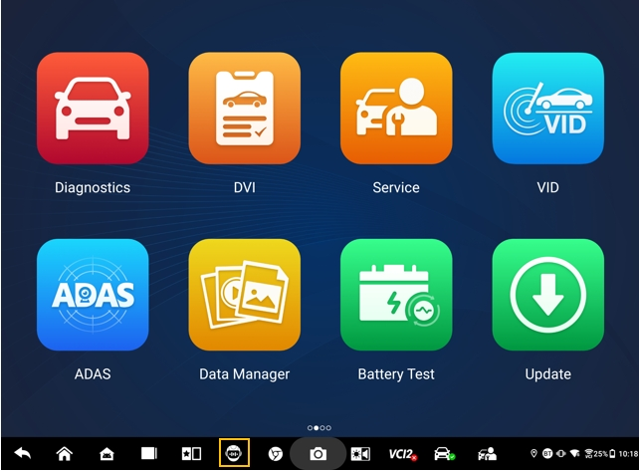
Figure 4-1 AI Technician Assistant Icon
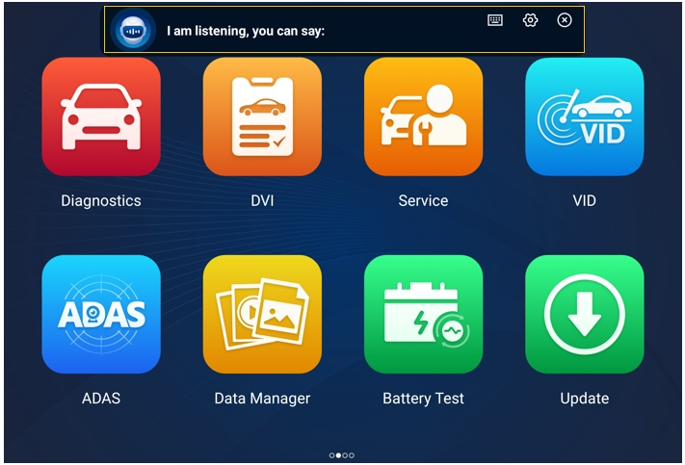
Figure 4-2 AI Technician Assistant Screen

When you give a command beginning with “Hey Max,” everything is extremely easy, such as opening applications or functions, identifying test vehicles, connecting the Wi-Fi, and turning on the camera, without lifting a finger.
The AI Technician Assistant function mainly assists you in doing the following tasks:
- Open system applications
You can say, " Open browser,” “Launch the browser,” “Open gallery,” “Turn on the camera,” “Turn on Bluetooth,” “Turn up the volume,” “Start the email,” etc.
- Open the applications on the MaxiSys Job Menu
You can say, “Open VID,” “Open Honda Diagnostic,” “Open the oscilloscope,” “Start the oscilloscope,” “Turn on VCI,” and so on.
- Search and locate the diagnostics functions
You can say: “Automatic selection,” “Open auto scan,” “Read DTC,” “I want to do EPB reset,” “Go to ECU reset”, “Open hot functions,” “Open maintenance light reset,” “Start injector functions,” etc.
- Control the function buttons
The function buttons, such as OK, ESC, and Fault Scan, can be controlled by voice instead of being tapped.

Digital Vehicle Inspection
Before diagnosing, a Digital Vehicle Inspection (DVI) is necessary for technicians to check the vehicle’s appearance, exterior and interior, brakes and tires, engine compartment, and more. Technicians can perform a comprehensive visual inspection and then record the results in the MaxiSys system.
- To perform the DVI
- Power up the tablet and ensure that it is connected to a power source.
- Tap the DVI application button on the MaxiSys Job Menu.
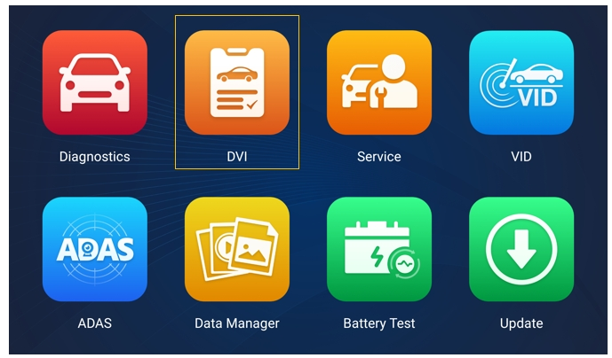
Figure 5-1 DVI Application Icon
- Choose Vehicle Information on the left navigation menu and enter the corresponding information on the right, including the repair shop information, technician information, customer information, and vehicle information.
NOTE
Fields marked with an asterisk (*) are mandatory.
- Select Vehicle Appearance on the navigation menu. For the damaged areas and the related components, tap the AI Scan button to take photos and tap Done. Tap Draw by Hand to draw circles with a finger on the photo to make marks and then tap Save. Tap OK to return to the Body Condition screen. Finish all the checks of the vehicle's appearance with the same steps.
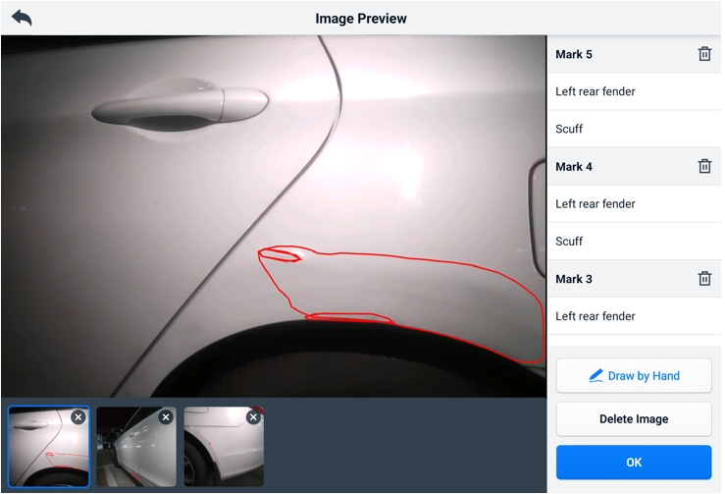
Figure 5-2 Vehicle Appearance Inspection Screen 1

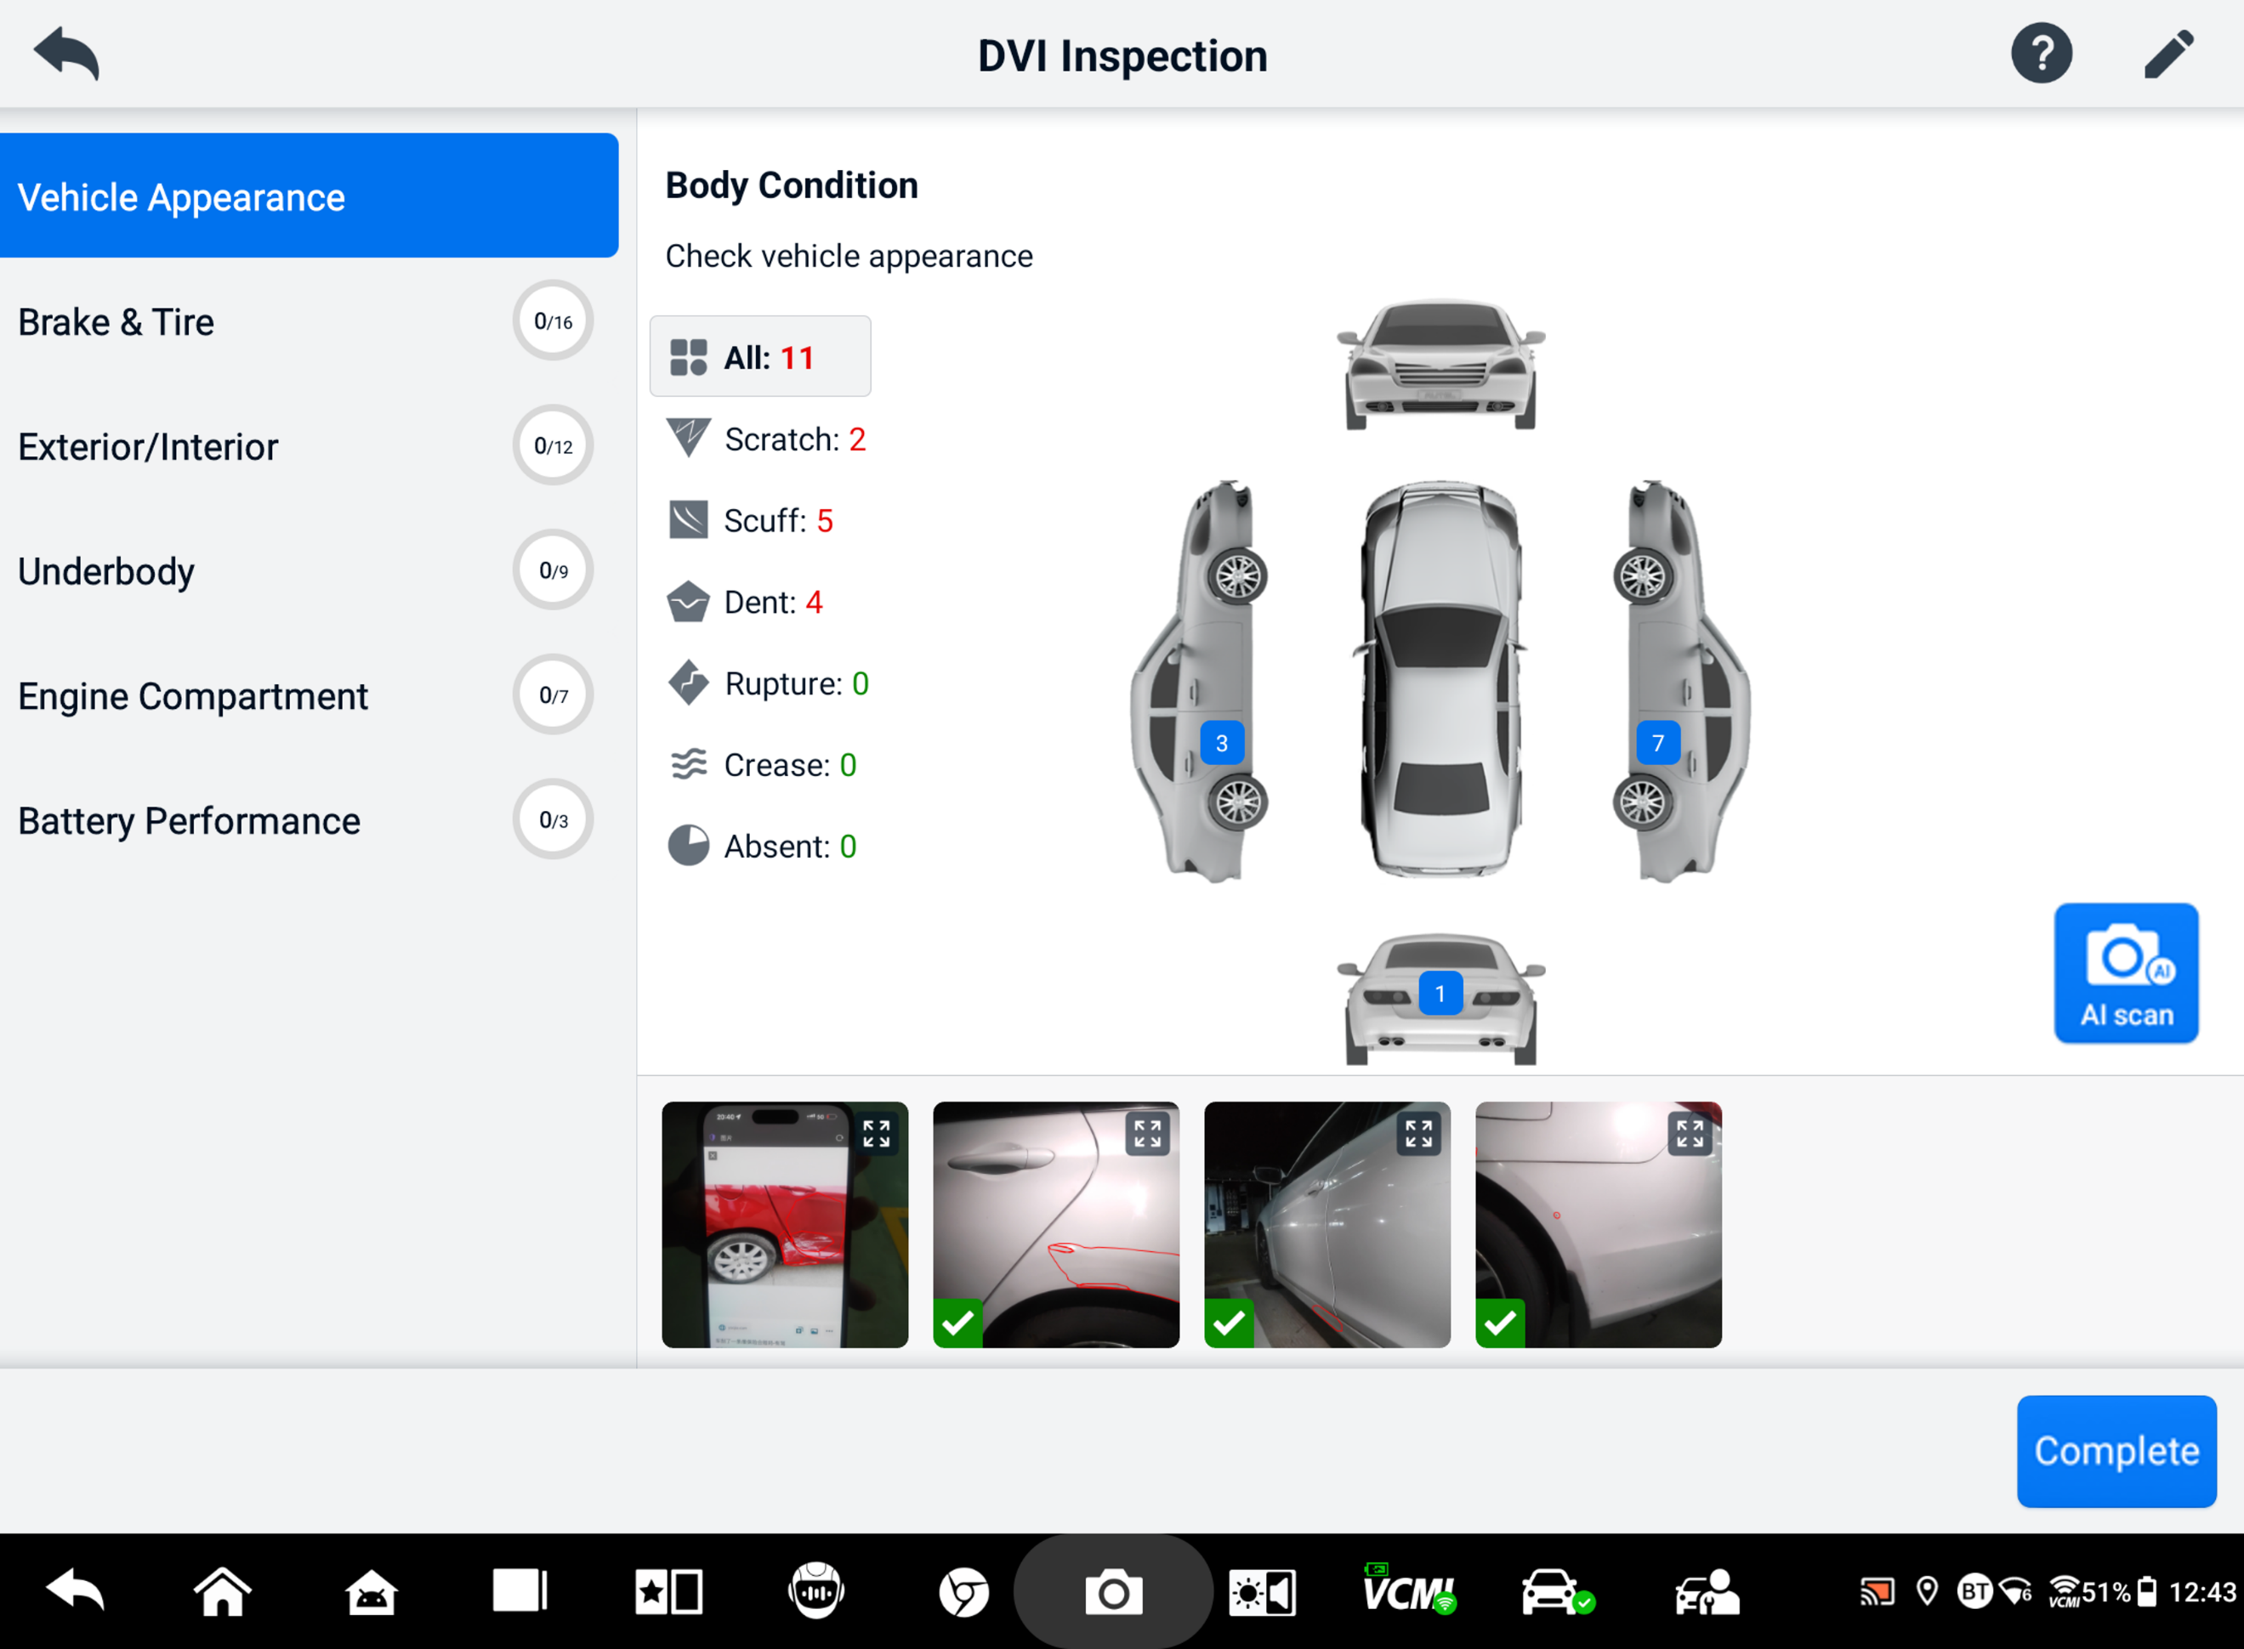
Figure 5-3 Vehicle Appearance Inspection Screen 2
- Select Brake & Tire on the navigation menu. Follow the onscreen instructions to check the vehicle’s brakes and tires.
- Make a visual inspection based on the actual situation. There are three options for selection: No errors, Attention needed, and Immediate attention needed.
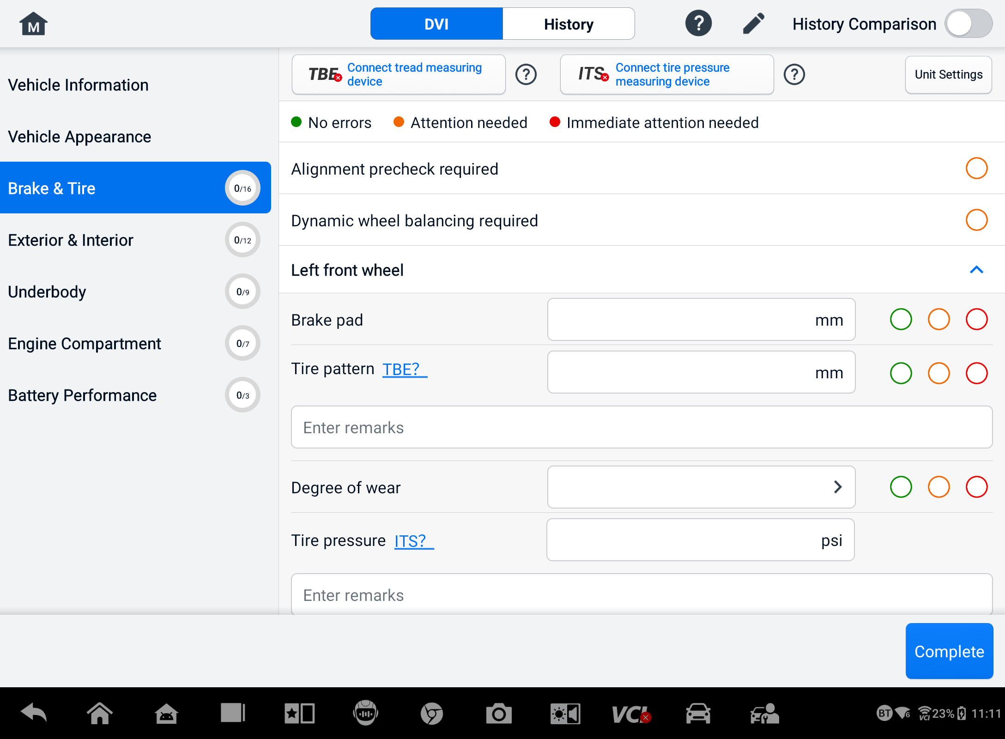
Figure 5-4 Brake & Tire Inspection Screen 1
- Tap the Help icon and follow the on-screen steps to connect a tread-measuring device or a tire pressure-measuring device to the MaxiSys MS909S2. The diagnostic tablet can automatically recognize the uploaded tire pressure or tread depth data. Enter the corresponding data on the screen.
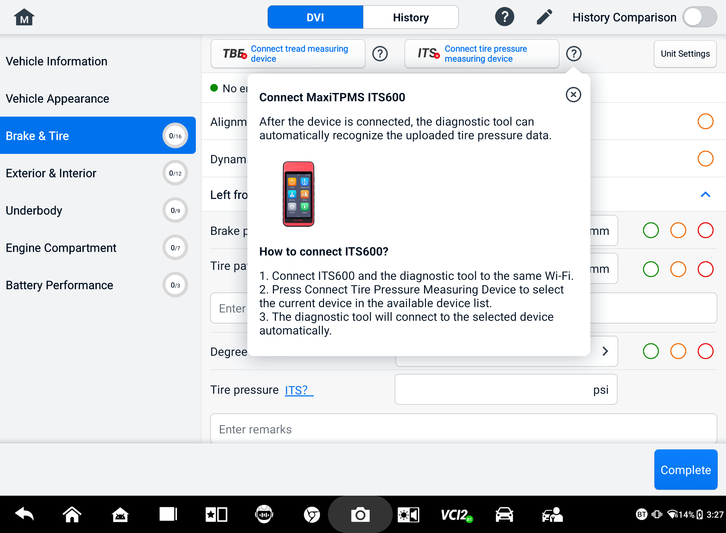
Figure 5-5 Brake & Tire Inspection Screen 2
NOTE
Tap the History Comparison toggle in the upper-right corner of the screen to make a comparison with the history conditions.
- Select a function item on the left navigation menu and follow the onscreen instructions to complete the inspections of the vehicle’s exterior/interior, underbody, engine compartment, and battery performance.
- Tap Complete at the bottom-right of the screen to save all the inspections. Tap Report to view the generated DVI report.
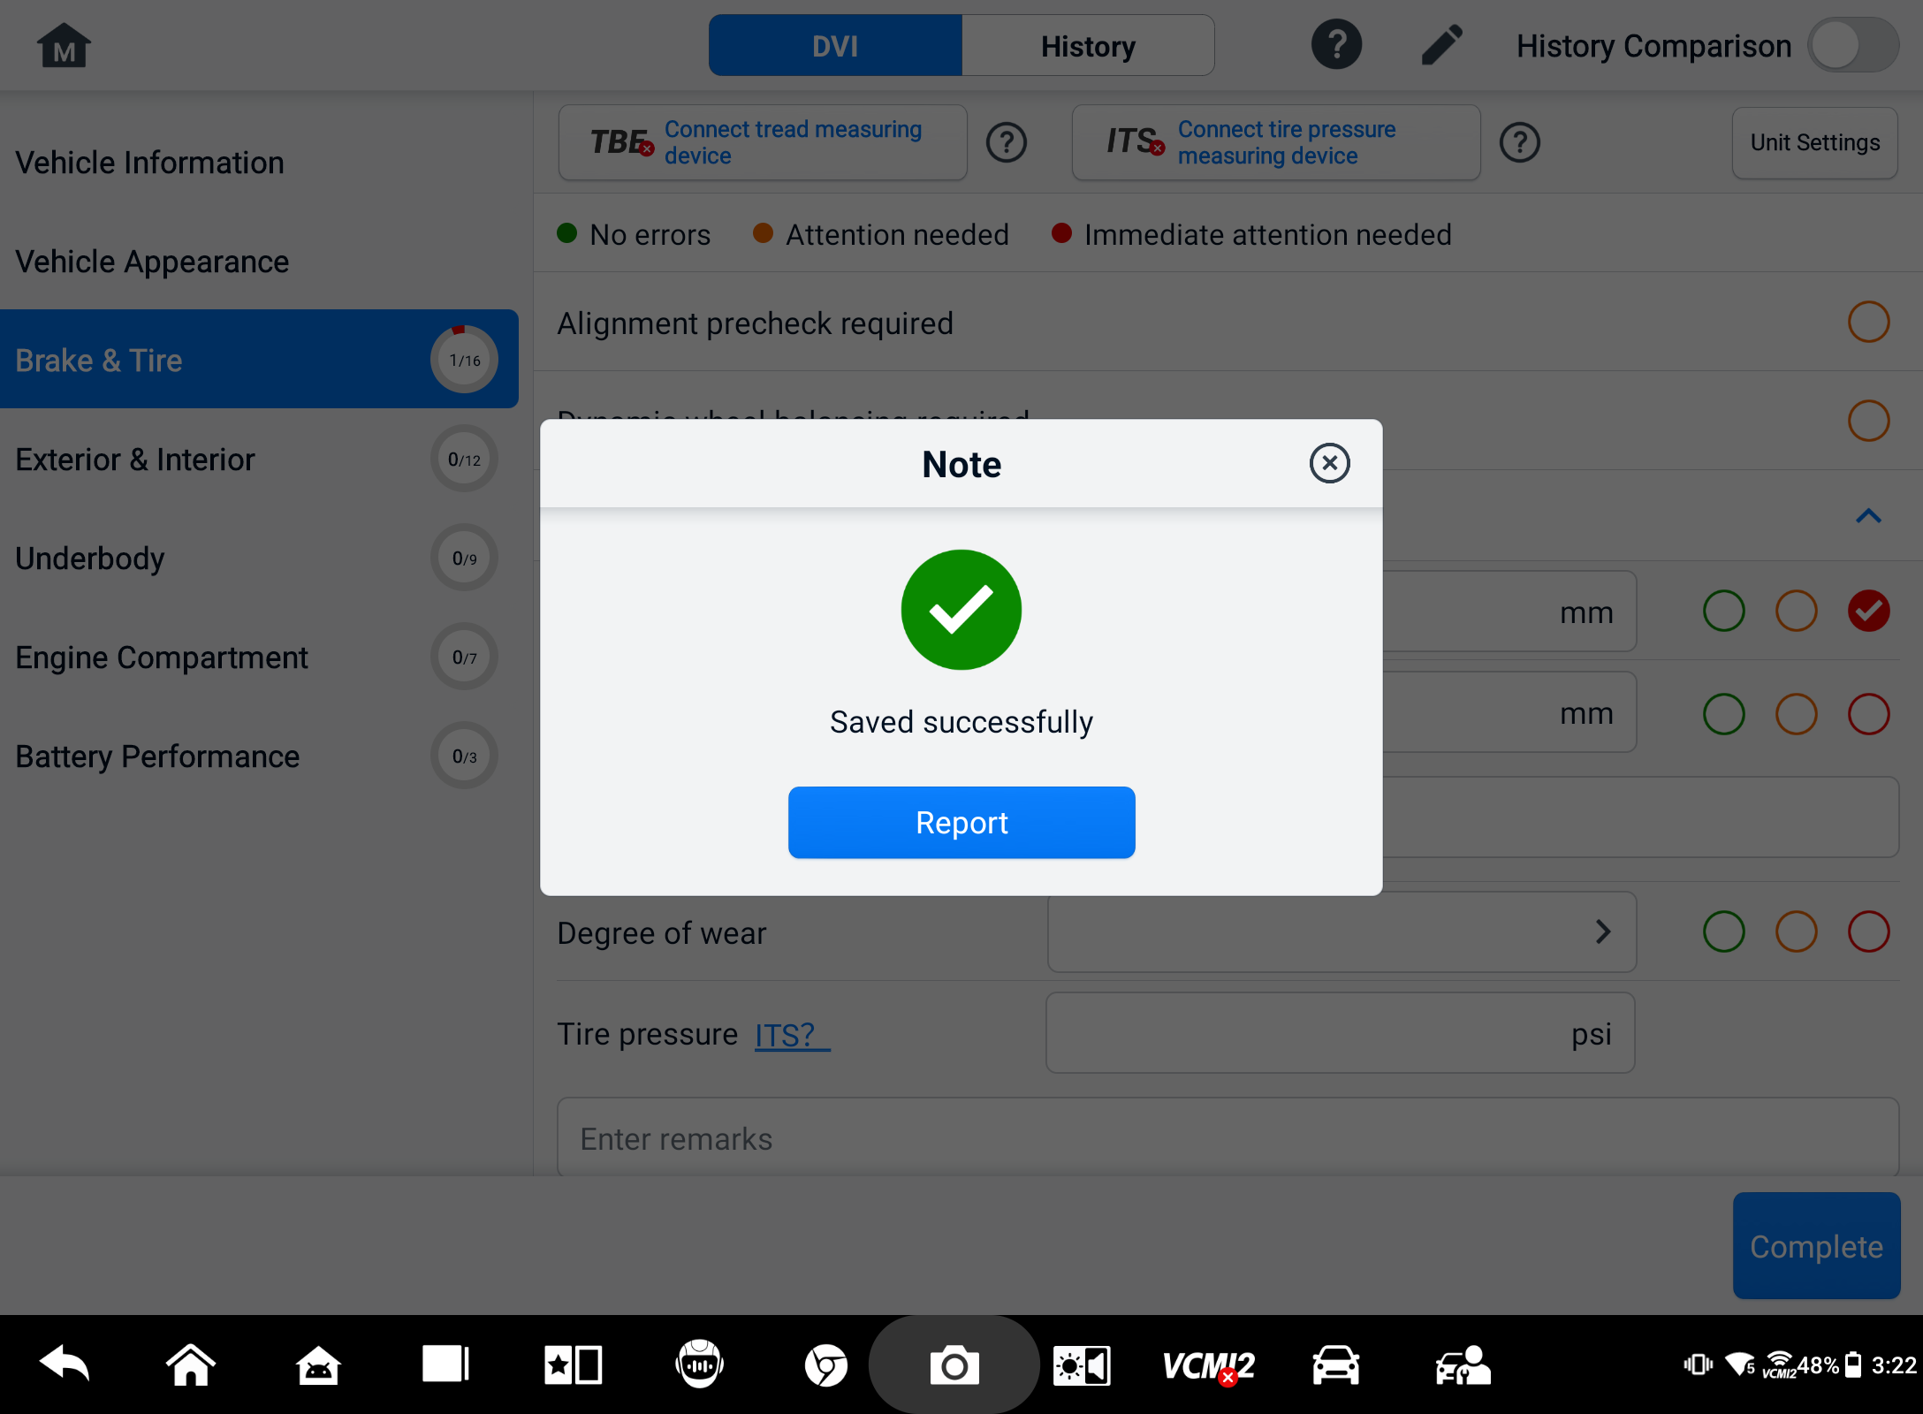
Figure 5-6 DVI Saving Screen
- The DVI report can also be viewed in the Data Manager application. Tap PDF or Cloud Report and select a report to open and view the detailed information.

Diagnostics
The Diagnostics application can access the electronic control module of multiple vehicle control systems, including but not limited to the engine, transmission, antilock brake system (ABS), and airbag system (SRS).

Establish Vehicle Communication
The Diagnostics operations require connecting the MaxiSys tablet to the test vehicle through the VCI2 using the main cable. (Use the applicable OBD I-type adapter if needed.) To establish proper vehicle communication with the tablet, you need to perform the following steps:
            - Connect the VCI2 to the vehicle’s DLC for both communication and power supply.
            - Connect the VCI2 to the tablet via Bluetooth pairing, Wi-Fi, or USB connection.
            - When the above steps are completed, check the VCI Manager Shortcut at the bottom of the screen. If a green BT, Wi-Fi, or USB icon displays at the lower-right corner, the MaxiSys tablet is ready to start vehicle diagnosis.

Vehicle Connection
The method used to connect the VCI2 to a vehicle’s DLC depends on the vehicle’s configuration as follows:
- A vehicle equipped with an On-board Diagnostics Two (OBDII) management system supplies both communication and 12-volt power through a standardized J-1962 DLC.
- A vehicle not equipped with an OBDII management system supplies communication through a DLC connection, and in some cases supplies 12-volt power through the auxiliary power outlet adapter receptacle or a connection to the vehicle battery.
OBDII Vehicle Connection
This type of connection only requires the main cable without any additional adapter.
- To connect to an OBDII vehicle
      - Connect the main cable’s female adapter to the Vehicle Data Connector on the VCI2, and tighten the captive screws.
      - Connect the cable’s 16-pin male adapter to the vehicle’s DLC, which is generally located under the vehicle dashboard.
NOTE
The vehicle’s DLC is not always located under the dashboard. Refer to the user manual of the test vehicle for additional connection information.
Non-OBDII Vehicle Connection
This type of connection requires both the main cable and a required OBDI adapter for the specific vehicle being serviced.
There are three possible conditions for non-OBDII vehicle connection:
- DLC connection supplies both communication and power.
- DLC connection supplies communication, and power is to be supplied via the auxiliary power outlet adapter connection.
- DLC connection supplies communication, and power is to be supplied via connection to the vehicle battery.
- To connect to a non-OBDII vehicle
- Connect the main cable’s female adapter to the Vehicle Data Connector on the VCI2, and tighten the captive screws.
- Locate the required OBDI adapter and connect its 16-pin jack to the main cable’s male adapter.
- Connect the attached OBDI adapter to the vehicle’s DLC.
NOTE
Some vehicles may have more than one adapter or may have test leads instead of an adapter. Make the proper connection to the vehicle’s DLC as required.
- To connect the auxiliary power outlet adapter
- Plug the DC power connector of the auxiliary power outlet adapter into the DC power supply input port on the device.
- Connect the male connector of the auxiliary power outlet adapter into the vehicle’s auxiliary power outlet adapter receptacle.
- To connect the clamp cable
- Connect the tubular plug of the clamp cable to the male connector of the auxiliary power outlet adapter.
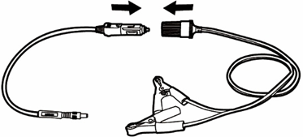
Figure 6-1 Connection Between Auxiliary Power Outlet Adapter and Clamp Cable
- Plug the DC power connector of the auxiliary power outlet adapter into the DC power supply input port of the VCI2.
- Connect the clamp cable to the vehicle’s battery.

VCI Connection
After the VCI2 is properly connected to the vehicle, the Power LED on the VCI2 lights solid green and a beep sound will be heard, indicating it is ready to establish communication with the tablet.
Coming with the MaxiSys tablet tool kit, the VCI2 supports three communication methods with the tablet: Bluetooth, Wi-Fi, and USB cable.

Bluetooth Connection
In open areas, the working range for Bluetooth communication is about 328 feet (100 m), giving technicians greater mobility to perform vehicle diagnosis from anywhere in the repair shop.
To expedite multi-vehicle diagnostics, more than one VCI2 can be used in busy repair shops, enabling technicians to quickly pair their MaxiSys tablet to each VCI2 via Bluetooth separately, therefore eliminating the need to unplug the VCI2 from one vehicle and then connect it to another each time.
- To pair the tablet with the VCI2 via Bluetooth
- Power up the tablet.
- Tap the VCI Manager application button on the MaxiSys Job Menu.
- Select VCI BT from the connection mode list and tap the Bluetooth toggle to turn it ON. The device automatically scans for available devices for Bluetooth pairing. The found devices are listed in the settings section on the bottom-right of the screen.

NOTE
If no VCI2 is found, this may indicate that the signal strength is too weak to be detected. Reposition the VCI2 and remove all possible objects that may cause signal interference. Tap the Scan button at the top-right corner of the screen to rescan for devices.
- Typically, the VCI2 name displays as “Maxi” suffixed with a serial number. Select the VCI2 for pairing. (If more than one VCI2 is used, ensure the correct VCI2 is selected to pair.)
- When the pairing is successful, the connection status displays as “Connected.”
- The VCI Manager Shortcut on the bottom of the screen displays a green circle BT icon when the tablet and the VCI2 are connected.
Refer to VCI Bluetooth Pairing for additional information.

Wi-Fi Connection
The VCI2 supports 5 GHz Wi-Fi connection. In open areas, the working range of 5G Wi-Fi communication is up to 328 feet (100 m).
- To pair the tablet with the VCI2 via Wi-Fi
- Power up the tablet.
- Tap the VCI Manager application button on the MaxiSys Job Menu.
- Select Wi-Fi from the connection mode list and tap the Wi-Fi toggle to turn it ON. The tablet automatically scans for available devices for Wi-Fi connection. Found VCI2 are listed in the settings section on the bottom-right of the screen.
- Typically, the VCI2 name displays as “Maxi” suffixed with a serial number. Select the required device for connection.
- When the pairing is successful, the connection status is shown as “Connected.”
- The VCI Manager Shortcut on the bottom of the screen displays a green circle Wi-Fi icon when the tablet and the VCI2 are connected.
Refer to Wi-Fi Connection for additional information.

USB Cable Connection
The USB cable connection is a simple and quick way to establish a communication between the tablet and the VCI2. After properly connecting the USB cable from the tablet to the VCI2, the VCI Manager Shortcut on the bottom of the screen displays a green badge and the Vehicle LED on the VCI2 lights solid green, indicating the connection between the devices is successful. The MaxiSys diagnostics tablet is now ready to perform vehicle diagnosis.
NOTE
For the most stable communication, it is recommended to use a USB connection between the tablet and the VCI2 when performing ECU programming or coding.

No Communication Message
- If the tablet is unable to connect to the VCI2, an “Error” message displays. An “Error” message indicates the tablet is not communicating with the VCI2. Troubleshoot the error by performing the following steps:
- Ensure the VCI2 is powered on.
- When using the wireless connection, ensure the network is configured correctly and the proper device has been connected.
- If the tablet loses communication abruptly during the diagnosis, ensure no objects are causing signal interruption.
- Ensure the VCI2 is properly positioned with the VCI2 front side up.
- Move the tablet closer to the VCI2. If using the wired connection, ensure the cable is securely attached to the VCI2.
- Ensure the VCI2 connection LED lights for the selected communication type: Bluetooth, Wi-Fi, or USB cable.
- If the VCI2 is unable to establish a communication link, a message will display troubleshooting instructions. Possible causes for the communication error include:
- The VCI2 is unable to establish a communication link with the vehicle.
- A vehicle system has been selected for diagnosis that is not supported by the vehicle.
- There is a loose connection.
- There is a blown vehicle fuse.
- The vehicle or the data cable has a wiring fault.
- There is a circuit fault in the data cable or adapter.
- The vehicle identification is incorrectly entered.

Getting Started
Prior to the first use of the Diagnostics application, ensure the VCI2 is properly connected to and is communicating with the tablet. See Establish Vehicle Communication for further details.
When the VCI2 is properly connected to the vehicle via the main cable, and paired to the tablet, the platform is ready to start vehicle diagnosis. Tap the Diagnostics application button on the MaxiSys Job Menu. The Vehicle Menu is displayed on the screen.
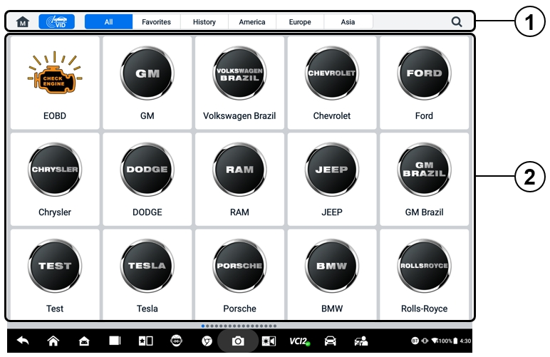
Figure 6-2 Vehicle Menu Screen
- Top Toolbar Buttons
- Manufacturer Icons
Top Toolbar Buttons
The operations of the toolbar buttons at the top of the screen are listed and described in the table below:
Table 6-1 Top Toolbar Buttons
Button | Name | Description
 | Home | Returns to the MaxiSys Job Menu.
 | VID | Tap this button to open a drop-down list:  - Tap Auto Detect for auto VIN detection.  - Tap Manual Input to enter the VIN code or license number manually.  - Tap Scan VIN/License Plate to scan the VIN code/license number by camera.
 | All | Displays all the vehicle makes in the Vehicle Menu.
 | Favorites | Displays user-selected favorite vehicle makes.
 | History | Displays the stored test vehicle history records. This option provides direct access to the previously tested vehicle recorded during the previous test. See Vehicle History.
 | America | Displays the American vehicle menu.
 | Europe | Displays the European vehicle menu.
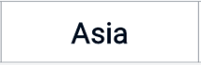 | Asia | Displays the Asian vehicle menu.
 | Search | Tap inside the search field to display a virtual keyboard and input the vehicle manufacturer to test.
Manufacturer Icons
The manufacturer icons display the various vehicle brands. Select the manufacturer icon after the VCI2 is properly connected to the test vehicle to start a diagnostic session.

Vehicle Identification
The MaxiSys system supports five methods of vehicle identification.
- Auto Detect
- Manual Input
- Scan VIN/License
- Manual Vehicle Selection
- OBDII Direct Entry

Auto Detect
The MaxiSys system features the latest VIN-based Auto Detect function to identify CAN vehicles with just one tap, enabling the technician to quickly identify the exact vehicle and scan its available systems for fault codes.
There are two entry options to perform the Auto Detect function:
- From the VID application
- To perform Auto Detect
- Connect the tablet with the VCI2 and establish a communication link via Bluetooth, Wi-Fi or USB cable. See Establish Vehicle Communication.
- Tap the VID application button on the MaxiSys Job Menu.
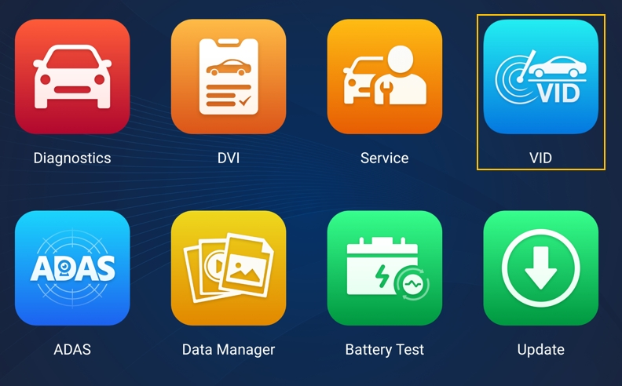
Figure 6-3 VID Application Screen
- The vehicle information will be automatically identified and then displayed on the screen. Tap Diagnostics or Service to execute the function.
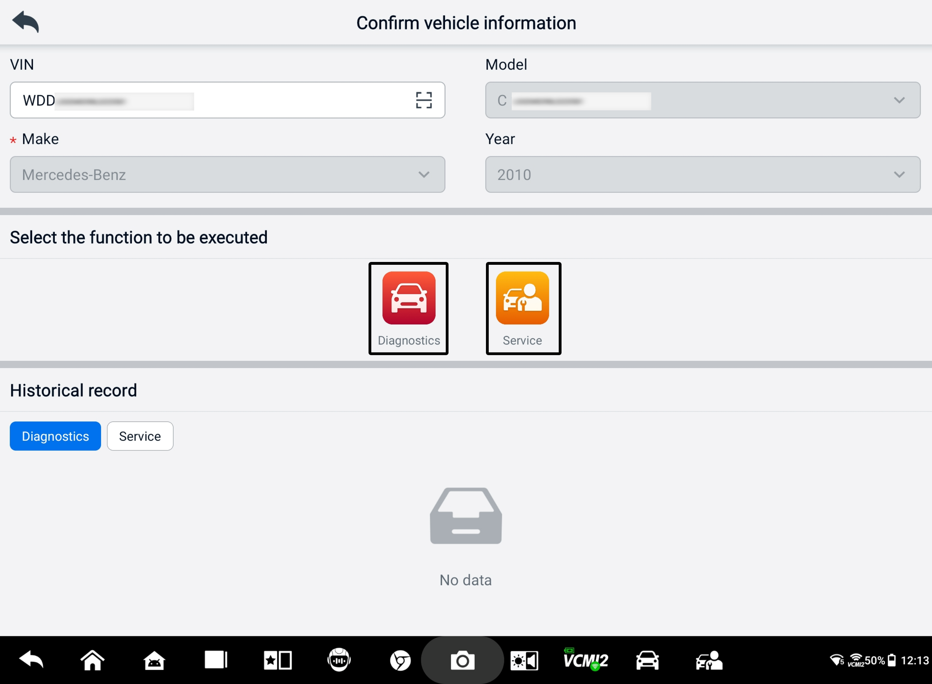
Figure 6-4 Vehicle Information Confirmation Screen 1
If the vehicle information can not be identified automatically, please manually enter the VIN or tap the Scan icon to scan and recognize the VIN. For detailed operation steps, please refer to Manual Input.
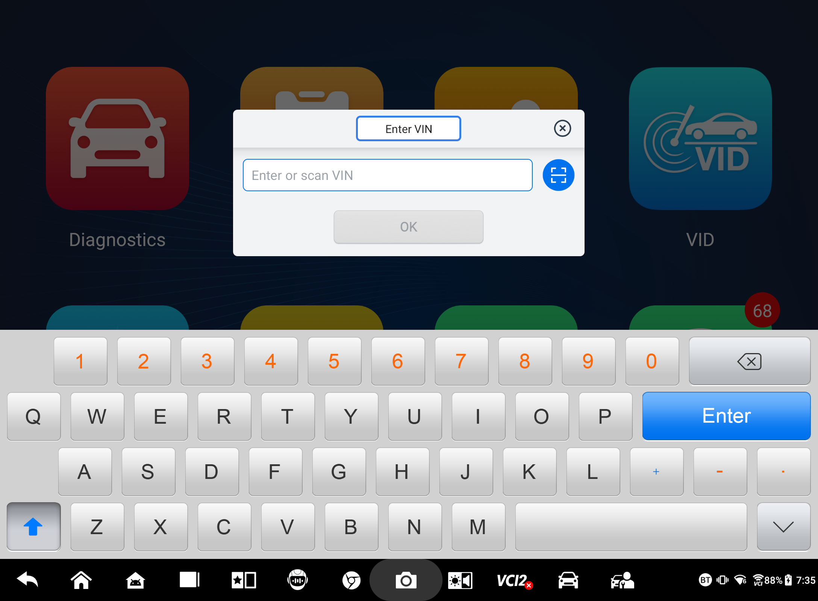
Figure 6-5 Vehicle Information Confirmation Screen 2
- From the Diagnostics application
- To perform Auto Detect
- Tap the Diagnostics application button on the MaxiSys Job Menu. The Vehicle Menu displays.
- Tap the VID button on the top toolbar. Select Auto Detect. The tablet starts VIN scanning on the vehicle's ECU. Once the test vehicle is successfully identified, the system will guide you to the Diagnostics Main Menu screen.
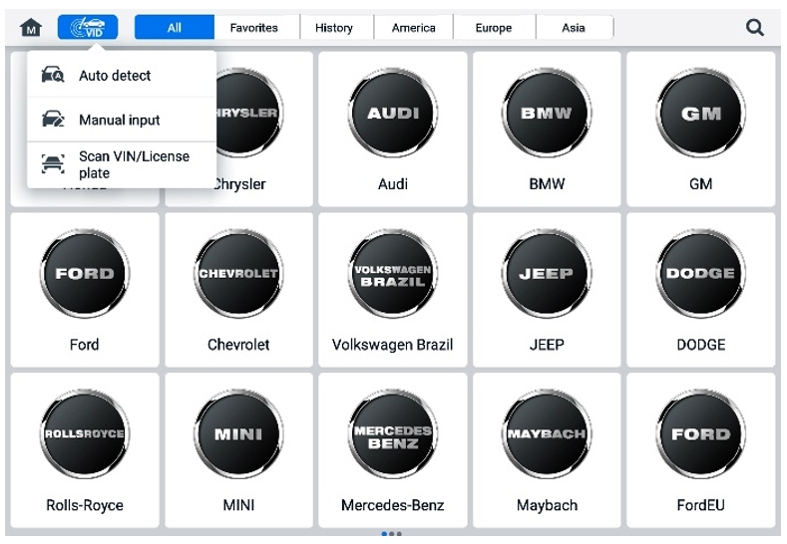
Figure 6-6 VID Button Screen

Manual Input
For vehicles that do not support the Auto Detect function, the MaxiSys system allows you to enter the vehicle VIN or license number manually, or simply take a photo of the VIN sticker or license plate for quick vehicle identification.
- To perform Manual Input
- Tap the Diagnostics application button on the MaxiSys Job Menu. The Vehicle Menu displays.
- Tap the VID button on the top toolbar (see Figure 6-6 VID Button Screen).
- Select Manual Input.
- Tap the input box and enter the correct VIN code or license number.
- Tap OK. The vehicle will be identified and matched to the vehicle database, and the system will guide you to the Diagnostics Main Menu screen.

Scan VIN/License
Tap Scan VIN/License in the dropdown list (see Figure 6-6 VID Button Screen), and the camera will be opened. On the right side of the screen, from top to bottom, three options are available: Scan Bar Code, Scan VIN, and Scan License.
NOTE
The method of Scan License is supported in some countries and areas. Please manually input the license number if it is not available.

Select one of three options and position the tablet to align the VIN or license number within the scanning window. The result displays in the Recognition result dialog box after scanning. Tap OK to confirm the result, and then the vehicle information confirmation screen will display on the tablet. If all the vehicle information is correct, tap the icon in the middle of the screen to confirm the VIN of the vehicle being tested, and tap OK to continue.
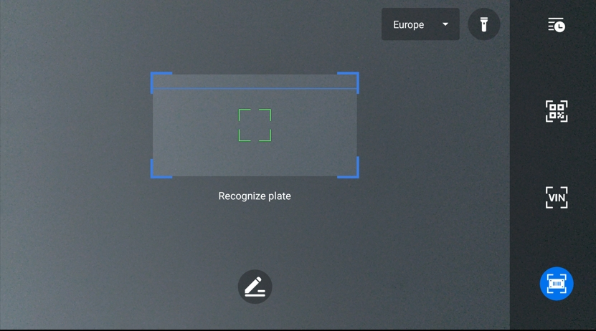
Figure 6-7 Scan VIN/License Screen
If the VIN/License number cannot be scanned, please manually input the VIN/License number. Tap OK to continue. Confirm the VIN of the vehicle being tested to proceed.

Manual Vehicle Selection
When the vehicle's VIN is not automatically retrievable through the vehicle's ECU, or the specific VIN is unknown, you can select the vehicle manually.
Step-by-step Vehicle Selection
This mode of vehicle selection is menu-driven. Select a vehicle manufacturer on the Vehicle Menu screen and the Acquire VIN Information screen displays, and then tap the Manual Selection button. Select the vehicle information, such as brand, Model, Capacity, Engine type, and Model year, on the same screen. Tap the ESC button at the lower-right corner of the screen to exit the vehicle selection. Tap the Reset button to reselect the vehicle information if needed.

OBDII Direct Entry
Occasionally, the tablet may not be able to identify a vehicle. For these vehicles, the user may perform a generic OBDII or EOBD diagnostic. See Generic OBDII Operations for additional information.

Navigation

Diagnostics Screen Layout
After the vehicle information is confirmed, tap OK to enter the main diagnostic program. This section describes common functions, including Auto Scan, Control Unit, Service, and Programming. The available functions may vary among different vehicles.
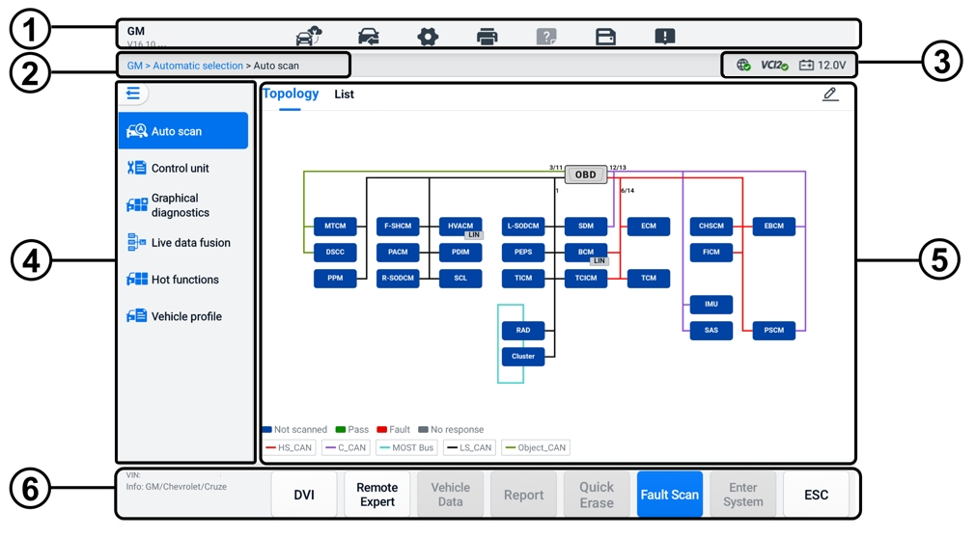
Figure 6-8 Diagnostics Main Menu Screen
- Diagnostics Toolbar
- Current Directory Path
- Status Information Bar
- Navigation Bar
- Main Section
- Function Buttons

Diagnostics Toolbar
The diagnostics toolbar contains buttons that allow you to print or save the displayed data and perform other operations. The table below provides a brief description for the operations of the diagnostics toolbar buttons:
Table 6-2 Diagnostics Toolbar Buttons
Button | Name | Description
 | Remote Expert | Tap to launch the Remote Expert application. This function is available in some countries and regions.
 | Vehicle Swap | Exits the diagnostic session and returns to the Vehicle Menu screen to select another vehicle for testing.
 | Settings | Opens the Settings screen. See Settings.
 | Print | Saves and prints a copy of the displayed data. See Printing Settings.
 | Help | Provides instructions or tips for the operation of various diagnostic functions.
 | Save | Opens a submenu that provides options for data storage.
 | Data Logging | Use this function when encountering an error while testing or diagnosing a vehicle. This function will record the communication data and ECU information of the test vehicle and send it to Autel's technical staff to review and provide solutions.  Go to the Support application to follow the processing progress. See Data Manager.
NOTE
The diagnostics toolbar (located on the top of the screen) will be active throughout the diagnostic session for tasks such as printing and saving the displayed data, obtaining help information, or performing data logging.
- To print data in Diagnostics
- Tap the Diagnostics application button on the MaxiSys Job Menu. The Print button on the diagnostics toolbar is available throughout all Diagnostics operations.
- Tap Print and a drop-down menu displays.
- Print This Page — prints a screenshot copy of the current screen.
- Print All Data — prints a PDF copy of all displayed data.
- A temporary file will be created and sent via the computer to the printer.
- When the file is sent, a confirmation message displays.
NOTE
Make sure the tablet and the printer are connected either by Wi-Fi or LAN before printing. For more instructions on printing, see Printing Settings for details.
- To submit Data Logging reports in Diagnostics
- Tap the Diagnostics application on the MaxiSys Job Menu. The Data Logging button on the diagnostics toolbar is available throughout all Diagnostics operations.
- Tap the Data Logging button to display the error options. Select a specific error, then tap OK, and a submission form will display to let you fill in the report information.
- Tap the Send button in the upper-right corner of the screen to submit the report form via the Internet. A confirmation message displays when sent successfully.

Current Directory Path
The current directory path shows all directory names to access the current page.

Status Information Bar
The status information Bar at the top-right of the Main Section displays the following items:
- Network Status Icon — indicates whether a network is connected.
- VCI2 Icon — indicates the communication status between the tablet and the VCI2.
- Battery Icon — indicates the battery status of the vehicle.

Navigation Bar
The navigation bar on the left side of the screen displays the main menu of the diagnostics functions. The main menu varies by the vehicle being tested. The common menu includes Auto Scan, Control Unit, Graphical Diagnostics, Live Data Fusion, Hot Functions, Vehicle Profile, and Programming. Tap the  icon in the upper-left corner of the navigation bar to hide the main menu, and tap it again to display.

Main Section
The main section varies depending on the stage of operations, which shows vehicle identification selections, the main menu, test data, messages, instructions, and other diagnostic information.

Function Buttons
The function buttons displayed at the bottom of the screen vary by operation. Function includes navigation, reporting, and code clearing. The functions of these buttons will be described in the following sections when relevant.

Screen Messages
Messages display when additional input is needed before proceeding. There are mainly three types of on-screen messages: Confirmation, Warning, and Error.

Confirmation Messages
This type of messages usually displays as an “Information” screen, when you are about to perform an action that cannot be reversed or when an action has been initiated and your confirmation is needed to continue.
When a user-response is not required, the message displays briefly.

Warning Messages
This type of messages displays when completing the selected action may result in an irreversible change or loss of data. An example of this message is the “Erase Codes” message.

Error Messages
Error messages display when a systemic or procedural error has occurred. Possible errors include cable disconnection and communication interruption.

Diagnostics Menu
The Diagnostics application enables you to establish a data connection with the vehicle’s ECU through the VCI2 for vehicle diagnosis and maintenance.
The Diagnostics Main Menu screen (see Figure 6-8 Diagnostics Main Menu Screen) navigates users to read codes, clear codes, or perform comprehensive automotive diagnostic functions, and so on. After the function is selected, the tablet will establish a communication with the vehicle through the VCI2, and enter the corresponding function menu or selection menu based on your selection.

Diagnostics Functions
Auto Scan
The Auto Scan function, which can be used to start auto scanning for all the available systems on the vehicle, will be listed on the navigation bar when accessing the diagnostics function.
On the Auto Scan screen, there are two tabs: Topology Tab and List Tab.

- Topology Tab Page
For a number of vehicle brands, including Volkswagen, Audi, BMW, Ford, Land Rover, Jaguar, Chrysler, Fiat, Volvo, etc., a topology map is available to display the relationship between vehicle systems. The ECU system of the tested vehicle is displayed in the form of a topology diagram, which describes the layout of the cables and systems of the vehicle control circuit and the path used for data transmission.
When selecting a system, the information such as ECU description, DTCs, location graphics, and PING network displays on the right side.
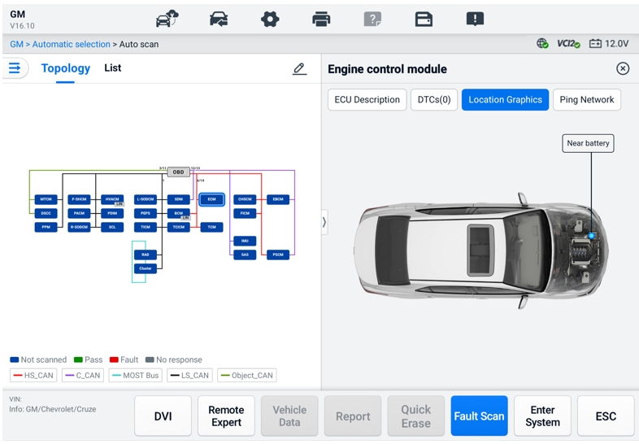
Figure 6-9 Topology Tab Page
- List Tab Page
The List Tab page is available for most vehicles.
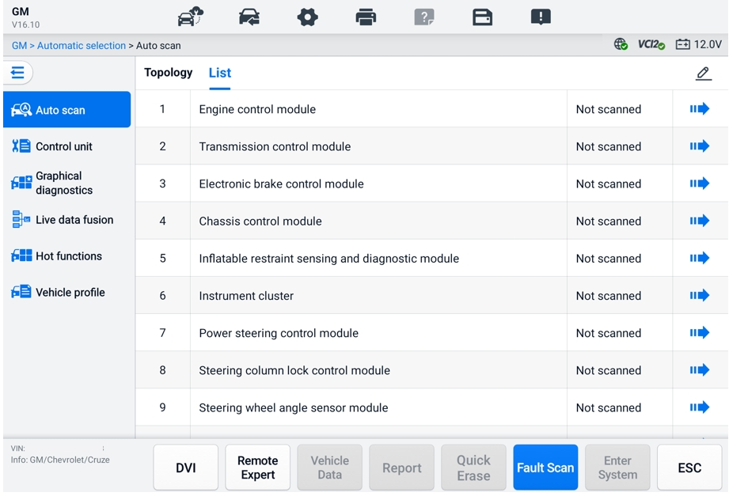
Figure 6-10 List Tab Page
- To perform an Auto Scan function
Take topology as an example:
- Tap the Diagnostics application button on the MaxiSys Job Menu. Choose the corresponding vehicle information and enter the Diagnostics Main Menu screen (see Figure 6-8 Diagnostics Main Menu Screen).
- Select Auto Scan from the navigation bar.
- The topology map displays in the main section. Tap the Fault Scan button at the bottom of the screen to scan the vehicle system modules.
Auto Scan Results
- Topology Tab Page
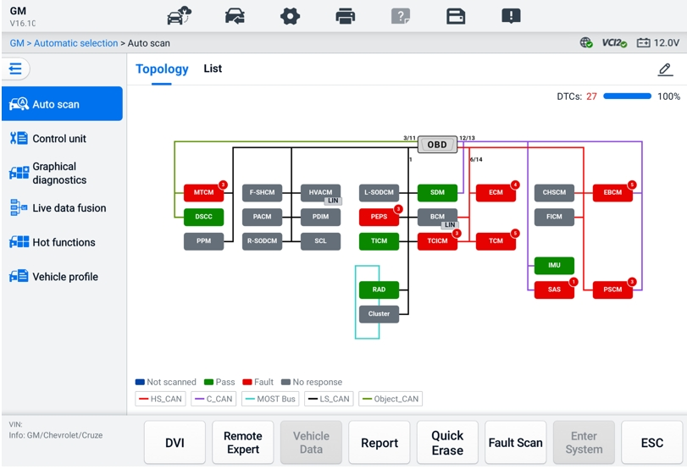
Figure 6-11 Scan Results in Topology Tab Page 1
The number of total faults will appear on the upper-right corner, and the results will be displayed in different colors after scanning:
- Green: the system has detected no faults.
- Red: the system has detected faults. The number of faults appears on the upper-right corner of the system.
- Gray: the system has not received a response.
- Blue: the system has not been scanned.
After scanning, you can tap a system with faults to view the information such as detailed DTCs, location graphics, and PING network on the right side.
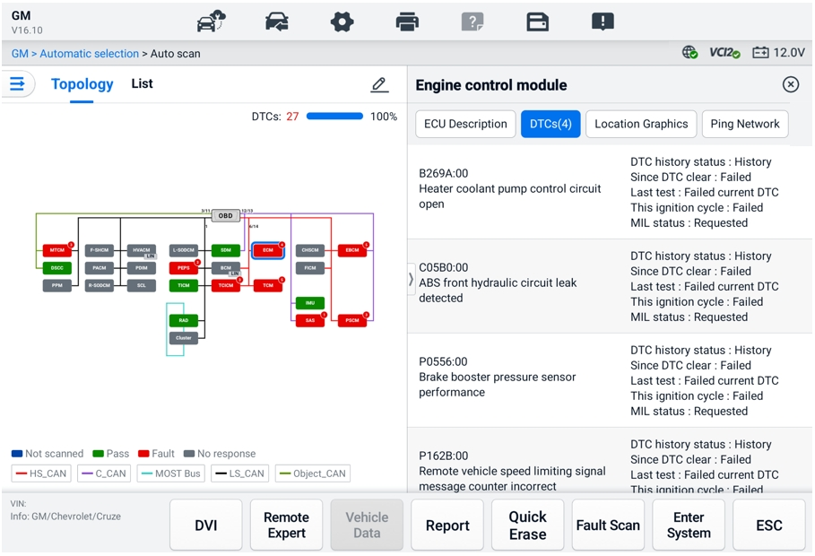
Figure 6-12 Scan Results in Topology Tab Page 2
Tap the Enter System button at the bottom to perform further diagnostics or perform functions based on the detected faults with voice commands beginning with “Hey Max.”
- List Tab Page
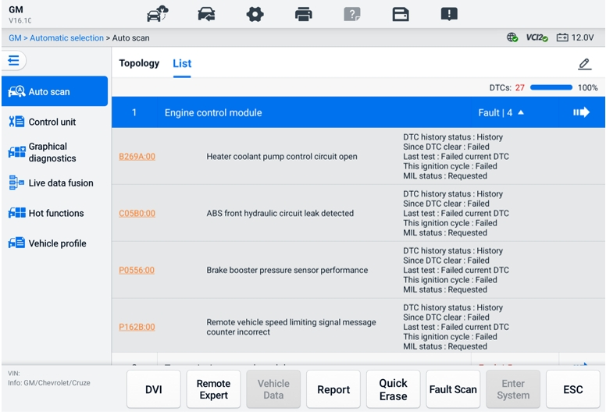
Figure 6-13 Scan Results in List Tab Page
The number of total faults will appear on the upper-right corner. The detailed scan results are displayed in four columns.
- Column 1 — displays the system numbers
- Column 2 — displays the scanned systems
- Column 3 — displays the scan results

- Fault | #: Indicates there is/are detected fault code(s) present; "#" indicates the quantity of detected faults.
- Pass | No Fault: Indicates the system was scanned and no fault has been detected.
- Not Scanned: Indicates the system has not been scanned.
- No Response: Indicates the system has not received a response.
- Column 4 — tap the  button to enter a system for performing further diagnostics.
The table below provides a brief description of the function buttons at the bottom of the Auto Scan screen:
Table 6-3 Function Button Descriptions
Name | Description
DVI | Accesses the DVI application screen.
Remote Expert | Exits the Diagnostics function and accesses the Remote Expert function to perform the remote service.
Vehicle Data | Displays the related vehicle data information.
Report | Displays the diagnostic data in report form.
Quick Erase | Erases all fault information after scanning.
Fault Scan | Scans vehicle system modules.
Pause | Pauses the scanning process.
Enter System | Enters the ECU system.
ESC | Returns to the previous screen or exits the Diagnostics screen.
Control Unit
The Control Unit function allows you to manually locate a required control system for testing through a series of choices. Simply follow the menu-driven procedures and make a proper selection each time; the program will guide you to the diagnostic function menu after a few choices you've made.
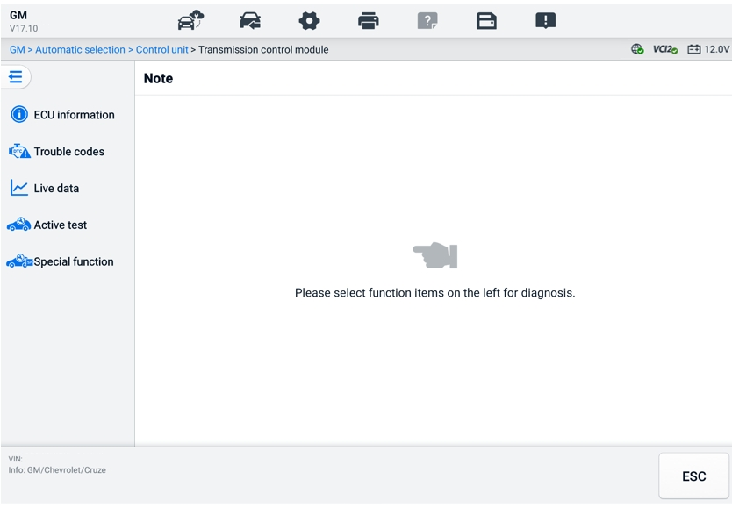
Figure 6-14 Control Unit Screen
Available functions may vary by vehicle. The function menu may include:
- ECU Information — displays detailed ECU information. Select to display the information screen.
- Trouble Codes — contains Read Codes and Erase Codes. The former displays detailed DTC information retrieved from the vehicle control module. The latter facilitates you to erase DTCs and other data from the ECU.
- Live Data — retrieves and displays live data and parameters from the vehicle’s ECU.
- Active Test — provides specific subsystem and component tests. Available tests vary by vehicle.
- Special Function — provides component adaptation or variant coding functions for custom configurations and allows the entry of adaptive values for certain components after repairs. Available functions vary by vehicle.

ECU Information
This function retrieves and displays the specific information for the tested control unit, including unit type, version numbers, and other information.
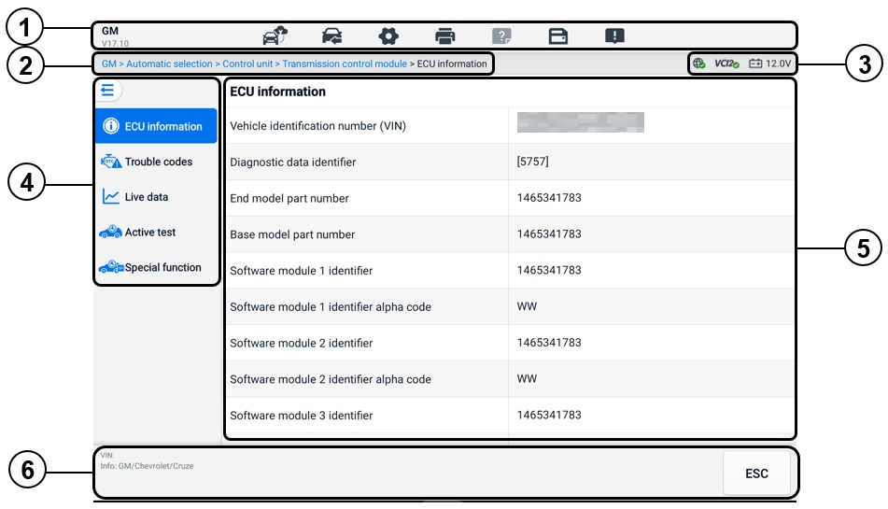
Figure 6-15 ECU Information Screen
- Diagnostics Toolbar — see Table 6-2 Diagnostics Toolbar Buttons for detailed descriptions of the operations of each button.
- Current Directory Path
- Status Information Bar
- Navigation Bar
- Main Section — the left column displays the item names; the right column displays the specifications or descriptions.
- Function Button — in this case, only an ESC button is available; tap it to exit after viewing.

Trouble Codes
The Freeze Frame, Read Codes, and Erase Codes function buttons are contained in the Trouble Codes screen. The Freeze Frame button will be activated if there are freeze frame data for viewing. Tap the Erase Codes button to erase DTCs and other data from the ECU, while tapping the Read Codes button to display the detailed DTC information retrieved from the vehicle control module. When tapping Trouble Codes from the navigation bar of the Control Unit screen, the tablet will automatically read the DTC information in ECU.
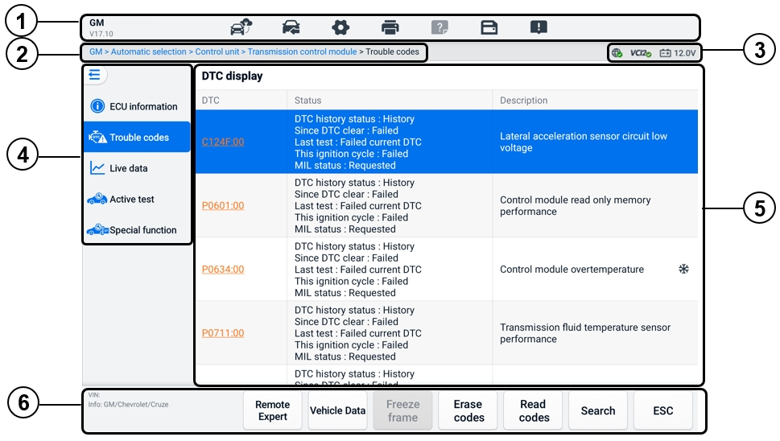
Figure 6-16 Trouble Codes Screen
- Diagnostics Toolbar — see Table 6-2 Diagnostics Toolbar Buttons for detailed descriptions of the operations of each button.
- Current Directory Path
- Status Information Bar
- Navigation Bar
- Main Section
- Column 1 — displays the retrieved codes from the vehicle
- Column 2 — indicates the status of the retrieved codes
- Column 3 — displays detailed descriptions for the retrieved codes
- Snowflake Icon — only displays when freeze frame data is available for viewing. Tap the icon to display data screen. The Freeze frame screen is similar to that of the Read codes screen and share similar operations
- Function Buttons
- Remote Expert — tap to access the remote expert function.
- Freeze Frame — a snowflake icon appears when freeze frame data is available for viewing.
- Erase Codes — tap to erase codes from the ECU. It is recommended to read DTCs and make necessary repairs before erasing the codes.
After reading the retrieved codes from the vehicle and certain repairs have been made, you can erase the codes from the vehicle using this function. Before performing this function, make sure the vehicle's ignition key is in the ON (RUN) position with the engine off.

- To erase codes
- Tap Erase Codes from the function buttons.
- A warning message displays to inform you of data loss when this function is applied.
- Tap OK to continue. A confirming screen displays when the operation is successfully done.
- Tap Cancel to exit.
- Tap ESC on the confirming screen to exit the Erase Codes screen.
- Check the Read Codes function again to ensure the operation is successful.
- Read Codes — retrieves and displays the DTCs from the vehicle control system. The Read Codes screen varies for each vehicle being tested.
- Search — tap to search the selected DTC for additional information on the Internet.
- ESC — tap it to return to the previous screen or exit the function.

Live Data
After tapping the Live Data option from the left navigation bar, the screen displays the parameter groups by default. Tap a group to enter the live data screen for details. You can also create a new data group by tapping the Add () icon.
The live data screen displays the data list for the selected system. The displayed parameters vary by vehicle. Gesture scrolling allows you to move quickly through the data list. Touch the screen and drag your finger up or down to reposition the parameters being displayed if the data occupies more than one screen.
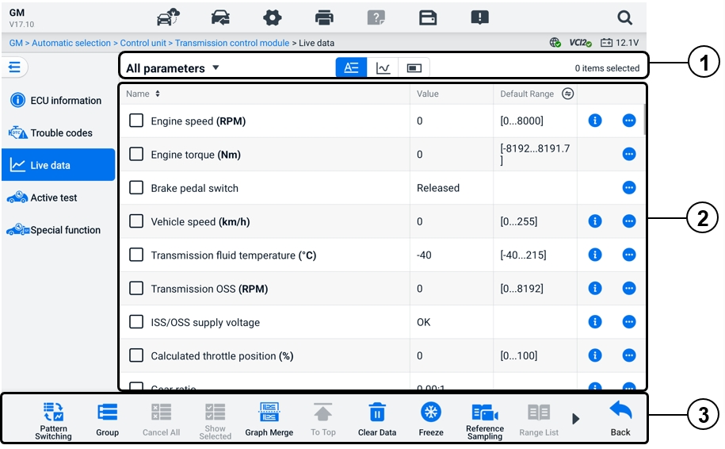
Figure 6-17 Live Data Screen
- Top Toolbar
- Data Group Selection — tap the dropdown button to select the data group needed.
- Display Mode — three display modes are available for a selected data group.
- Text Mode — the default mode that displays the parameters as a text list.
- Waveform Graph Mode — displays the parameters in waveform graphs.
- Digital Gauge Mode — displays the parameters in the form of a digital gauge graph.
- Main Section
- Name Column — displays the parameter names.
- Check Box — tap the check box to the left of a parameter to select the item. Tap the check box again to deselect it.
- Value Column — displays the values of the parameters.
- Default Range Column — displays the default ranges of the parameters.
NOTE
Tap the icon on the right of the Range column to switch the display between the maximum & minimum values at the recording function and the reference value.
- Overflow Menu Button — tap the icon to open a submenu that provides four display modes and other options.
- Help information Button — tap the icon to open the Live Data Help screen that provides help information of the selected live data, such as meaning, principle and related parts.

Display Mode
There are four types of display modes available for data viewing, allowing you to view various types of parameters in the mode best suited to represent the data.
Icon | Display Mode
 | Text Mode
 | Waveform Graph Mode. The digital-type parameters and status parameters are supported.
 | Digital Gauge Mode. Only digital-type parameters are supported.
 | Analog Gauge Mode. Only digital-type parameters are supported.
- To select the display mode
- Select the data group you need at the left corner of the top toolbar.
- Tap a display mode among the text mode, waveform graph mode, and digital gauge mode for the selected data group.
- Or tap the overflow menu button to select a display mode for a specific parameter. Each parameter item displays the selected mode independently.
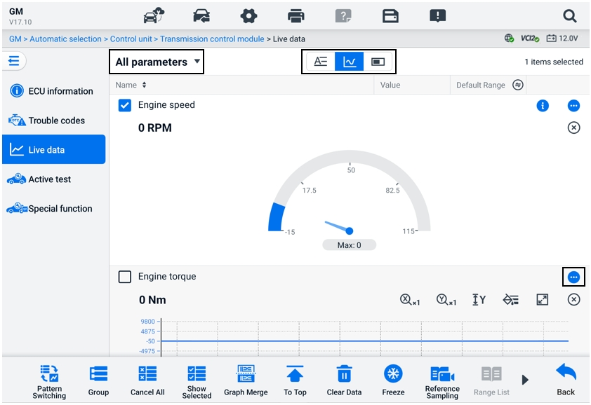
Figure 6-18 Display Mode Screen

Control Button
A total of 4 control buttons will be displayed: Unit Switching, Trigger Setting and Add to Group.
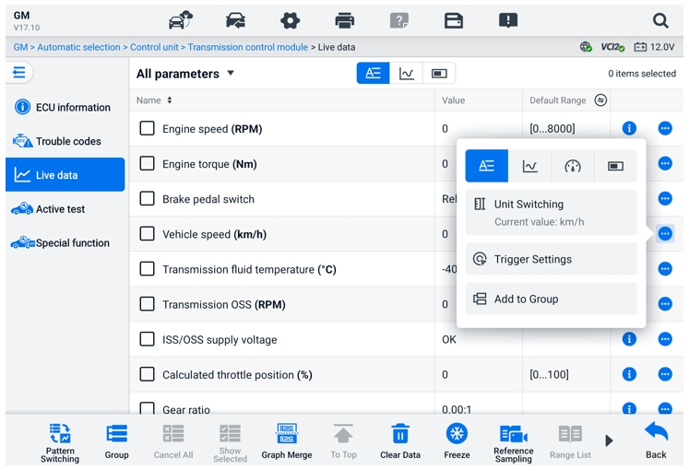
Figure 6-19 Control Button Screen
- Unit Switching — tap to switch the unit for the parameter value.
- Trigger Settings — tap to display the Trigger Settings window.
On the trigger settings screen, you can set a standard range by filling in a minimum value and a maximum value. When exceeding this range, the trigger function will be executed, and the device will automatically record and save the generated data. You can check the saved live data by tapping the Review button at the bottom of the screen.
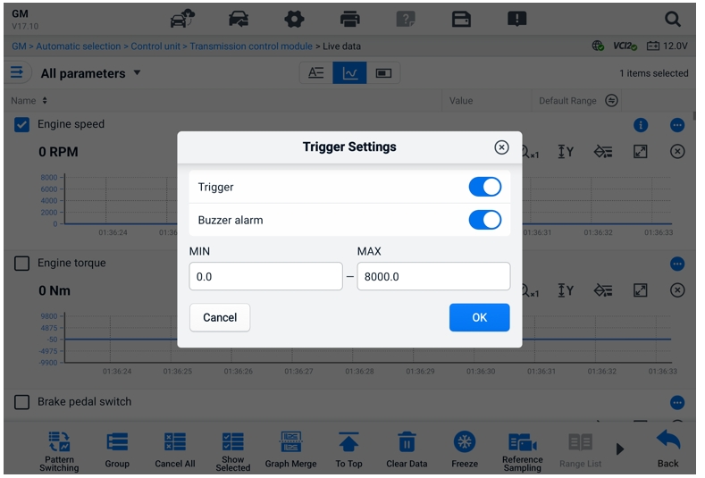
Figure 6-20 Trigger Settings Screen
Two buttons and two input boxes are available in the Trigger Settings window.
- Trigger — switches the trigger on and off. The trigger is ON by default.
- Buzzer Alarm — switches the alarm on and off. The alarm function makes a beeping sound as an alert when the data reading reaches the preset minimum or maximum point. The buzzer alarm will only sound at the first trigger.
- MIN — tap this input box to display a virtual keyboard to enter the required lower limit value.
- MAX — tap this input box to display a virtual keyboard to enter the required upper limit value.
  - To set a trigger
- Tap the overflow button on the right side of the parameter to open a submenu.
- Tap the Trigger Settings button under the Text Mode in the submenu to open the Trigger Settings window.
- Tap the MIN input box and enter the required minimum value.
- Tap the MAX input box and enter the required maximum value.
- Tap OK to save the setting and return to the Live Data screen; or tap Cancel to exit without saving.
When the trigger is successfully set, a trigger mark displays in front of the parameter name. The mark is gray when not triggered and displays orange when triggered. Moreover, two horizontal lines are displayed on each of the data graphs (when Waveform Graph Mode is applied) to indicate the alarm point. The limit lines are shown in different colors to differentiate them from the parameter waveforms.
- Add to Group — tap to add the selected parameters to the custom group.
- Text Mode — the default mode that displays the parameters as a text list.
- Waveform Graph Mode
In this mode, six control buttons will display on the right side of the parameter item, allowing you to manipulate the display status.
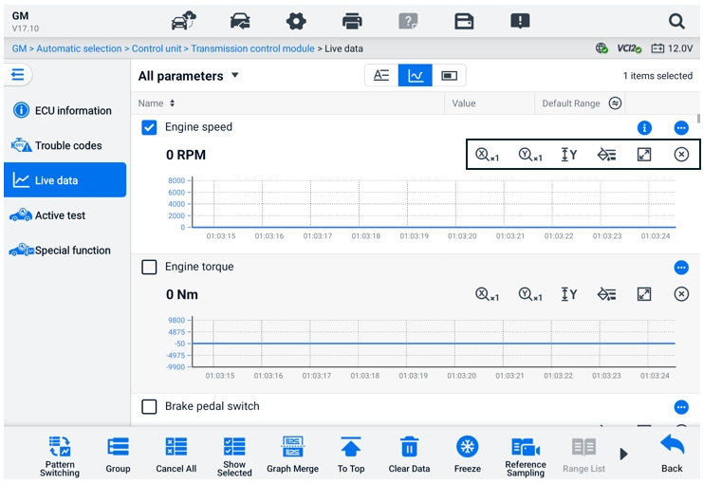
Figure 6-21 Waveform Graph Mode Screen
- Scale Button for the X-axis: There are four scales available for the X-axis: x1, x2, x4, and x8.
- Scale Button for the Y-axis: There are three scales available for the Y-axis: x1, x2, and x4.
- Settings Button (SetY) — sets the minimum and maximum value of the Y-axis.
- Edit Button — edits the waveform color and the line thickness.
- Zoom-in Button — tap to display the selected data graph in full screen.
- Exit Button — tap to exit the waveform graph mode.
Full Screen Display — There are five control buttons available on the top-right side of the screen.
- Scale Button for the X-axis: There are four scales available for the X-axis: x1, x2, x4, and x8.
- Scale Button for the Y-axis: There are three scales available for the Y-axis: x1, x2, and x4.
- Edit Button — tap to open an edit window, in which you can set the waveform color and the line thickness displayed for the selected parameter item.
- Zoom-out Button — tap to exit the full-screen display.
- Exit Button — tap to exit the waveform graph mode.
- To edit the waveform color and line thickness
- Select a parameter item to display in Waveform Graph mode.
- Tap the Edit button, and an edit window will display.
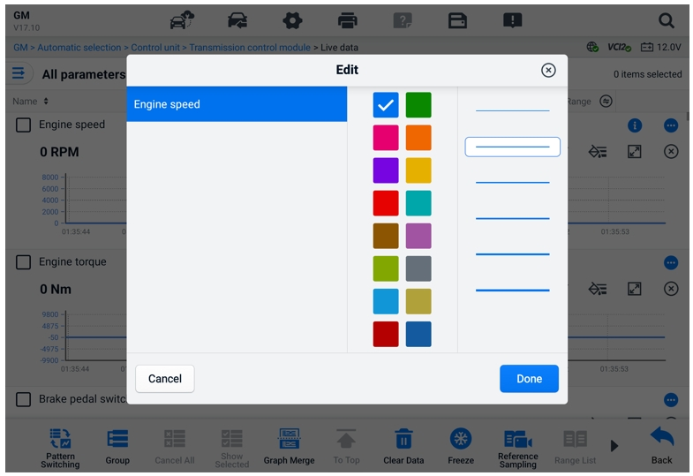
Figure 6-22 Waveform Edit Screen
- The parameter item is selected automatically in the first column.
- Select a color from the second column.
- Select a line thickness from the third column.
- Tap Done to save the setting and exit, or tap x to exit without saving.
NOTE
In the full-screen display, edit the waveform color and line thickness by tapping the Edit button on the top-right side of the screen.
- Analog Gauge Mode — displays the parameters in gauge charts.
- Digital Gauge Mode — displays the parameters in the form of a digital gauge graph.
- Function Buttons
The operations of the available functional buttons on the Live Data screen are described below:
- Pattern Switching — tap to switch between the vertical list mode and grid list mode. Long press the button to display a pop-up window showing all the grid mode patterns, such as 12-grid, 9-grid, 6-grid, etc. Select a pattern to display the parameters.
- Group — tap to create a new group or select an existing custom group. The Edit Group and Delete Group buttons are available at the bottom of the screen once the Group button is selected.
- Cancel All — tap to cancel all selected parameter items. Up to 50 parameters can be selected at one time.
- Show Selected/Show All — tap this button to switch between the two options: one displays the selected parameter items, and the other displays all the available items.
- Graph Merge — tap this button to merge selected data graphs (for Waveform Graph Mode only). This function is very useful when comparing different parameters.
NOTE
This mode supports 2 concurrent curve fusion groups of up to 8 parameters per group that can be represented digitally. Non-digital parameters are not supported.
  - To merge selected data graphs
- Select the parameters to be merged.
- Tap the Graph Merge button at the bottom of the Live Data screen.
- The selected parameters are displayed on the screen. Tap the selectable check box on the right to choose the parameter and group. The grey check box is not available to select.
- Tap Start Fusion to start.
- Tap the Back button to exit.
- To Top — tap to move a selected data item to the top of the list.
- Clear Data — tap to clear all cached live data.
- Freeze — tap to display the retrieved data in freeze mode.
- Resume — tap to exit the freeze data mode and return to normal data display.
- Previous Frame — tap to move to the previous frame of frozen data.
- Play/Pause — tap to play/pause the frozen data.
- Next Frame — tap to move to the next frame of frozen data.
- Reference Sampling — tap to perform cyclic sampling of all live data in the current system and provide the maximum, minimum, and average values of the sampled data. Technicians can customize sampling conditions. This function can be used for the comparative analysis of live data, assisting technicians in quickly identifying the abnormal data.
- Range List— tap to display the sampled reference values including the maximum, minimum, and average values.
- Record — tap to start recording the live data of the selected data items. Tap the Record button at the bottom of the Live Data screen. A message will display, prompting the user to select the parameters to record. Tap the Got It button to confirm. Scroll down and select the data items to record. Tap the Record button to start recording. Tap the Complete button to stop recording. The recorded live data can be viewed in the Review section at the bottom of the Live Data screen. The recorded data can also be reviewed in the Data Manager application.
- Complete — Tap to stop data recording and return to normal data display.
- Flag — displays when the Record function is applied. Tap this button to set flags to note points of interest when recording data. Notes can be added during playback in Review or Data Manager. Select the preset flag to open a popup window and display a virtual keyboard to input notes.
- Review — tap to review the recorded data. Tap the Review button to display a recording list and select one item to review.
NOTE
Only the data recorded during the current operation can be reviewed on the Live Data screen. All the historical recorded data can be reviewed in "Review Data" in the Data Manager application.
- Pattern Switching — switches the display pattern.
- Graph Merge — merges selected data graphs.
- Show Selected — displays the selected parameters.
- Previous Frame — switches to the previous frame of recorded data.
- Play/Pause — tap to play/pause the recorded data.
- Next Frame — switches to the next frame of recorded data.
- Back — exits the Review screen and returns to the Live Data screen.
- Back — returns to the previous screen or exits the function.

Active Test
The Active Test function is used to access vehicle-specific subsystem and component tests. Available tests vary by vehicle.
During an active test, the tablet sends commands to the ECU to activate the actuators. This test determines the integrity of the system or part by reading ECU data, or by monitoring the operation of the actuators. Such tests may include switching a solenoid, relay, or switch, between two operating states.
Selecting Active Test displays a menu of test options. Available tests vary by vehicle.
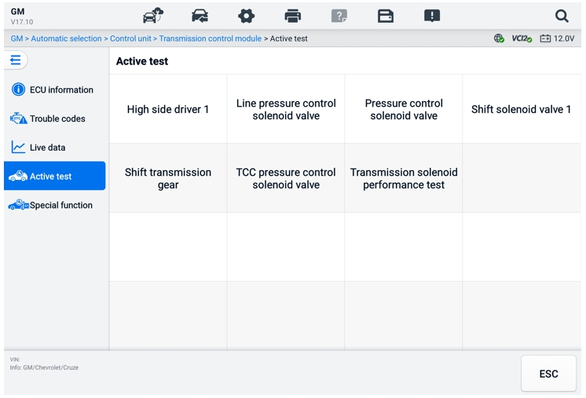
Figure 6-23 Active Test Screen
Select a test from menu options. Follow the instructions displayed on the screen to complete test. Procedures and instructions vary by vehicle.
The function buttons in the lower-right corner of the Active Test screen manipulate the test signals. The operational instructions are displayed in the main section of the test screen. Follow the on-screen instructions and make appropriate selections to complete the tests. Tap the ESC button to exit the test when finished.

Special Functions
Depending on the test vehicle, this selection may sometimes appear as Learning Process, Correction Programming, Emissions Inspection (Not valid for USA), OBD I/M Check (Not valid for USA), or something similar. You can select one to proceed according to your demands.
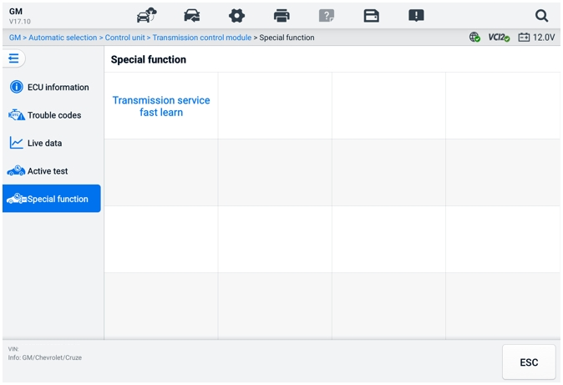
Figure 6-24 Special Functions Screen

Graphical Diagnostics
This function displays the vehicle system in a graphical format. It can intuitively show the relative position of the sensors in the system and the corresponding real-time data. The general diagnostic functions, including reading code, erasing code, and fault scanning, are also supported in this section. See Diagnostics Functions for details.
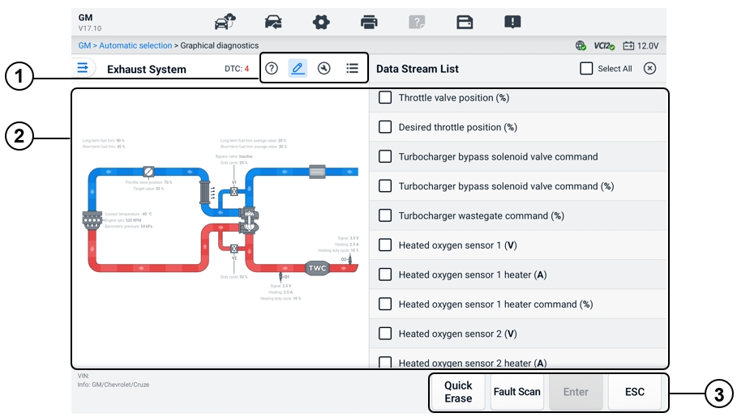
Figure 6-25 Graphical Diagnostics Screen
      - Top Icons — the corresponding contents will display on the right of the main section after tapping a top icon.
Help Information — tap to display the code description and the icon description of the vehicle system.
Live Data Selection — tap to select the live data you need from the list. The selected live data will be highlighted in the graphs on the left of the main section. The unselected live data and values will show as grey in the graphs.
Active Test — tap to display the Active Test screen. Follow the onscreen instructions and set values for a test. This function helps technicians troubleshoot problems more intuitively and efficiently.
System List Switching — tap to display the vehicle system in a list format.
      - Main Section — the left displays the selected system in intuitive graphs. The right shows the corresponding contents after tapping a top icon.
      - Function Buttons — the buttons vary by the test vehicle. The function buttons in the above screenshot are as follows:
Quick Erase: Erases all fault information after scanning.
Fault Scan: Scans vehicle system modules.
Enter: Enters the system.
ESC: Exits the function.

Live Data Fusion
For multiple systems, this function provides a quick way to create a new group, conducting the fusion performance based on the custom group items.
NOTE
This function is supported for certain vehicles.
- To perform the live data fusion function
- Tap the Live Data Fusion option on the navigation bar from the Diagnostics Main Menu Screen.
- Tap the Add icon or the Create button to add a new group. You can also select the temporary group, which is generated by default.
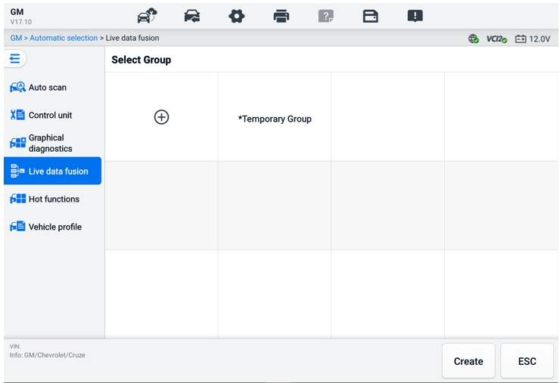
Figure 6-26 Live Data Fusion Screen 1
- Tap the dropdown button on the upper-left corner of the main section to select the specific module you need. Tap the Add icon on the right of the parameters to add.
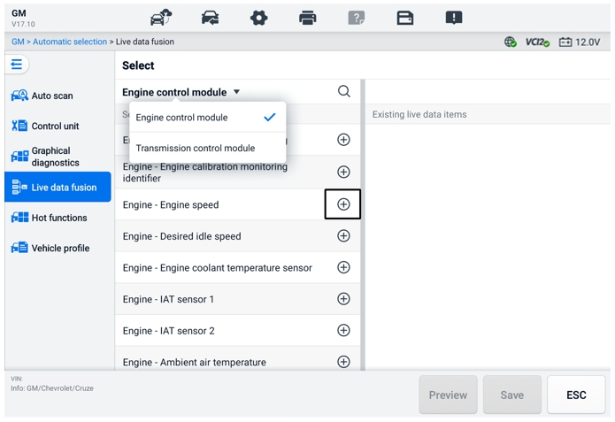
Figure 6-27 Live Data Fusion Screen 2
- Tap Save at the bottom to add a new group or select an existing custom group. Tap OK. The screen displays the saved parameters.
- Follow the operations in the Live Data function to proceed. See Live Data for details.

Programming and Coding
Since the introduction of OBDII and leading up to modern hybrids and EVs, hardware and software technologies in cars have been advancing at an exponential rate. Updating software may be the only way to fix the following issues:
- Drivability
- Fuel Efficiency
- Power Loss
- Fault Codes
- Durability of Mechanical Parts
The Programming and Coding function is used to re-flash the vehicle control modules, which allows you to update the computer software of the vehicle to the latest version, as well as to reprogram adaptive data of certain components after making repairs or replacements.
NOTE
The programming function applies only when the vehicle is connected with a VCI2, which serves as a PassThru interface to establish communication with and transfer data to the vehicle’s ECU.
Available programming or coding operations vary by test vehicle. Only the available operations display in the tablet menu.
There are two general types of programming operations:
- Coding — also known as Teach-in Program, or Component Adaptation, is used to reprogram adaptive data for vehicle control modules after repairs or replacements of vehicle parts.
- Reprogramming — downloads the latest version of software from the online server database through Internet access (this procedure is done automatically when the tablet is connected to the Internet, so there is no need to check for software updates yourself), and reprograms the newest version into the vehicle's ECU.
NOTE
Ensure that the tablet is connected to a stable internet access before applying the ECU programming function, so that the tablet is able to obtain access to the vehicle manufacturer's server for update service.
Selecting the Programming opens a menu of operation options that vary by vehicle make and model. Selecting a menu option either displays a programming screen or opens another menu of additional choices. Follow the on-screen instructions to operate. How and what information is presented on the screen vary by the type of operation being performed.

Coding
The main section of the Coding screen displays a list of vehicle components and the coding information that mainly consists of two parts:
- All available systems for coding are displayed on the left side, and the coding data or value on the right side.
- The bottom of the main section displays the functional buttons that enable you to manipulate the operation.
Check the vehicle condition and the coding information carefully. Use the functional button to edit Codes for the corresponding components. Tap Send when you finish editing all items. When the operation is completed, an execution status message such as Completed, Finished or Successful, may display.
Tap the ESC button to exit the function.

Reprogramming
Before reprogramming begins:
- It is mandatory that the tablet is connected to a stable Wi-Fi network.
- The tablet must be connected to the VCI2 via a USB cable.
- The tablet battery must be fully charged during module programming. Connect the tablet to a charger if needed.
- Attach the battery maintainer to the vehicle battery to ensure a steady voltage is maintained throughout programming. Voltage requirements differ by vehicle manufacturer. Consult vehicle manufacturer recommendations prior to programming a module.
- Do not quit the application during a module reprogramming as the process may fail and may also result in permanent damage to the module.
Typical reprogramming operations require you to input and validate VIN number first. Tap the input box and enter the correct number. The programming interface then displays.
The main section of the reprogramming interface offers information of the hardware, the current software version, and the newest software versions to be programmed into the control units.
A series of on-screen operational instructions will display to guide you through the programming procedure.
Carefully read the on-screen information and follow the instructions to execute the programming procedure.

Re-flash Errors
IMPORTANT
When reprogramming onboard, always make sure the vehicle battery is fully charged and in good working condition. During reprogramming, the operation may fail if voltage falls below the proper operation voltage. Sometimes a failed operation can be recovered, but the failed reprogramming can also ruin the control module. We recommend connecting an external battery maintainer to the vehicle to ensure a steady voltage is maintained throughout programming. The required voltage differs by vehicle manufacturer. Consult vehicle manufacturer for correct voltage to be maintained.
Occasionally a flash update procedure may not complete properly. Common causes of flash errors include poor cable connections between the tablet, VCI, and vehicle, the vehicle ignition being switched off before the flash procedure is complete, or low vehicle battery voltage.
If the process quits, recheck all the cable connections to assure good communications and initialize the flash procedure. The programming procedure will automatically repeat if the previous operation does not succeed.

Generic OBDII Operations
The OBDII/EOBD vehicle diagnosis option offers a quick way to check for DTCs, isolate the cause of an illuminated malfunction indicator lamp (MIL), check monitor status prior to emissions certification testing, and perform other emissions-related services. The OBDII direct access option is also used for testing OBDII/EOBD compliant vehicles that are not included in the database. Diagnostics Toolbar Buttons at the top of the screen are available for specific vehicle diagnostics. See Table 6-2 Diagnostics Toolbar Buttons for details.

General Procedure
- To access the OBDII/EOBD diagnostics functions
- Tap the Diagnostics application button on the MaxiSys Job Menu. The Vehicle Menu displays.
- Tap the EOBD button. There are two options to establish communication with the vehicle.
- Auto Scan — select it to establish communication using each protocol in order to determine which one the vehicle is using.
- Protocols — select it to open a submenu of various protocols. A communication protocol is a standardized way of data communication between an ECM and a diagnostic tool. Global OBD may use several different communication protocols.
- Select a specific protocol if the Protocol option is selected. Wait for the OBDII/EOBD Diagnostic Menu to appear.
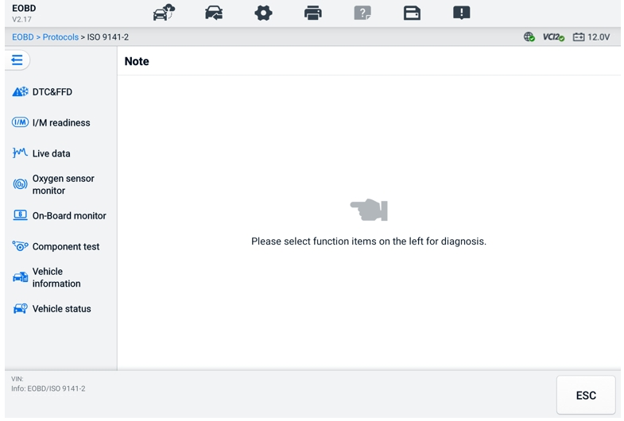
Figure 6-28 OBDII Diagnostic Menu
- Select a function option to continue.
- DTC & FFD
- I/M Readiness
- Live Data
- Oxygen Sensor Monitor
- On-Board Monitor
- Component Test
- Vehicle Information
- Vehicle Status
NOTE
The supported functions may vary by vehicle.

Function Descriptions
This section describes the various functions of each diagnostic option.

DTC & FFD
When this function is selected, the screen displays a list of Stored Codes and Pending Codes. When the Freeze Frame data of certain DTCs are available for viewing, a snowflake button will display on the right side of the DTC item. The Erase Codes and Read codes functions can be applied by tapping the Function Buttons at the bottom of the screen.

- Current Codes
Current codes are emission-related DTCs from the ECM of the vehicle. OBD II/EOBD Codes have a priority according to their emission severity, with higher-priority codes overwriting lower-priority ones. The priority of the code determines the illumination of the Malfunction Indicator Lamp (MIL) and the codes erase procedure. Manufacturers rank codes differently, so DTCs may vary by vehicle.
- Pending Codes
These are codes whose storing conditions have been met during the last drive cycle, but need to be met on two or more consecutive drive cycles before the DTC stored. The purpose of displaying pending codes is to assist the service technician after a vehicle repair when diagnostic information is cleared, by reporting test results after a single driving cycle.
- If a test fails during the driving cycle, the DTC associated is reported. If the pending fault does not occur again within 40 to 80 warm-up cycles, the fault is automatically cleared from memory.
- Test results reported do not necessarily indicate a faulty component or system. If test results indicate another failure after additional driving, a DTC is stored to indicate a faulty component or system.
- Freeze Frame
In most cases the stored frame is the last DTC reported. Certain DTCs, those that have a greater impact on vehicle emission, have a higher priority. In these cases, DTC of the highest priority is the one for which the freeze frame records are retained. Freeze frame data includes a "snapshot" of critical parameter values at the time the DTC is stored.
- Erase Codes
This option is used to clear all emission-related diagnostic data including DTCs, freeze frame data and specific manufacturer-enhanced data from the vehicle ECM. This option resets the I/M Readiness Monitor Status for all vehicle monitors to Not Ready or Not Complete status.
A confirmation screen displays when the clear codes option is selected to prevent accidental loss of data. Select Yes on the confirmation screen to continue, or select No to exit.

I/M Readiness
This function is used to check the readiness of the monitoring system. It is an excellent function to use prior to having a vehicle inspected for state emissions compliance. Selecting I/M Readiness opens a submenu with two choices:
- Since DTCs Cleared — displays the status of monitors since the last time the DTCs are erased.
- This Driving Cycle — displays the status of monitors since the beginning of the current drive cycle.

Live Data
This function enables the display of real-time PID data from the ECU. Displayed data includes analog and digital input and output, and system status information broadcast in the vehicle data stream.
Live data can be displayed in various modes, see Live Data for detailed information.

Oxygen Sensor Monitor
This function allows retrieval and review of recent oxygen sensor monitor test results stored on the vehicle's on-board computer.
The Oxygen Sensor Monitor test function is not supported by vehicles that communicate using a controller area network (CAN). For Oxygen Sensor Monitor test results of CAN-equipped vehicles, refer to On-Board Monitor.

On-Board Monitor
This function allows you to view the results of On-Board Monitor tests. The tests are useful after the service when a vehicle's control module memory is already erased.

Component Test
This function enables dual-directional control of the ECM so that the diagnostic tool can transmit control commands to operate the vehicle systems. This function is useful in determining how well the ECM responds to a command.

Vehicle Information
This function enables the display of the vehicle identification number (VIN), calibration identification number, calibration verification number (CVN), and other information of the test vehicle.

Vehicle Status
This function checks the current condition of the vehicle, such as the communication protocols of OBDII modules, number of fault codes, and status of the Malfunction Indicator Light (MIL).

Diagnostic Report

Pre-Scan and Post-Scan Functions
After performing pre-scan and post-scan functions by entering the same maintenance order number, tap Data Manager > Vehicle History to select the historical test record named with the maintenance order number. Both the pre-scan results and post-scan results will be displayed in the same historical test record, which can be generated as a PDF report for easily comparing the changes between pre-scan and post-scan.
- Pre-Scan Function
Select and tap a vehicle button from the Vehicle Menu screen. Enter the maintenance order number in the pop-up box to scan and detect the whole vehicle. You can also add pictures to record the current condition of the vehicle. Once the pre-scan is completed, you are not allowed to perform the pre-scan again, and the scan result cannot be modified.
- Post-Scan Function
After the pre-scan is completed, exit the current test vehicle and tap the vehicle button from the Vehicle Menu screen to reconnect again. Enter the same maintenance order number in the pop-up box. The screen for post-scan will display. The post-scan record will be generated when the scan is completed. The pre-scan results and post-scan results will be displayed in the same historical test record.
NOTE
The post-scan function can be performed repeatedly. After exiting the vehicle, you only need to tap the vehicle button from the Vehicle Menu screen to reconnect again, and then enter the same maintenance order number in the pop-up box and follow the steps to rescan. The last one is the final post-scan result.

Diagnostics Report Saving, Viewing, and Sharing
The diagnostic report can be reviewed, saved, and shared with others through many ways.

Diagnostics Report Saving
- Via the History function
- Tap the Diagnostics application button on the MaxiSys Job Menu, and select History on the top toolbar.
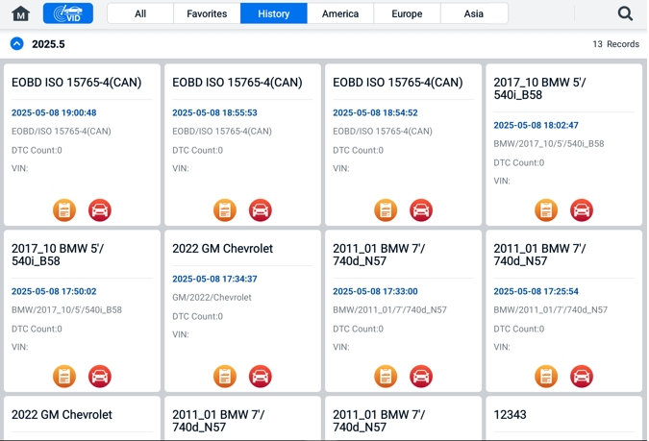
Figure 6-29 History Screen
- Select a history record, and tap the  button on the upper-right corner.
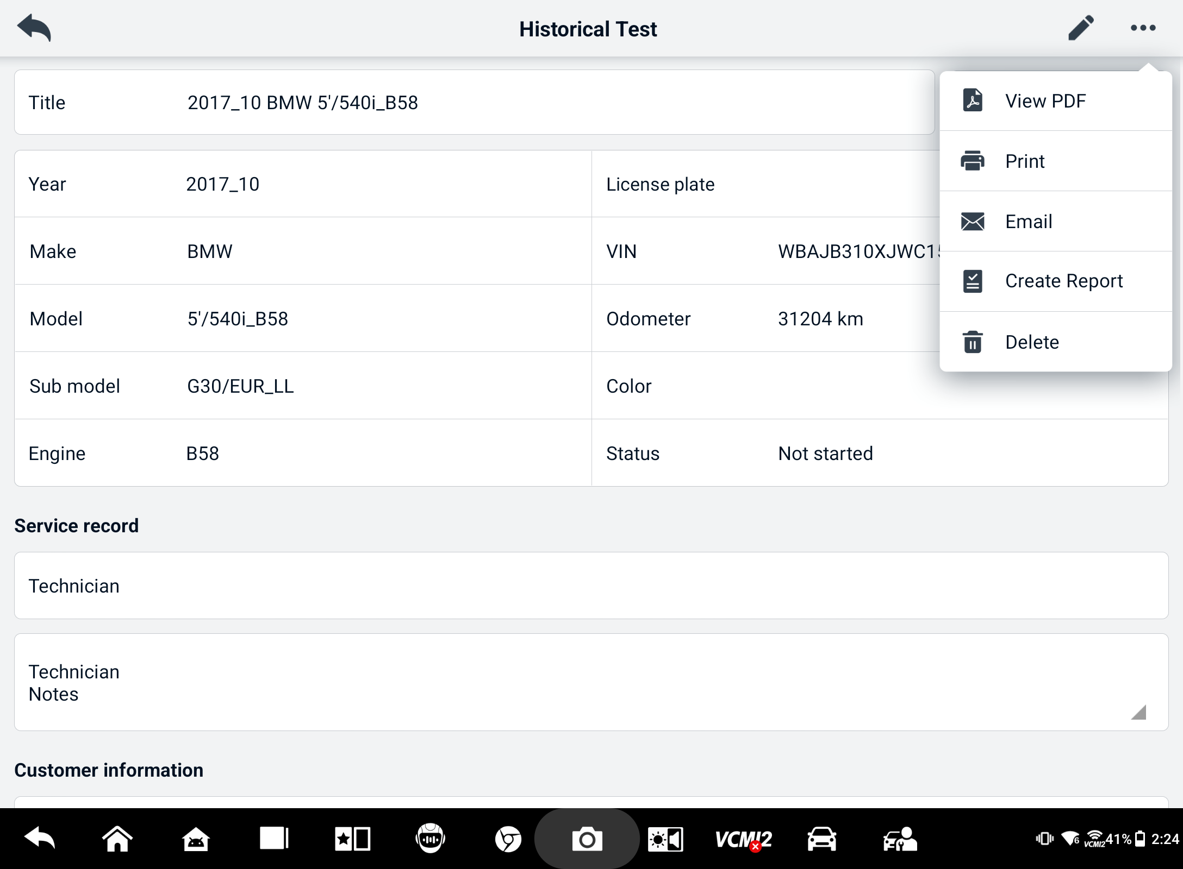
Figure 6-30 Historical Test Record Sheet
- Tap Create Report. Enter the license plate and current mileage. Tap Save.
- Via the Auto Scan function
- Enter the Auto Scan screen and tap Fault Scan from the function buttons at the bottom of the screen.
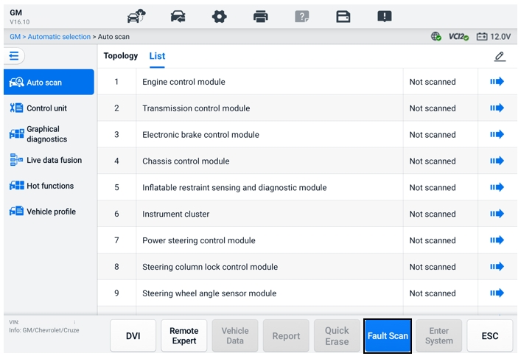
Figure 6-31 Auto Scan Screen 1
- When the system scan is completed, tap Report from the function buttons at the bottom of the screen. Enter the odometer reading and tap OK.
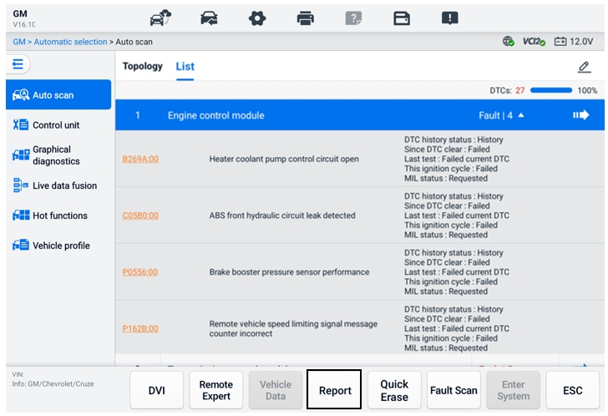
Figure 6-32 Auto Scan Screen 2
- Via the functions on the diagnostics toolbar
The diagnostic report can also be viewed from diagnostics functions screen including Auto scan and Trouble codes. There are two ways to view the saved reports:
- Tap the  button in the diagnostics toolbar and select Save as PDF. Enter the odometer reading and then tap Save. Tap the File button on the upper-right corner of the screen and select a saved report to view.
- Tap the button in the diagnostics toolbar and select Report to Cloud. Enter the odometer reading. Tap Save > View Report to view the saved report.
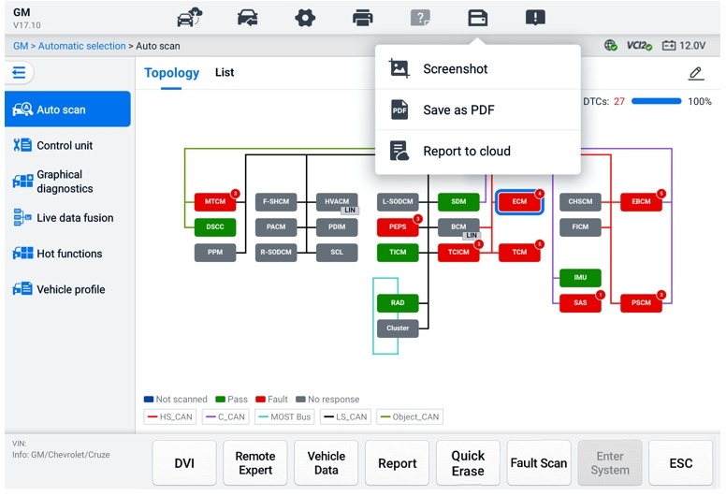
Figure 6-33 Auto Scan Screen 3

Diagnostics Report Viewing
All the saved reports can be viewed in the Data Manger application.
- Tap Data Manager > Vehicle History. Select a specific vehicle history record and then tap > View PDF in the upper-right corner to view the report.
- Once you save the reports by tapping the Save as PDF button, tap Data Manager > PDF to view these reports.
- Once you save the reports by tapping the Create Report or Report to Cloud button, tap Data Manager > Cloud Report to view these reports.

Diagnostics Report Cloud Sharing
- Tap Data Manager > Cloud Report to enter the Report List screen.
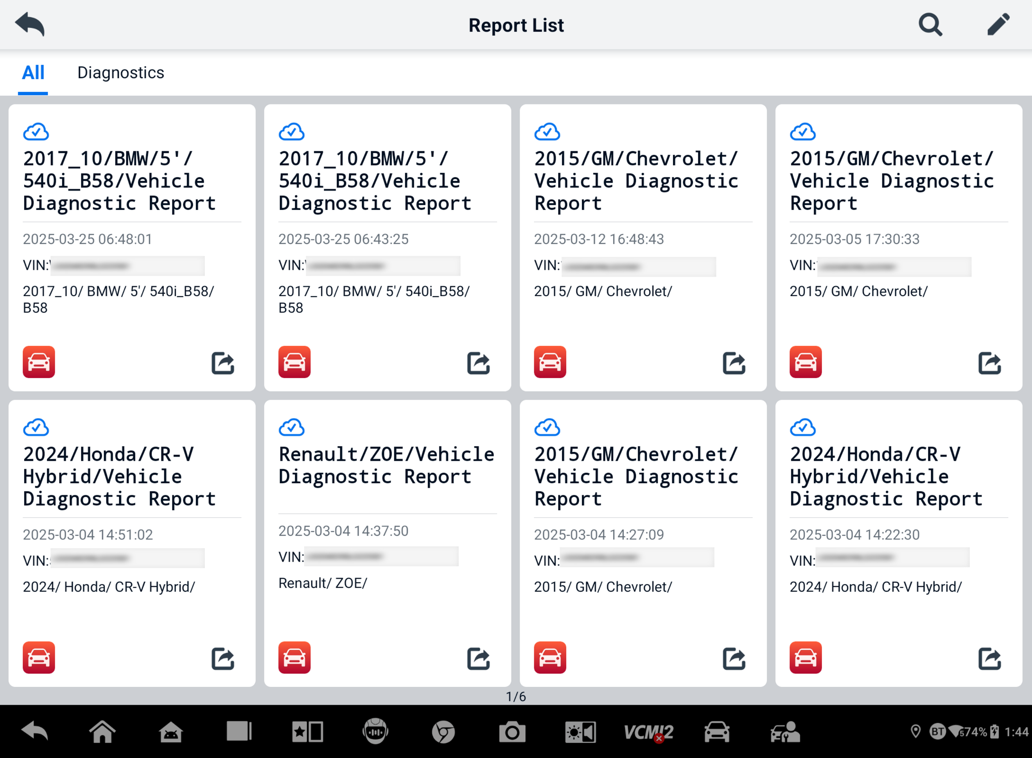
Figure 6-34 Report List
NOTE
Note that if the report displays , it means the report has been uploaded to the cloud successfully, and you can share the report with others; if the report displays, it means the report has failed to upload to the cloud, but will try to automatically upload to the cloud when entering the Report again.
- Tap the  icon on the lower-right corner of the report.
- There are three ways for report cloud sharing: scan the QR code, send by email, send by SMS (via phone number).

Exit Diagnostics
The Diagnostics application operates while communication with the vehicle is still active. It is important to properly exit from the diagnostics operation screen to stop all communications with the vehicle before closing the Diagnostics application.
NOTE
Damage to the vehicle electronic control module (ECM) may occur if communication is disrupted. Ensure all forms of communication link such as data cable, USB cable, and wireless or wired network, are properly connected throughout the test. Exit all screens before disconnecting the test cable and power supply.
- To exit the Diagnostics application
- On an active diagnostics screen:
- Tap the Back or ESC button to exit a diagnostic session step by step.
- Or tap the Vehicle Swap button in the Diagnostics Toolbar to return to the Vehicle Menu screen.
- On the Vehicle Menu screen:
- Tap the Home button on the Top Toolbar.
- Or tap the Back button on the Navigation Bar at the bottom of the screen.
- Or tap the Home button on the Diagnostics Toolbar to exit the application directly and return to the MaxiSys Job Menu.
NOTE
After exiting the Diagnostics application, the tablet is no longer communicating with the vehicle and it is safe to open other MaxiSys applications.

Service
The Service section is specially designed to provide quick access to the vehicle systems for various scheduled service and maintenance tasks. The typical service operation screen is a series of menu-driven executive commands. Follow on-screen instructions to select appropriate execution options, enter correct values or data, and perform necessary actions. The application will display detailed instructions to complete selected service operations.
After entering each special function, the screen will display two application choices: Diagnosis and Hot Functions. The Diagnosis enables the reading and clearing of codes which is sometimes necessary after completing certain special functions. Hot Functions consists of sub-functions of the selected special function.
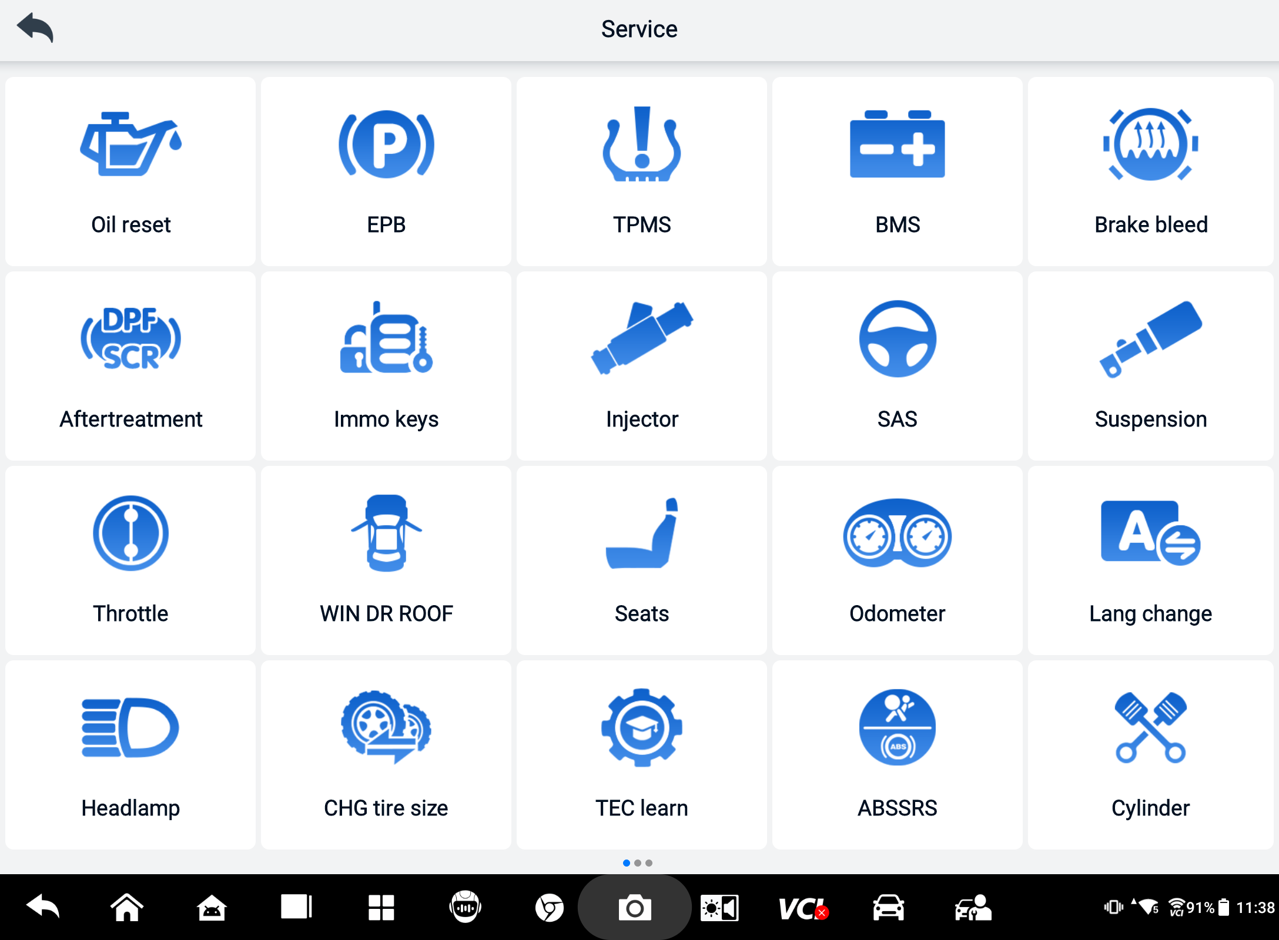
Figure 7-1 Service Menu
Several most commonly used services are described in this chapter.

Oil Reset Service
Perform reset for the Engine Oil Life system, which calculates an optimal oil life change interval depending on the vehicle driving conditions and climate. The Oil Life Reminder must be reset each time the oil is changed, so the system can calculate when the next oil change is required.


NOTE
- Always reset the engine oil life to 100% after every oil change.
- All required work must be carried out before the service indicators are reset. Failure to do so may result in incorrect service values and cause DTCs to be stored by the relevant control module.
- For some vehicles, the scan tool can reset additional service lights such as maintenance cycle and service interval. On BMW vehicles for example, service resets include engine oil, spark plugs, front/rear brakes, coolant, particle filter, brake fluid, micro filter, vehicle inspection, exhaust emission inspection and vehicle checks.

Electric Parking Brake (EPB) Service
This function has a multitude of usages to maintain the electronic braking system safely and effectively. The applications include deactivating and activating the brake control system, assisting with brake fluid control, opening and closing brake pads, and setting brakes after disc or pad replacement.
EPB Safety
It can be dangerous to perform Electric Parking Brake (EPB) system maintenance, so before you begin the service work, please keep these rules in mind.
- Ensure that you are fully familiar with the braking system and its operation before commencing any work.
- The EPB control system may be required to be deactivated before carrying out any maintenance/diagnostic work on the brake system. This can be done from the tool menu.
- Only perform maintenance work when the vehicle is stationary and on level ground.
- Ensure that the EPB control system is reactivated after the maintenance work has been completed.
NOTE
Autel accepts no responsibility for any accident or injury arising from the maintenance of the Electric Parking Brake system.

Tire Pressure Monitoring System (TPMS) Service
This function allows you to quickly look up the tire sensor IDs from the vehicle ECU, as well as to perform TPMS replacement and reset procedures after tire sensors are replaced.

Battery Management System (BMS) Service
The Battery Management System (BMS) allows the tool to evaluate the battery charge state, monitor the close-circuit current, register the battery replacement, activate the rest state of the vehicle, and charge the battery via the diagnostic socket.
NOTE
- This function is not supported by all vehicles.
- The sub functions and actual test screens of the BMS may vary by vehicle, please follow the on-screen instructions to make correct option selection.
The vehicle may use either a sealed lead-acid battery or an Absorbed Glass Mat (AGM) battery. Lead acid battery contains liquid sulphuric acid and can spill when overturned. AGM battery (known as VRLA battery, valve regulated lead acid) also contains sulphuric acid, but the acid is contained in glass mats between terminal plates.
It is recommended that the replacement aftermarket battery has the same specifications, such as capacity and type, as the exiting battery. If the original battery is replaced with a different type of battery (e.g. a lead-acid battery is replaced with an AGM battery) or a battery with a different capacity (mAh), the vehicle may require reprogramming of the new battery type, in addition to, performing the battery reset. Consult the vehicle manual for additional vehicle-specific information.

Diesel Particulate Filter (DPF) Service
The Diesel Particulate Filter (DPF) function manages DPF regeneration, DPF component replacement teach-in and DPF teach-in after replacing the engine control unit.
The ECM monitors driving style and selects a suitable time to employ regeneration. Vehicles driven a lot at idle speed and low load will attempt to regenerate earlier than those driven at higher speed and load. For regeneration to take place, a prolonged high exhaust temperature must be obtained.
In the event of the car being driven in such a way that regeneration is not possible, i.e., frequent short journeys, a diagnostic trouble code will eventually be registered in addition to the DPF light and “Check Engine” indicators displaying. A service regeneration can be requested in the workshop using the diagnostic tool.
Before performing a forced DPF regeneration using the tool, check the following items:
- The fuel light is not on.
- No DPF-relevant faults are stored in system.
- The vehicle has the specified engine oil.
- The oil for diesel is not contaminated.
IMPORTANT
Before diagnosing the problematic vehicle and attempting to perform an emergency regeneration, it is important to obtain a full diagnostic log and read out relevant measured value blocks.

NOTE
- The DPF will not regenerate if the engine management light is on, or there is a faulty EGR valve.
- The ECU must be re-adapted when replacing the DPF and when topping up the fuel additive Eolys.
- If the vehicle needs to be driven in order to perform a DPF service, a second person is needed for the function. One person should drive the vehicle while the other person observes the screen on the Tool. Do not attempt to drive and observe the scan tool at the same time. This is dangerous and puts your life and the lives of other motors and pedestrians at risk.

Steering Angle Sensor (SAS) Service
SAS Calibration permanently stores the current steering wheel position as the straight-ahead position in the SAS EEPROM. Therefore, the front wheels and the steering wheel must be set exactly to the straight-ahead position before calibration. In addition, the VIN is also read from the instrument cluster and stored permanently in the SAS EEPROM. On successful completion of calibration, the SAS fault memory is automatically cleared.
Calibration must always be carried out after the following operations:
- Steering wheel replacement
- SAS replacement
- Any maintenance that involves opening the connector hub from the SAS to the column
- Any maintenance or repair work on the steering linkage, steering gear or other related mechanism
- Wheel alignment or wheel track adjustment
- Accident repairs where damage to the SAS or assembly, or any part of the steering system may have occurred.

NOTE
- Autel accepts no responsibility for any accident or injury arising from servicing the SAS system. When interpreting DTCs retrieved from the vehicle, always follow the manufacturer's recommendation for repair.
- All software screens shown in this manual are examples, and actual test screens may vary by test vehicle. Pay attention to the menu titles and onscreen instructions to make correct option selections.
- Before starting procedure, make sure the vehicle has an ESC button. Look for button on dash.

ADAS
Advanced Driver Assistance Systems (ADAS) are an array of vehicle systems that aid the driver either through passive alerts or by active control of the vehicle to drive safer and with greater awareness and precision.
Cameras, sensors, ultrasound, radar and LIDAR are some of the systems used to capture the driving environment data, including travelling or static vehicles position, pedestrian location, road sign, driving lane and intersection detection, road (curves) and driving conditions (poor visibility or evening driving). This information is used to instruct the vehicle to take its predetermined action. Cameras, sensors, and sensing systems are typically located in front and rear bumpers, windshield, front grill, and side and rearview mirrors.
Autel ADAS Calibration Tool provides comprehensive and precise ADAS calibration.
- Covers many vehicle manufacturers, including Benz, BMW, Audi, Volkswagen, Porsche, Infiniti, Lexus, GM, Ford, Volvo, Toyota, Nissan, Honda, Hyundai, Kia, etc.
- Supports the calibration of multiple driver assistant systems, including Adaptive. Cruise Control (ACC), Night Vision System (NVS), Lane Departure Warning (LDW), Blind Spot Detection (BSD), Around View Monitoring (AVM), Rear Collision Warning (RCW), Heads-up Displays (HUD), etc.
- Supplies graphic illustrations and step-by-step instructions.
- Provides demos to guide the technician through the calibration.
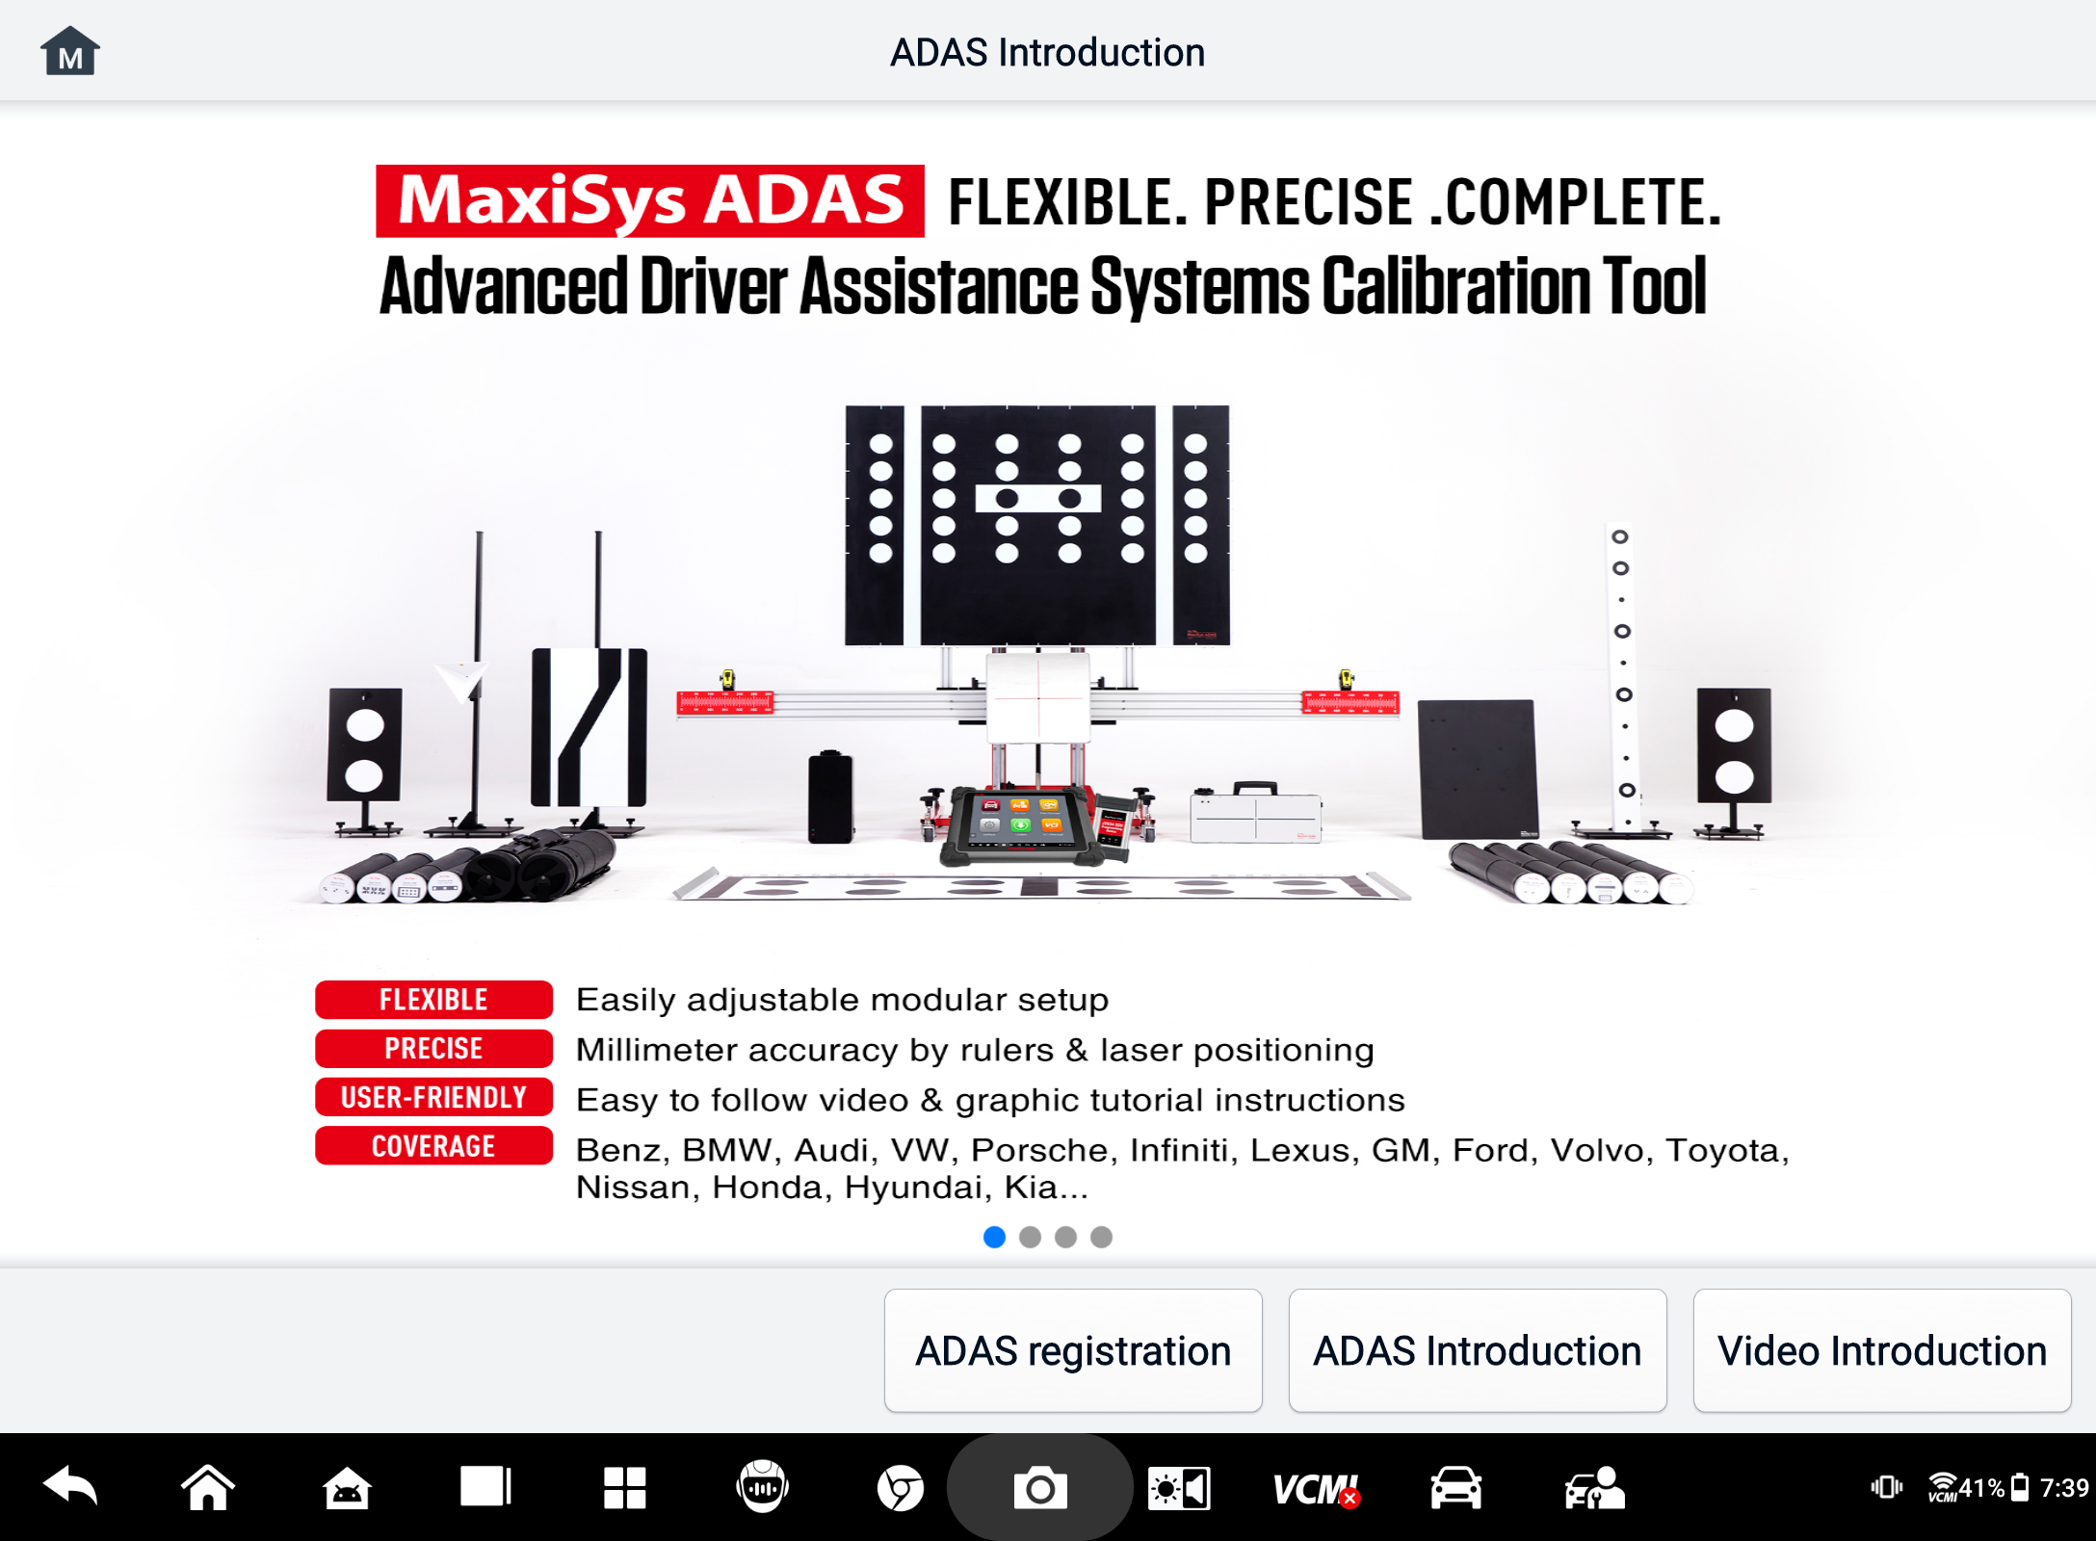
Figure 8-1 ADAS Introduction Screen

Data Manager
The Data Manager application allows you to store, print, and review saved files, manage workshop information, and customer information records, and store test-vehicle histories. In addition, you can back up data to Autel Cloud and view it on the Data Manager application.
Selecting the Data Manager application opens the file system menu. There are eleven main functions available.
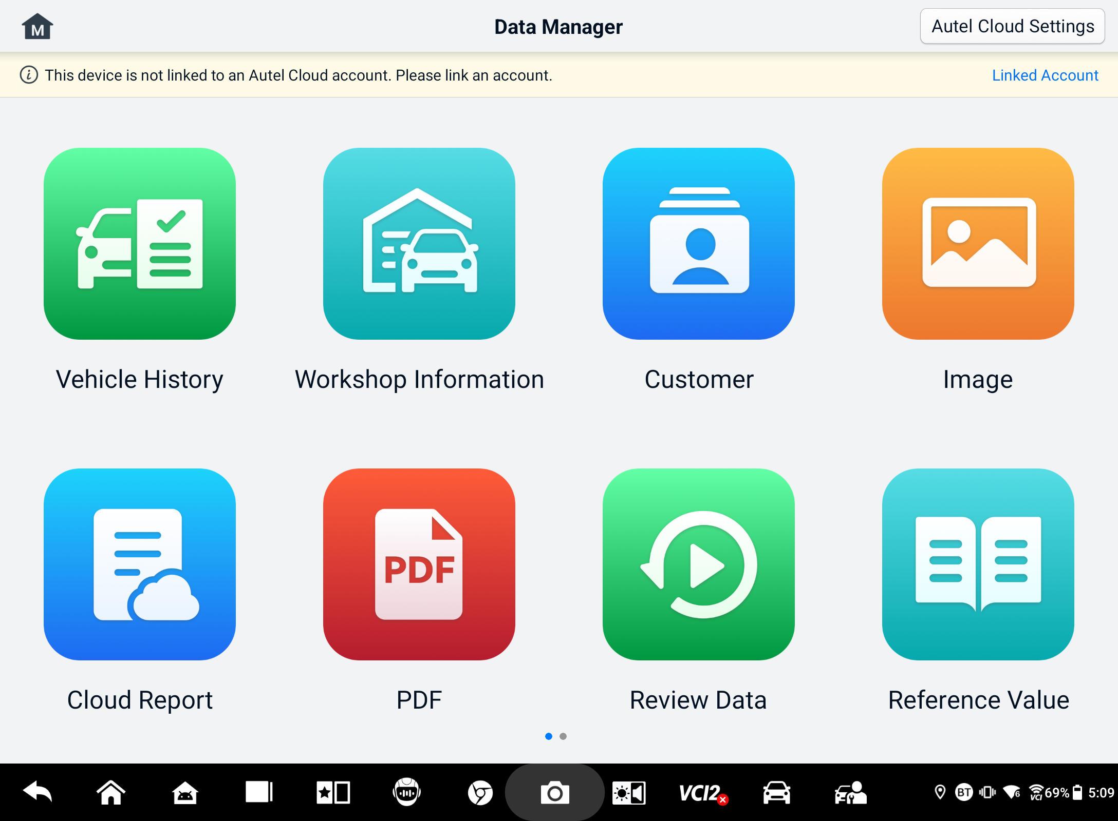
Figure 9-1 Data Manager Main Screen
In the Data Manager application, data can be backed up to Autel Cloud automatically or manually. Before backing up data, you first need to link the device to Autel Cloud.
- To link the device to Autel Cloud
- On the Data Manager main screen, tap Link Account to access Autel Cloud.
- Tap Add your device, enter the device serial number and device registration password, and tap Save. The linked device will appear on the Device List screen. (To find the device serial number and device registration password, go to Settings > About.)
- To switch a linked account
On the Data Manager main screen, tap Switch Linked Account and log in with your Autel account.

- To back up data to Autel Cloud automatically
- On the Data Manager main screen, tap Autel Cloud Settings and toggle the Automatic Upload buttons to On.
- Data including reports, images, PDF files, review data, and reference values are backed up to Autel Cloud automatically.
The table below briefly describes each of the function buttons in the Data Manager application.
Table 9-1 Buttons in Data Manager
Button | Name | Description
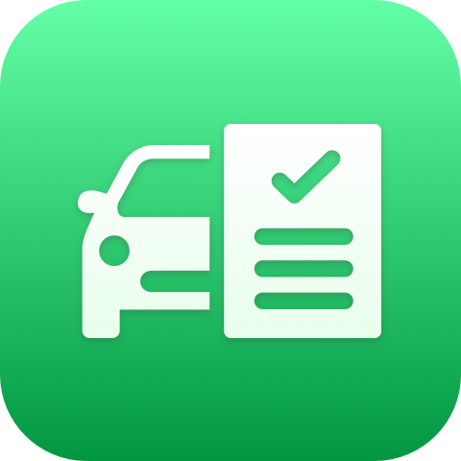 | Vehicle History | Tap to review the diagnostics history record.
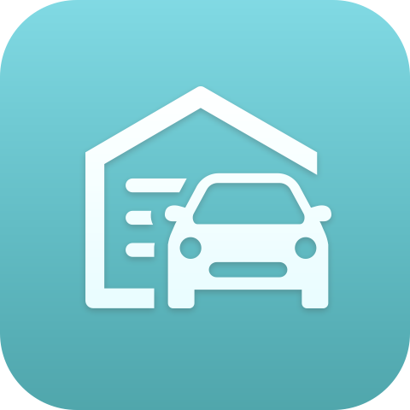 | Workshop Information | Tap to edit the information of workshops.
 | Customer | Tap to create new customer information.
 | Image | Tap to review the screenshots.
 | Cloud Report | Tap to review the saved reports and share cloud reports.
 | PDF | Tap to review the reports stored as PDF files.
 | Review Data | Tap to review the recorded data.
 | Reference Value | Tap to view, edit, and share the data related to the live data function reference values. Both local reference values and cloud backups are included.
 | Data Logging | Tap to review the communication data and ECU information of the vehicle. The saved data can be reported and sent to the technical center via the Internet.
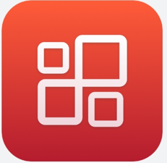 | Uninstall Apps | Tap to uninstall applications.
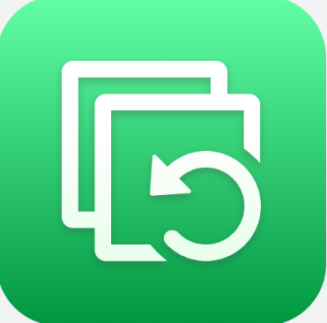 | Backup & Restore | Tap to enter the Backup & Restore screen to back up data to Autel Cloud or restore data to the device.

Vehicle History
This function stores records of test vehicle history, including vehicle information and the retrieved DTCs from previous diagnostic sessions. Test information is summarized and displayed in an easy-to-read table listing. The Vehicle History also provides direct access to the previously tested vehicle and allows you to directly restart a diagnostic session without needing to perform auto or manual vehicle selection.
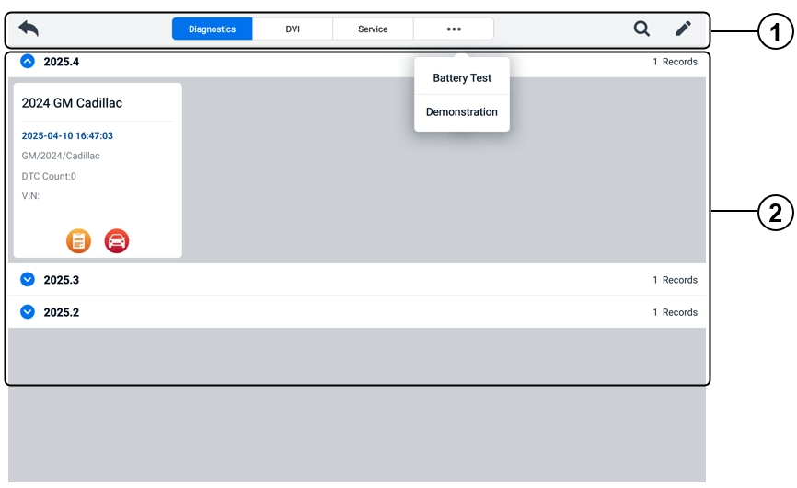
Figure 9-2 Vehicle History Screen
- Top Toolbar Buttons — navigation and application controls.
- Main Section — displays all the vehicle history records.
- To activate a test session for the recorded vehicle
- Tap the Data Manager application button on the MaxiSys Job Menu.
- Select Vehicle History to open the screen. Tap the relevant application tab to select the test record. For example, tap Diagnostics to select diagnostics test records.
- Tap the Diagnostics or DVI icon at the bottom of the thumbnail of a vehicle record item.
- The Diagnostics screen of the vehicle displays and a new diagnostics session is activated after the Diagnostics icon is tapped. See Diagnostics to continue the diagnostics. The DVI application opens after the DVI icon is tapped. See Digital Vehicle Inspection to continue the inspections.
- Or select a vehicle thumbnail to open a record. A Historical Test record sheet displays. Review the recorded information of the test vehicle. Tap the Diagnostics button or the DVI button on the upper-right corner.
NOTE
The MaxiSys tablet must establish a stable connection to the VCI2 to restart test sessions on previously tested vehicles.
Historical Test Record
The Historical Test Record is a detailed data form of the vehicle, which includes general vehicle information, service record, customer information, and the diagnostic trouble codes retrieved from the previous test sessions. Technician Notes will also appear if present.
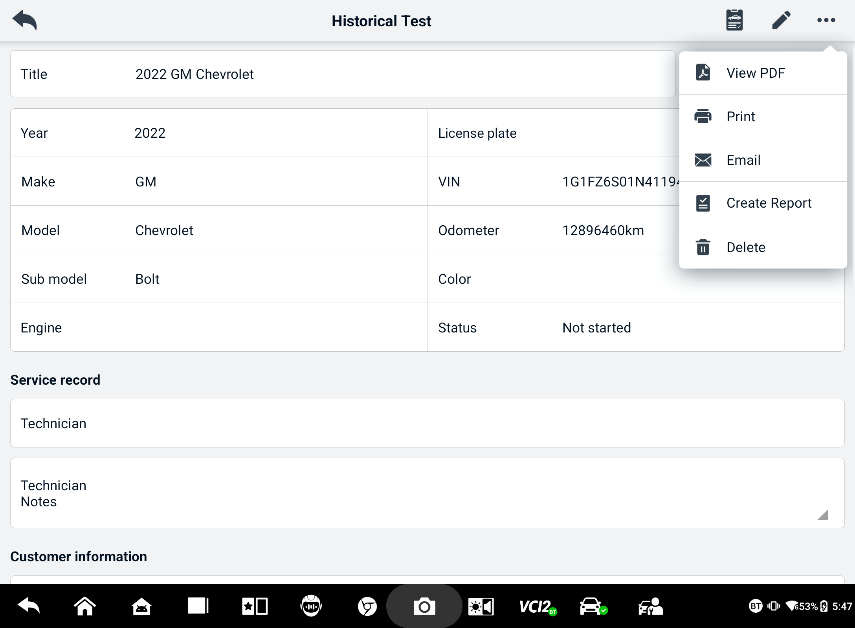
Figure 9-3 Historical Test Record Sheet
  - To edit the Historical Test record
- Tap the Data Manager application button on the MaxiSys Job Menu.
- Select Vehicle History.
- Select the specific vehicle history record thumbnail from the main section. The Historical Test record will display.
- Tap Edit (a pen icon) to start editing.
- Tap each item to enter information.
NOTE
The vehicle VIN, license number, and customer account information are correlated by default. Vehicle records will automatically be correlated using this vehicle and customer identification.
- Tap Add to Customer to correlate the Historical Test record sheet to an existing customer account, or add a new associated account to be correlated with the test vehicle record. See Customer for more information.
- Tap Done to save the updated record, or tap Cancel to exit without saving.

Workshop Information
The Workshop Information form allows you to edit, input, and save the detailed workshop information, such as shop name, address, phone number, and other remarks, which, when printing vehicle diagnostic reports and other associated test file, will display as the header of the printed documents.
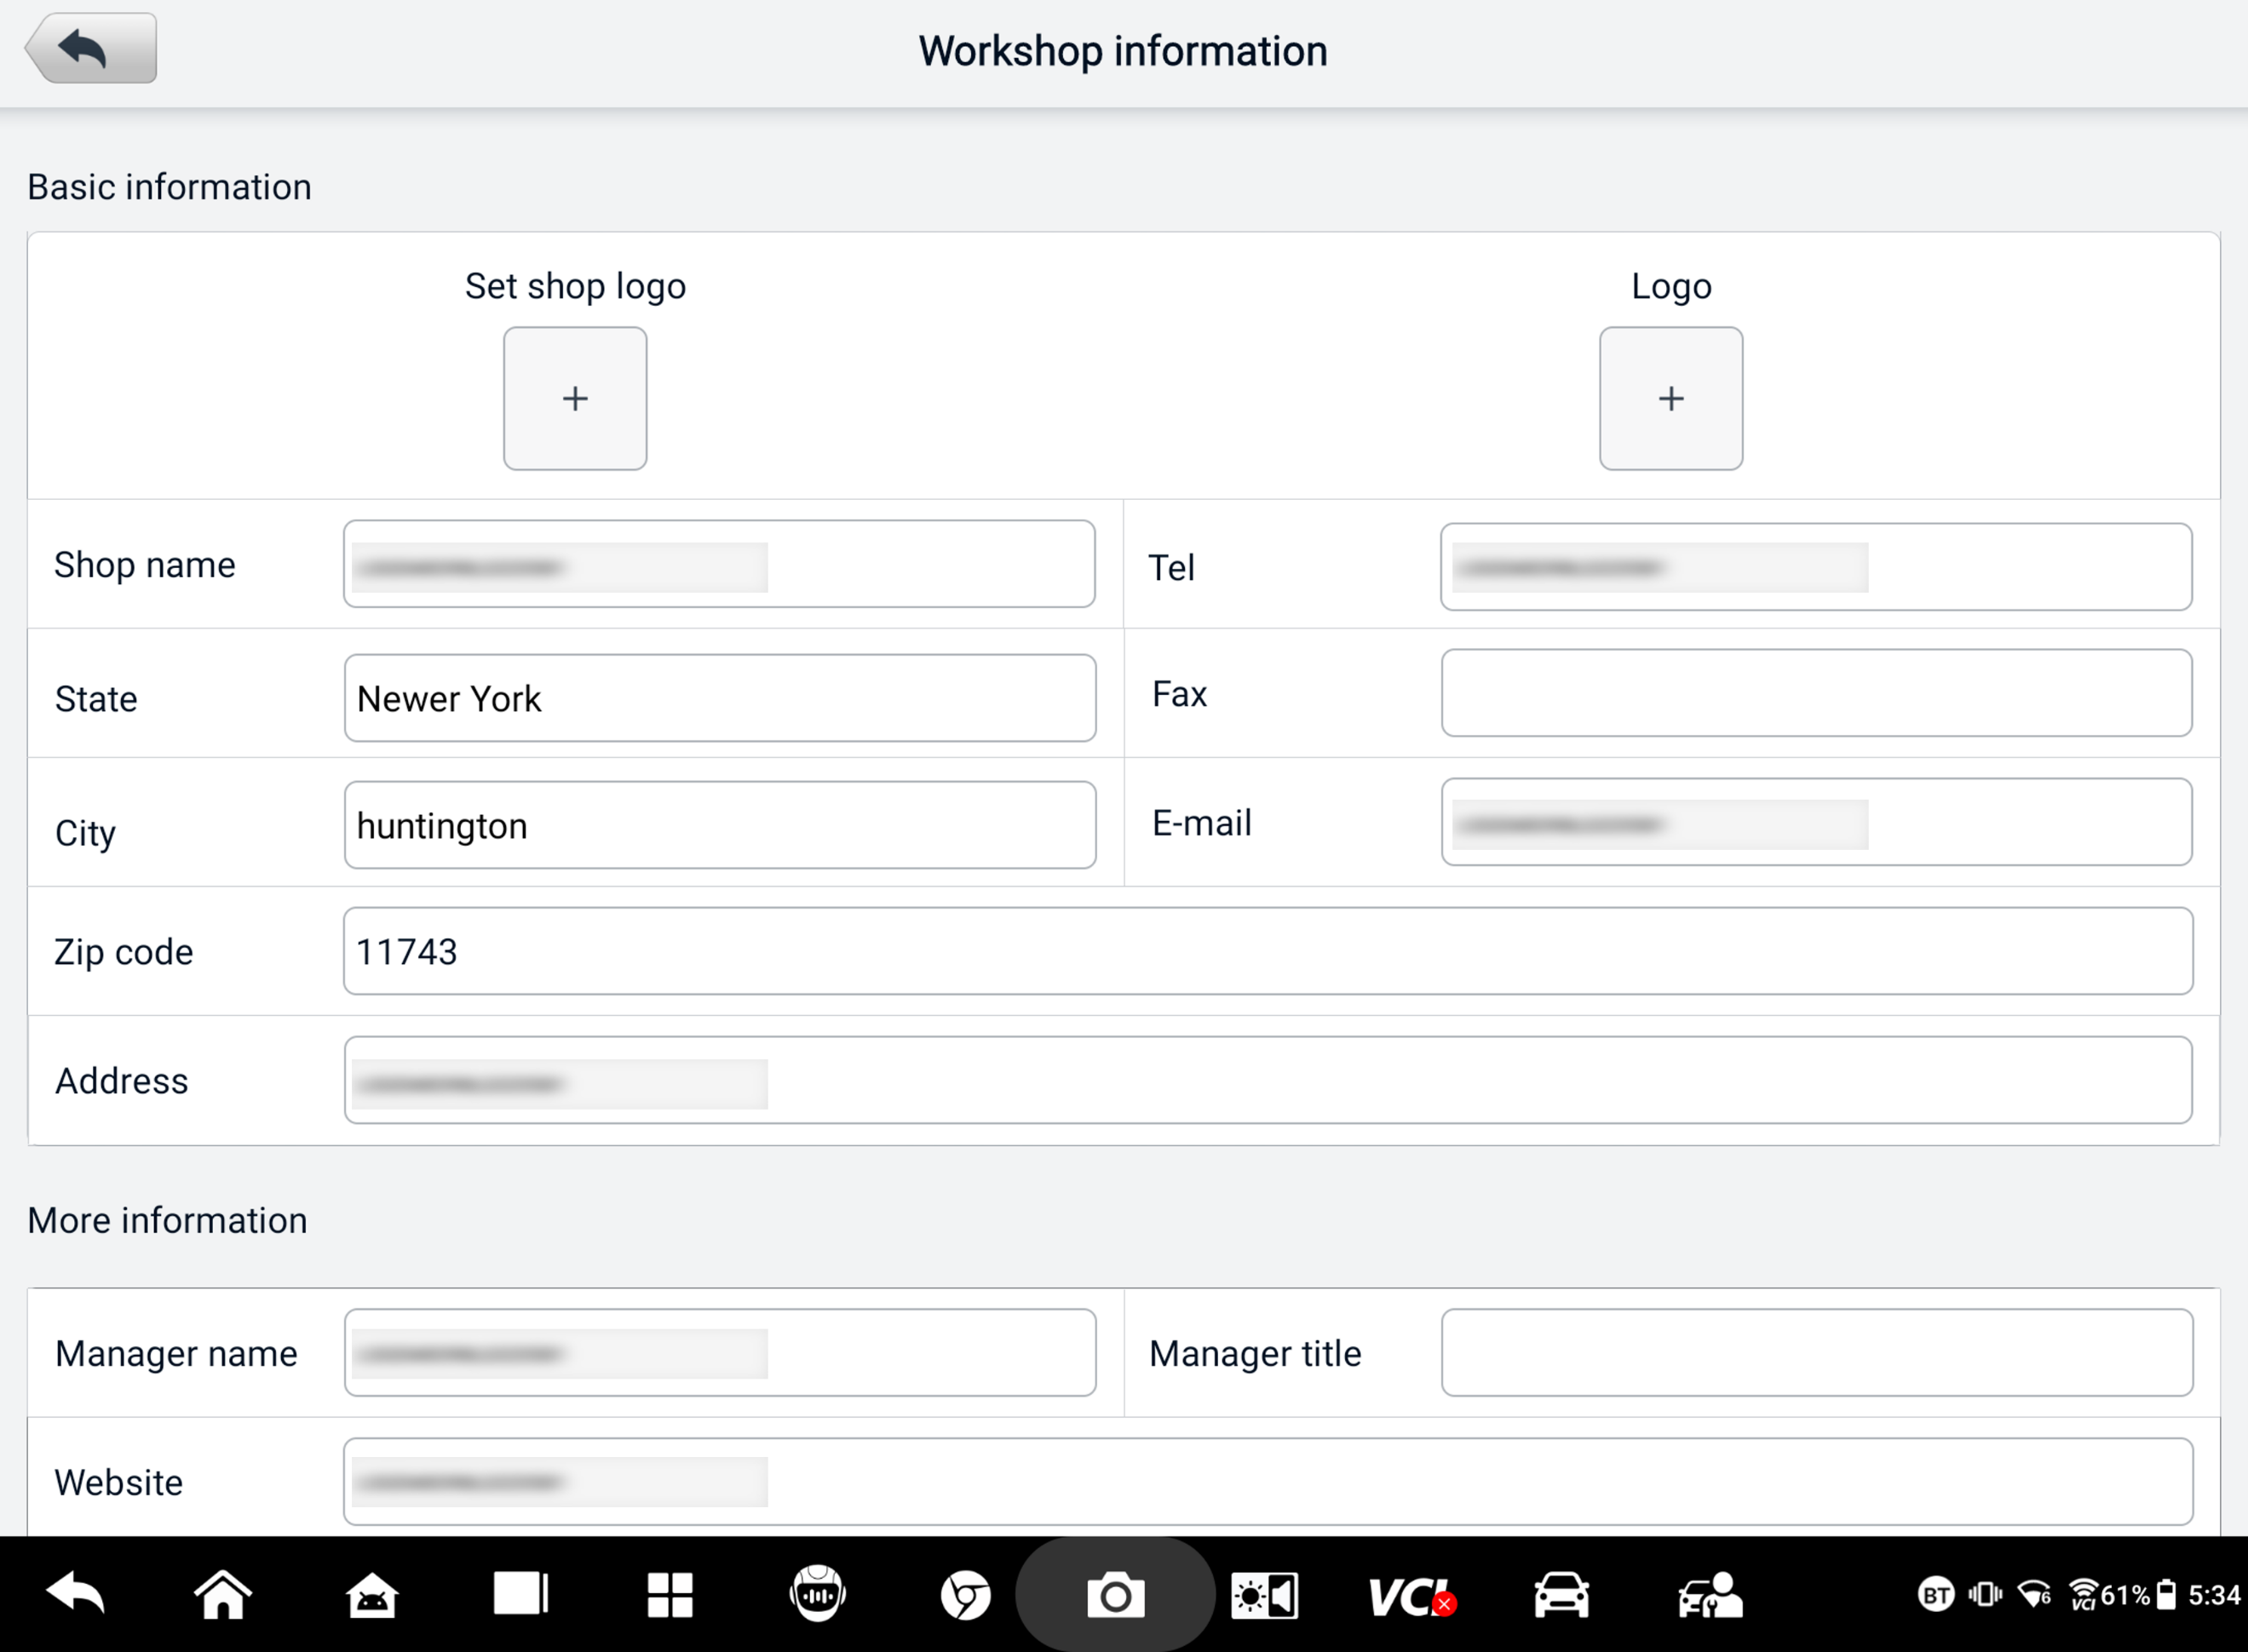
Figure 9-4 Workshop Information Sheet
  - To edit the Workshop Information sheet
- Tap the Data Manager application button on the MaxiSys Job Menu.
- Select Workshop Information.
- Tap on each field to input the appropriate information.
- The information will be saved automatically after input.

Customer
The Customer function allows you to create and edit customer accounts. It helps you to save and organize all customer information accounts that are correlated with the associated test vehicle history records.
  - To create a customer account
- Tap the Data Manager application button on the MaxiSys Job Menu.
- Select Customer.
- Tap the Add a Customer button. An empty information form displays; tap each field to input the appropriate information.
NOTE
Fields marked with an asterisk (*) are mandatory.
- Some customers may have more than one vehicle for service; you can always add new vehicle information to the account. Tap Add New Vehicle Information, and then fill in the vehicle information. Tap the button to cancel.
- Tap Complete to save the account, or tap Cancel to exit without saving.
  - To edit a customer account
- Tap the Data Manager application button on the MaxiSys Job Menu.
- Select Customer.
- Select a customer account by tapping the corresponding name card. A Customer Information record displays.
- Tap the Edit icon on the top toolbar to start editing.
- Tap on the input field to edit or amend information, and enter the updated information.
- Tap Complete to save the updated information, or tap Cancel to exit without saving.
  - To delete a customer account
- Tap the Data Manager application button on the MaxiSys Job Menu.
- Select Customer.
- Tap the Delete icon on the right of a customer account. A message displays.
- Tap OK to confirm the command, and the account is deleted, or tap Cancel to cancel the command.

Image
The Image section is a PNG database containing all captured screenshots.
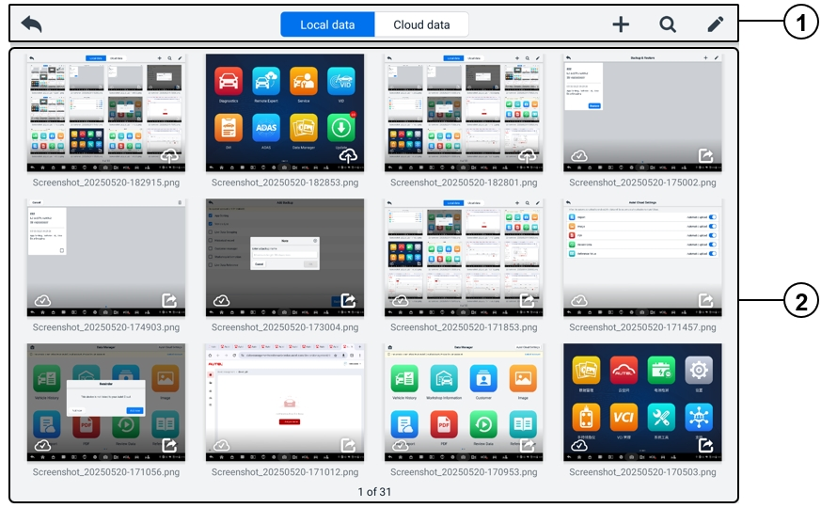
Figure 9-5 Image Database Screen
- Toolbar Buttons — used to edit, print, or delete the image files. See the following table for detailed information.
- Main Section — displays the stored images.
Table 9-2 Toolbar Buttons in PNG Database
Button | Name | Description
 | Back | Returns to the previous screen.
 | Search | Tap to search the image by entering its stored time.
 | Edit | Tap to display the editing toolbar to select, delete, print, or email the image(s).
 | Cancel | Tap to close the editing toolbar or cancel file search.
 | Print | Tap to print the selected image.
 | Delete | Tap to delete the selected image.
 | Email | Tap to send the selected image to an email.
- To edit/delete image(s)
- Tap the Data Manager application button on the MaxiSys Job Menu.
- Select Image to access the PNG database.
- Tap the Edit icon on the top-right corner of the window. The editing screen will appear.
- Select the image(s) you want to edit by tapping the check box at the bottom-right corner of the image.
- Tap the Delete icon to delete the selected images or delete all images. Tap the Print icon to print the selected image(s). Tap the Email icon to send the selected image(s) to an email.
- To share images
- Tap the Data Manager application button on the MaxiSys Job Menu.

- Select Image to access the PNG database.
- Tap the icon to share the image via QR code.
- To upload images to Autel Cloud
- Tap the Data Manager application button on the MaxiSys Job Menu.
- Select Image to access the PNG database.
- Tap the icon to upload the image to Autel Cloud.

Cloud Report
This section displays the saved reports, which can be transferred to the Autel cloud platform once a stable network connection is established. These reports can then be viewed or shared with others. See Report Settings and Diagnostics Report Saving, Viewing, and Sharing for further details.

PDF Files
The PDF files designated for local viewing are displayed in this section. Enter the PDF database and select a file to access the saved information.
This section uses the standard Adobe Reader application for file viewing and editing. Please refer to the associated Adobe Reader manual for more detailed instructions.

Review Data
The Review Data section allows you to play back or share the recorded data frames of live data streams.
On the Review Data main screen, select a record file to play back.
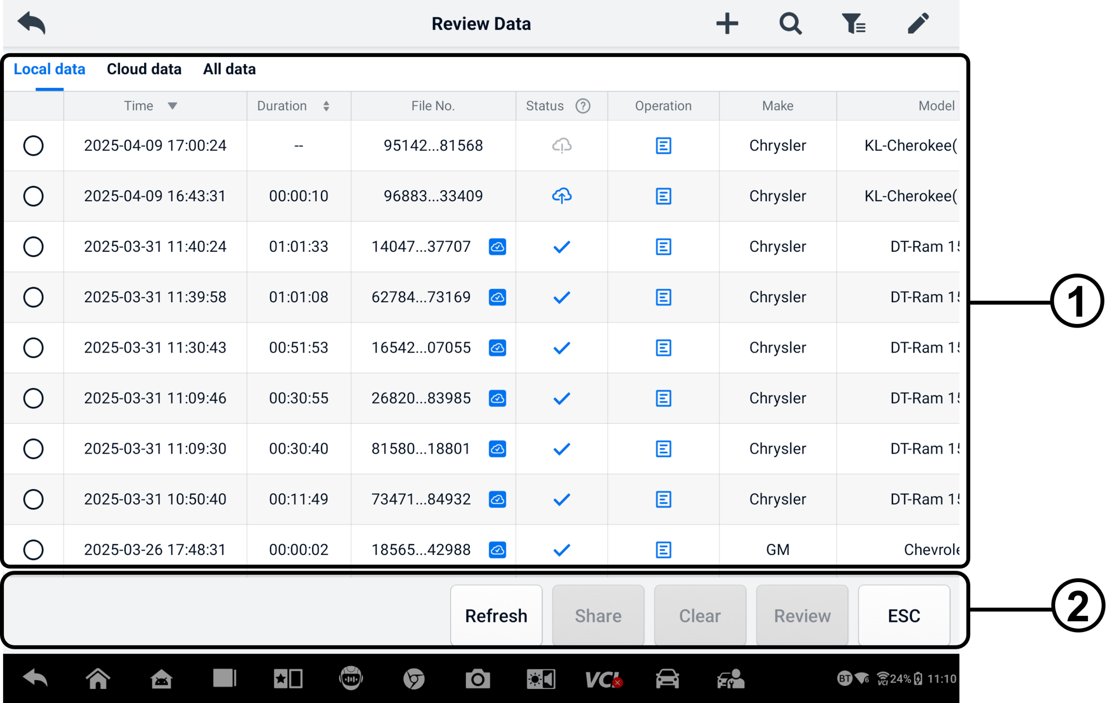
Figure 9-6 Data Playback Screen
- Main Section — displays the recorded data frames.
- Navigation Toolbar — allows you to manipulate data playback.
Use the Navigation Toolbar buttons to play back the recorded data frame-by-frame.

Reference Value
The Reference Value section allows you to view, search, edit, and share the data related to the live data function reference values. Both local reference values and cloud backups are included.
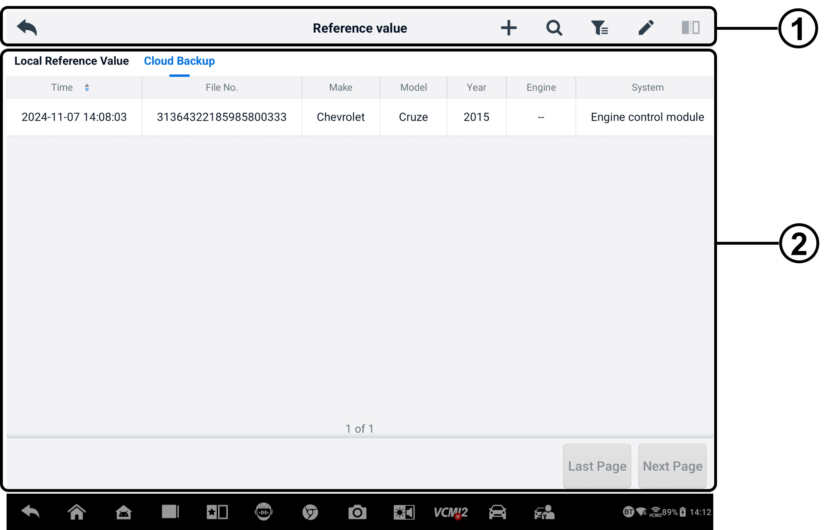
Figure 9-7 Reference Value Screen
- Toolbar Buttons — see the following table for detailed information.
- Main Section — displays the information including the time, file number, vehicle make, year, engine, and system.
Table 9-3 Toolbar Buttons in Reference Value Screen
Button | Name | Description
 | Back | Returns to the previous screen.
 | Add | Adds a reference value file when scanning the corresponding QR code after tapping the Share button in the Reference Value list or just manually entering the file number.
 | Search | Searches the reference value file once the file number or MMY (Make, Model, Year) is entered.
 | Filter | Select the information such as the Make, Model, Year, Engine, and System to locate the specified reference value files.
 | Edit | Deletes the reference value files.
 | Comparison | Select two reference value files and make a comparison of the sampled maximum, minimum, and average values. Only the local reference value files are supported.

Data Logging
The Data Logging section allows you to launch the Support platform directly to view all records of all feedback or no feedback data loggings on the diagnostic system. For more details, see Data Logging.

Uninstall Apps
This section allows you to manage the software applications installed on the MaxiSys system. Selecting this section opens a managing screen, on which you can check all available vehicle diagnostic applications.
Select the vehicle software you want to delete by tapping on the vehicle manufacturer icon. The selected item will display a blue mark at the upper-right corner. Tap the Delete icon on the top toolbar to delete the software from the system database.

Backup & Restore
This section allows you to back up the data to Autel Cloud and restore the data to the device.
- To back up data to Autel Cloud
- Tap the Data Manager application button on the MaxiSys Job Menu.
- Select Backup & Restore to enter the Backup & Restore screen.
- Tap Add Backup to enter the Add Backup screen.
- Check the box to select the desired data and tap Backup. The system will display a dialogue box.
- Enter a name in the input box and tap OK to back up the data to Autel Cloud. The backup data record will appear on the Backup & Restore screen.

If you need to back up more data, tap the icon to enter the Add Backup screen and perform step 4 through 5 again to back up the data to Autel Cloud.
- To restore data to the device
- Tap the Data Manager application button on the MaxiSys Job Menu.
- Select Backup & Restore to enter the Backup & Restore screen.
- Tap Restore > OK to restore the data to the device.
If necessary, tap Pause to pause the restoration process.

- To delete stored backup data
- Tap the Data Manager application button on the MaxiSys Job Menu.

- Select Backup & Restore to enter the Backup & Restore screen.

- Tap the icon, check the box to select the backup data, and tap the icon. Tap OK to delete the selected data.

Autel Cloud
Autel Cloud is a device and data management platform with which you can easily upload, manage, and share reports (supporting diagnostics, wheel alignment, battery testing, etc.), live data, images, and PDF files.
You can access Autel Cloud via the MaxiSys tablet or by visiting the Autel website.
- Via the MaxiSys tablet
- Tap the Autel Cloud application button on the MaxiSys Job Menu to enter the Autel Cloud Introduction screen.
- Tap Enter Autel Cloud to enter the Autel Cloud Login screen.
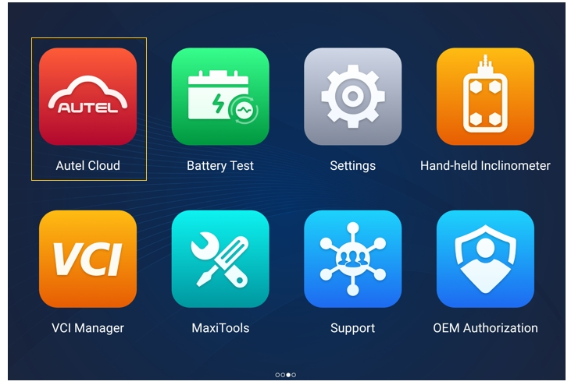
Figure 10-1 Autel Cloud Application
- Via the Autel website
Visit the following website according to your region.
North America: https://cloud-us.autel.com
Europe: https://cloud-eu.autel.com
NOTE
The functionality of Autel Cloud is the same whether accessing it via a MaxiSys tablet or the Autel website. The illustrations in this manual are based on accessing Autel Cloud via the MaxiSys tablet.

Registration and Login
To use Autel Cloud, you need to register an Autel account and log in to your account.
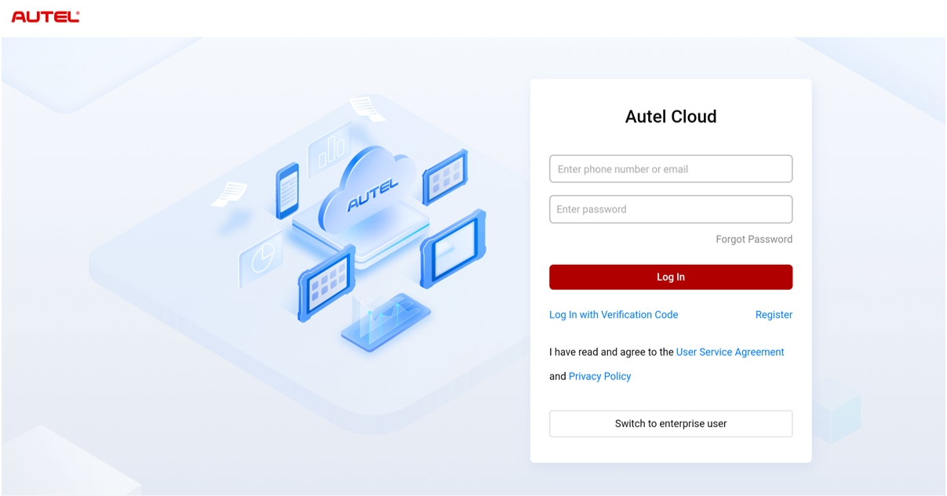
Figure 10-2 Autel Cloud Login Screen
- To register an account
If you don't have an Autel account yet, tap Register to create an account.
- To log in to Autel Cloud
You can log in to Autel Cloud with password or with a verification code. Or you can log in as an enterprise user if you have an enterprise account.
- To log in with a password: tap Log In with Password, enter your phone number or E-mail address and password, and tap Log In.
- To log in with a verification code: tap Log In with Verification Code, enter your phone number, and tap Request to get a verification code. Enter the received verification code and tap Log In.
- To log in as an enterprise user: tap Switch to enterprise user to enter the Devices and Reports Management System Login screen. Enter your phone number or E-mail address and password, and tap Log In.

Device Management
Device Management allows you to link your devices, export device list, assign repair shops, and check the location distribution of devices through the map.

Device List
After login, the system automatically enters the Device List screen.
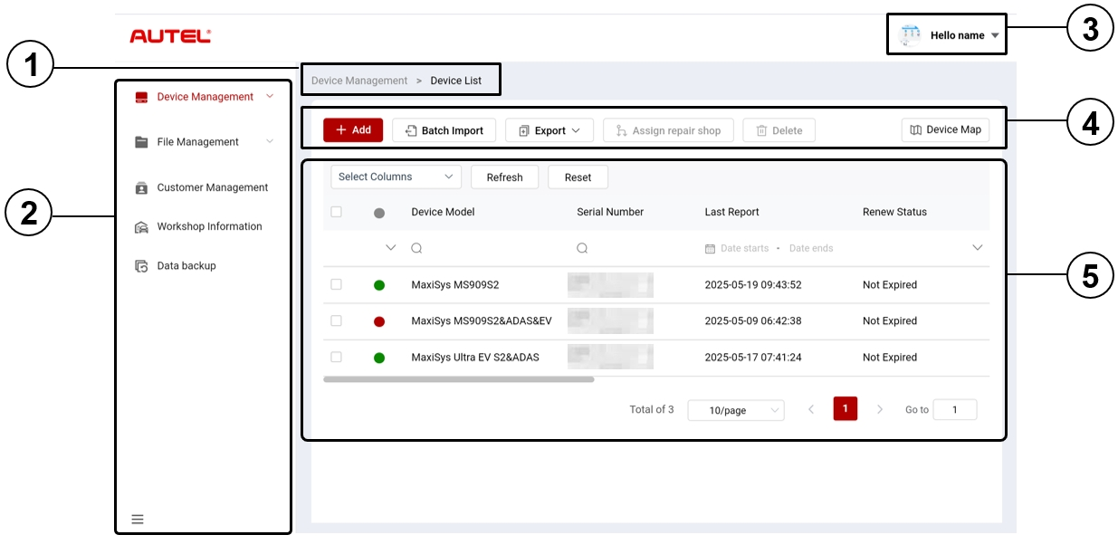
Figure 10-3 Device List Screen
- Current Directory Path
The current directory path shows all directory names to access the current page.
- Navigation Bar
The navigation bar on the left side of the screen displays the main menu of the Autel Cloud functions. The main menu includes Device Management, File Management, Customer Management, Workshop Information, and Data Backup. Tap the  icon in the bottom-left corner of the navigation bar to hide the main menu, and select it again to display.
- User Center
In user center, you can edit your personal profile, submit complaints and feedback, and manage your accounts.
- Function Buttons
The function buttons include Add, Batch Import, Export, Assign repair shop, Delete, and Device Map. The functions of these buttons are described as follows.
Name | Description
Add | Adds a new device.
Batch Import | Imports device information in batches.
Export | Exports device information.
Assign repair shop | Assigns the selected device to an affiliated repair shop.
Delete | Deletes the selected device information.
Device Map | Opens the device map.

- Main Section
The main section includes a toolbar, an information list, and page-turning controls.
Toolbar:
- Select Column — tap to select the desired column information.
- Refresh — tap to refresh the information list.
- Reset — tap to reset the search criteria.
Information list:
- Check box: tap to select an item.
- Search icons: tap the icon to pop up the search criteria of the relevant column; tap the  icon to enter the search criteria; tap the  icon to select a date.
Page-turning controls：
- Scrollbar: scroll left or right to view the hidden columns or return to earlier columns.
- Items Per Page dropdown list: tap to select the number of items displayed per page.
- Previous/Next button: tap to go to the previous or next page.
- Page navigation box: tap to enter the page number to jump to a specific page.
- To link the device(s)
- To link device individually
- Tap Device Management > Device List to enter the Device List screen.
- Tap Add to enter the New Device screen.
- Enter the device serial number and device registration password in the input box and select an affiliated repair shop. (To find the device serial number and device registration password, go to Settings > About.)
NOTE
Fields marked with an asterisk (*) are mandatory.

- Tap Save to save the information.
If necessary, tap Cancel or the “X” icon to exit the screen.
- After saving, the linked device will appear on the Device List screen.
- To link multiple devices simultaneously
- Tap Device Management > Device List to enter the Device List screen.
- Tap Batch Import to enter the Batch Import screen.
- Tap Download Template to download the batch import device template.
- After the template is filled out, tap Batch Import to enter the Batch Import screen. Select a repair shop, click or drag the file to the upload area, and tap Confirm to import the device information in batches.
- After importing, the linked devices will appear on the Device List screen.
- To export device list
- Tap Device Management > Device List to enter the Device List screen.
- Select the desired column information from the Select Column and check the box to select the desired device information. Tap Export and select an export format to export the device list.
- To assign a repair shop
- Tap Device Management > Device List to enter the Device List screen.
- Check the box to select the desired device information and tap Assign Repair Shop to enter the Assign Repair Shop screen.
- Select an affiliated repair shop from the dropdown list and tap Confirm to assign the selected device to the desired repair shop.
- To view device details
You can view your device details, including device model, renew status, serial number, etc., and check the reports and add tags on the Device Detail screen.
To view your device details, tap a piece of device information to enter the Device Detail screen.
- To search a device
- Tap Device Management > Device List to enter the Device List screen.
- Enter or select the search criteria. Tap the icon to pop up the search criteria of the relevant column; tap the icon to enter the search criteria; tap the icon to select a date.
If necessary, tap Reset to reset the search criteria.
- The screen displays the results according to the search criteria.

Device Map
To check the location distribution of the devices, perform the following steps.
- Tap Device Map to enter the Device Map screen and check the location distribution of the devices.
- Tap Device List to exit the screen.
NOTE
This functionality is currently unavailable in Europe.

File Management
File Management allows you to manage the reports, live data, images, and PDF files.

Report Management
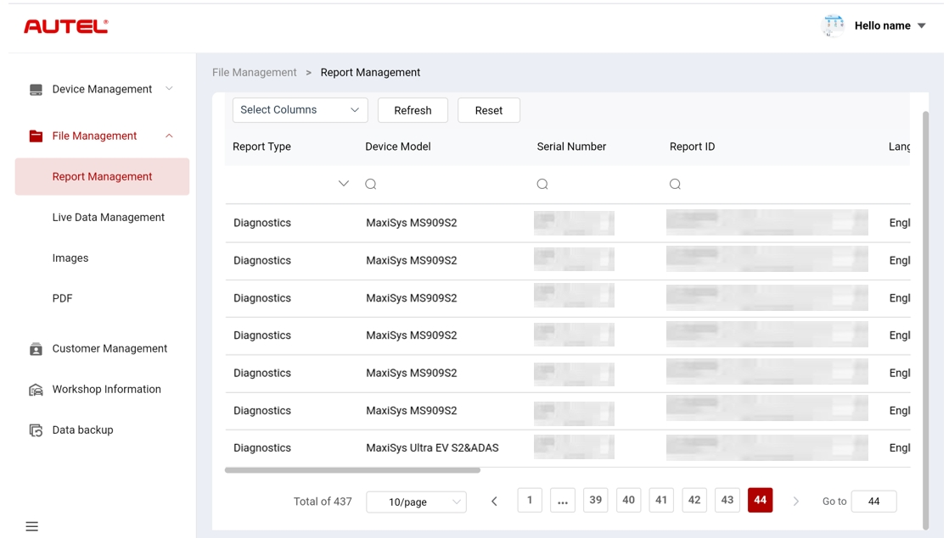
Figure 10-4 Report Management Screen
- To search a report
- Tap File Management > Report Management to enter the Report Management screen.
- Enter or select the search criteria. Tap the icon to pop up the search criteria of the relevant column; tap the icon to enter the search criteria; tap the icon to select a date.
If necessary, tap Reset to reset the search criteria.
- The screen displays the results according to the search criteria.
- To download and share a report
- Tap a line of report data to enter the report.
- Scan the QR code or tap the  icon on the right to download the report.
- Tap the  icon to enter the Share screen. Select Email or Text Message and tap Send to share the report with others.

Live Data Management
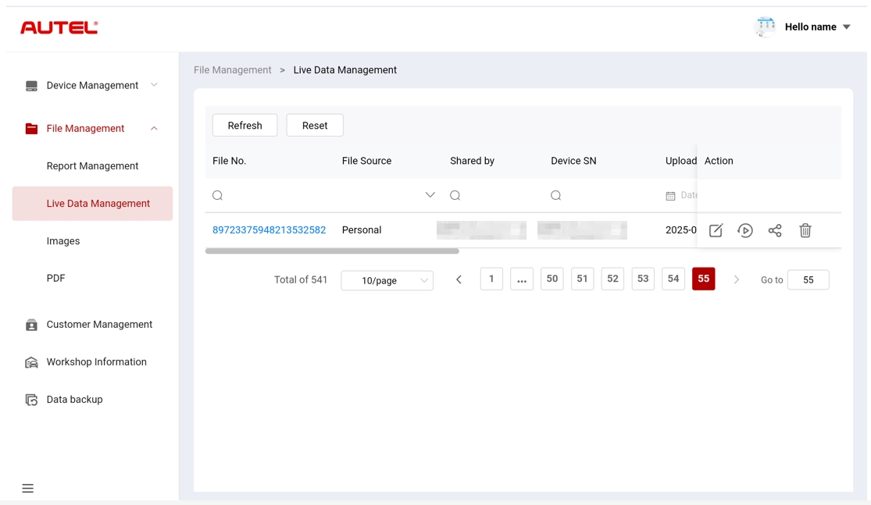
Figure 10-5 Live Data Management Screen
- To search live data
- Tap File Management > Live Data Management to enter the Live Data Management screen.
- Enter or select the search criteria. Tap the icon to pop up the search criteria of the relevant column; tap the icon to enter the search criteria; tap the icon to select a date.
If necessary, tap Reset to reset the search criteria.
- The screen displays the results according to the search criteria.
- To add notes to the live data
- Tap File Management > Live Data Management to enter the Live Data Management screen.
- Tap the  icon to pop up a textbox, enter your notes, and tap OK to save it.

- To play the live data
- Tap File Management > Live Data Management to enter the Live Data Management screen.
- Tap the  icon or tap the file number to enter the Live Data Detail screen. The live data function here is similar to that of the diagnostics section. See Live Data for operation instructions.
- To share live data
- Tap File Management > Live Data Management to enter the Live Data Management screen.
- Tap the  icon to enter the Share screen.
- Select a sharing method to distribute the live data information to others.
- To delete live data
- Tap File Management > Live Data Management to enter the Live Data Management screen.
- Tap the  icon and tap Confirm to delete the live data.

Images
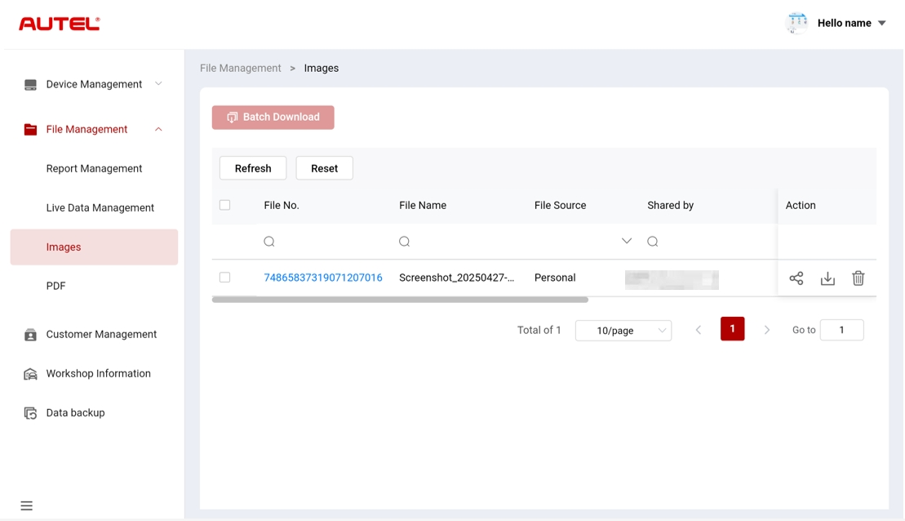
Figure 10-6 Image Management Screen
- To search an image
- Tap File Management > Images to enter the Images screen.
- Enter or select the search criteria. Tap the icon to pop up the search criteria of the relevant column; tap the icon to enter the search criteria; tap the icon to select a date.
If necessary, tap Reset to reset the search criteria.
- The screen displays the results according to the search criteria.
- To view an image
- Tap the file number to view the image.
- Zoom in, zoom out, and flip the image as required.
- To share an image
- Tap File Management > Images to enter the Images screen.
- Tap the icon to enter the Share screen.
- Select a share way to share the image with others.
- To download images
- Tap File Management > Images to enter the Images screen.
- Check the box to select the desired images and tap Batch Download to download the selected images.
Or you can tap the  icon to download an image.
- To delete an image
- Tap File Management > Images to enter the Live Data Management screen.
- Tap the icon and tap Confirm to delete the image.

PDF
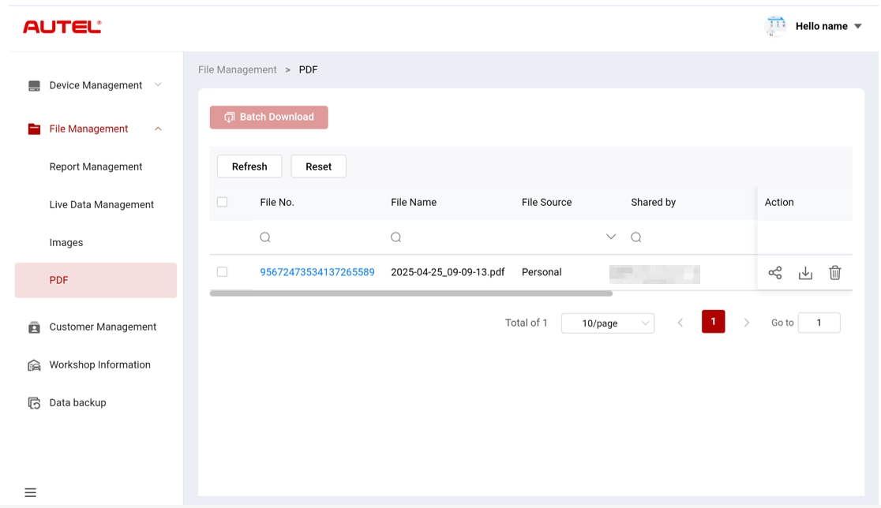
Figure 10-7 PDF File Management Screen
On the PDF screen, you can search, share, download, and delete PDF files. The functional operation of this screen is similar to that of the Images screen. See Images.

Customer Management
Customer Management allows you to manage customer information and share it between Autel Cloud and the linked devices.
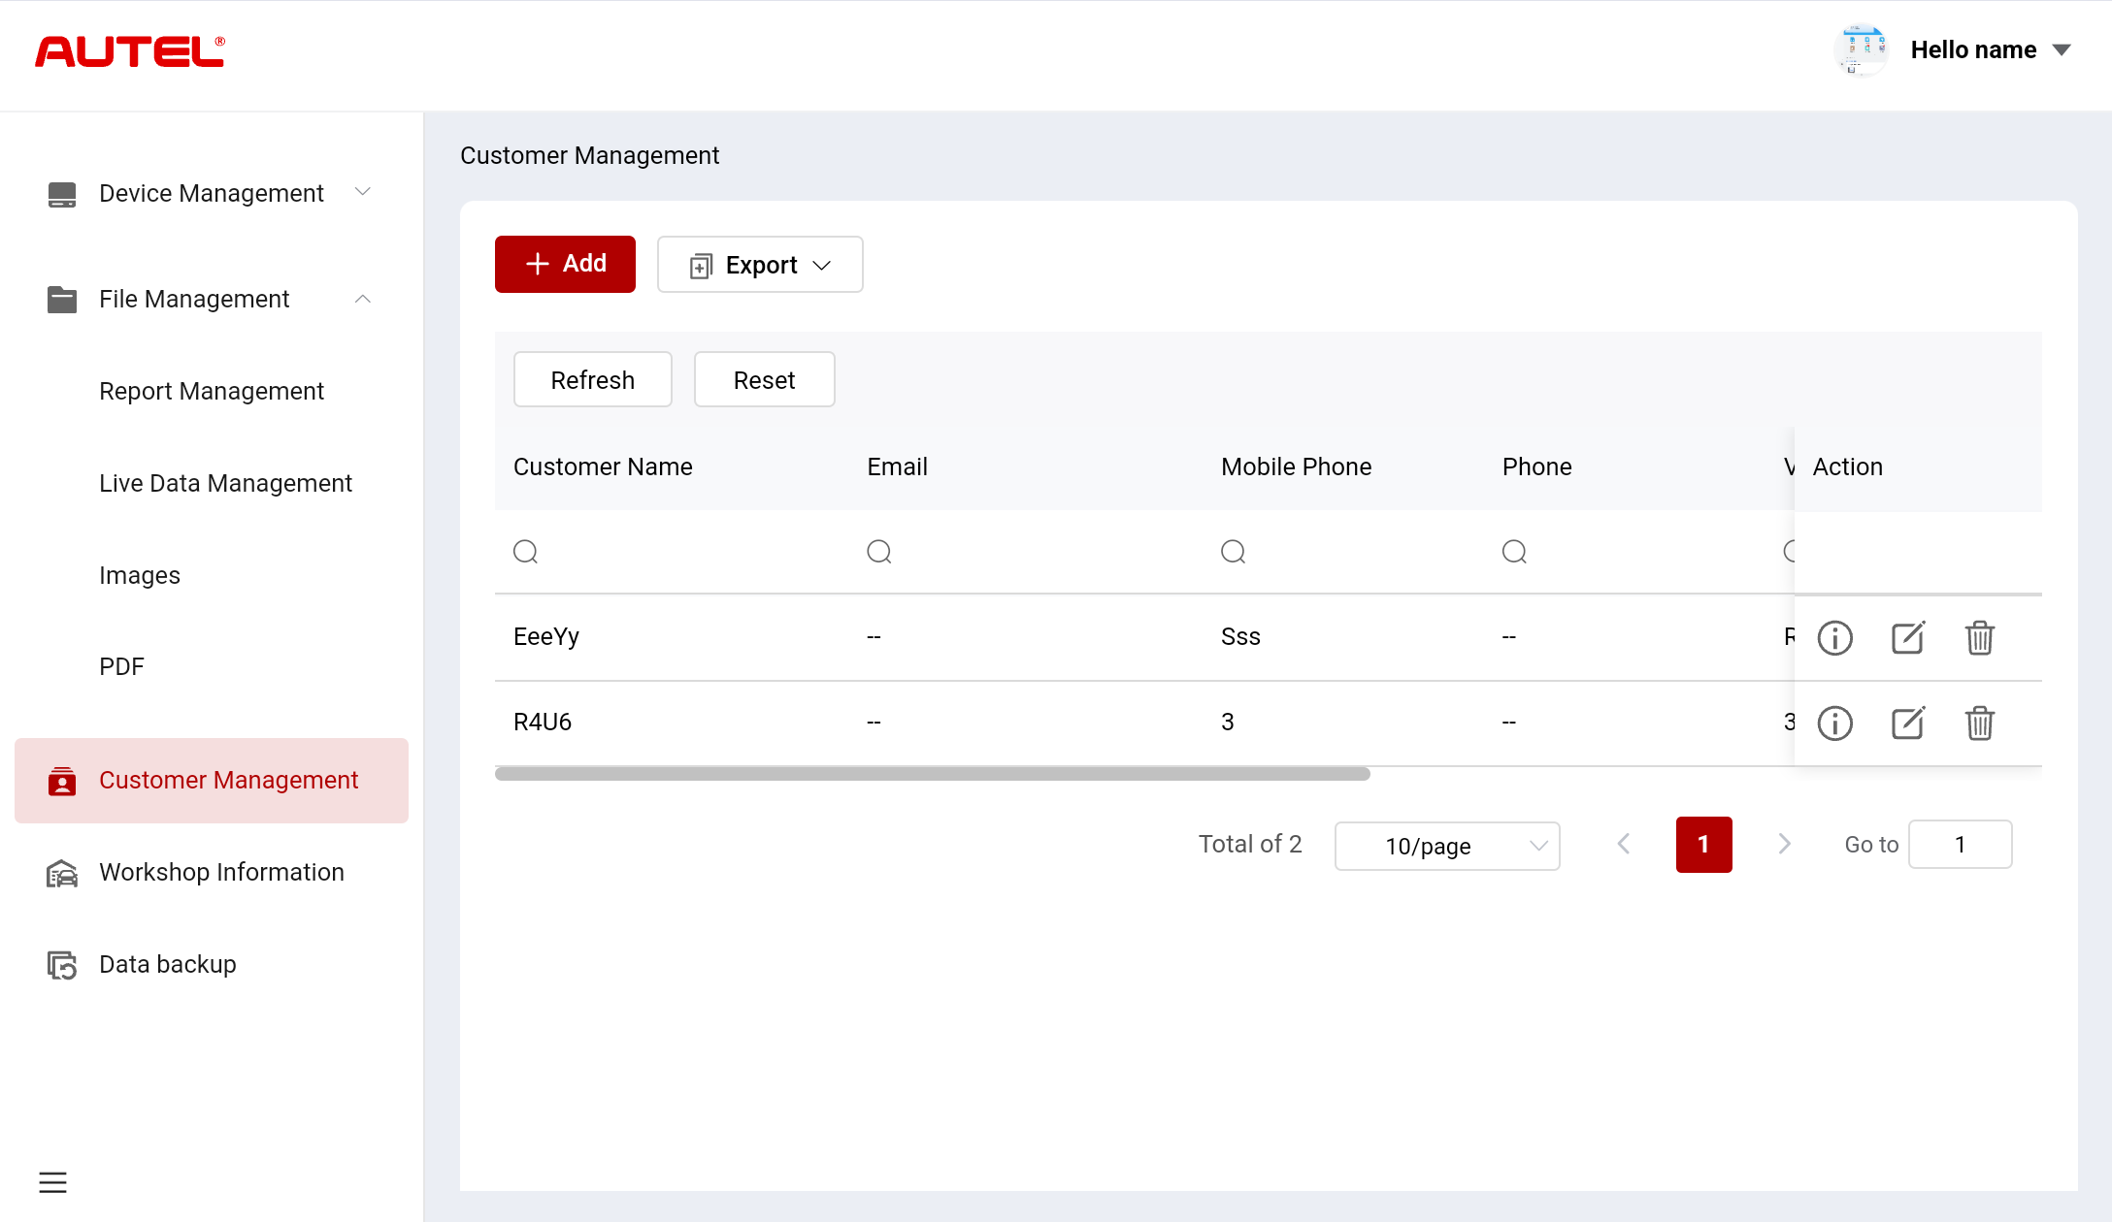
Figure 10-8 Customer Management Screen
- To add a customer
- Tap Customer Management to enter the Customer Management screen.
- Tap Add to enter Add Customer screen. Enter the user and vehicle information, and tap Confirm to save it.
NOTE
Fields marked with an asterisk (*) are mandatory.
If you need to add more vehicle information, tap Add.
- The added customer is displayed on the Customer Management screen.
- To export customer information
- Tap Customer Management to enter the Customer Management screen.
- Tap Export and select an export format to export the customer information.
- To search customer information
- Tap Customer Management to enter the Customer Management screen.
- Enter or select the search criteria. Tap the icon to pop up the search criteria of the relevant column; tap the icon to enter the search criteria; tap the icon to select a date.
If necessary, tap Reset to reset the search criteria.
- The screen displays the results according to the search criteria.
- To view and edit customer details
- Tap Customer Management to enter the Customer Management screen.
- Tap the  icon to view customer details, including user and vehicle information.
- Tap Edit to edit customer details. Or tap the icon on the Customer Management screen to edit customer details.
If you need to add more vehicle information, tap Add.
- Tap Save to save the information.
- To delete customer information
- Tap Customer Management to enter the Customer Management screen.
- Tap the icon and tap Confirm to delete the customer information.

Workshop Information
Workshop Information allows you to manage repair shop information and synchronize the repair shop information with all devices associated with that repair shop.
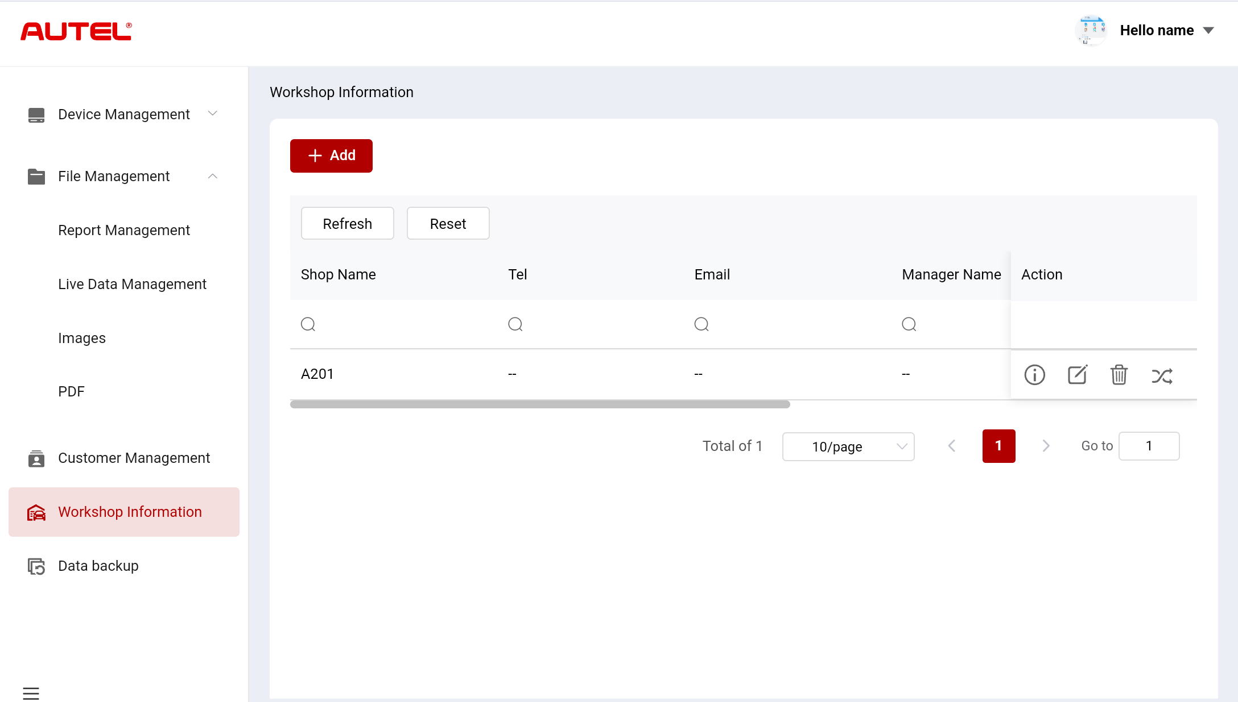
Figure 10-9 Workshop Information Screen
- To add a repair shop
- Tap Workshop Information to enter the Workshop Information screen.
- Tap Add to enter the Create Repair Shop screen.
- Enter the basic information and device information, and tap Save. The added repair shop will appear on the Workshop Information screen.
NOTE
Fields marked with an asterisk (*) are mandatory.
- To search a repair shop
- Tap Workshop Information to enter the Workshop Information screen.
- Enter or select the search criteria. Tap the icon to pop up the search criteria of the relevant column; tap the icon to enter the search criteria; tap the icon to select a date.
If necessary, tap Reset to reset the search criteria.
- The screen displays the results according to the search criteria.
- To view and edit the repair shop details
- Tap Workshop Information to enter the Workshop Information screen.
- Tap the icon to view the repair shop details including basic information and device information.
- Tap Edit to edit repair shop details. Or tap the icon on the Workshop Information screen.
If you need to add more device information, tap Add.
- Tap Save to save the information.
- To delete repair shop information
- Tap Workshop Information to enter the Workshop Information screen.
- Tap the icon and tap Confirm to delete the repair shop information.
- To synchronize repair shop information
- Tap Workshop Information to enter the Workshop Information screen.
- Tap the  icon and tap Confirm to synchronize the repair shop information with all devices associated with that repair shop.

Data Backup
Data Backup allows you to back up your MaxiSys tablet data to Autel Cloud. In the case that your device becomes lost or damaged, or needs to be replaced, you can easily download the stored data that has been backed up to Autel Cloud through the tablet to avoid data loss.
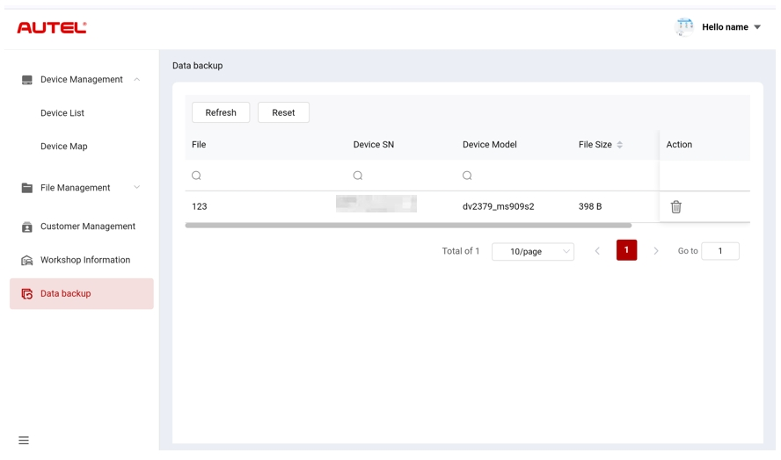
Figure 10-10 Data Backup Screen
- To search backup data
- Tap Data Backup to enter the Data Backup screen.
- Enter or select the search criteria. Tap the icon to pop up the search criteria of the relevant column; tap the icon to enter the search criteria; tap the icon to select a date.
If necessary, tap Reset to reset the search criteria.
- The screen displays the results according to the search criteria.
- To delete the backup data
- Tap Data Backup to enter the Data Backup screen.
- Tap the icon and tap Confirm to delete the backup data.

Battery Test
The Battery Test application allows the user to perform in-vehicle battery test and out-vehicle battery test functions when the BT506 battery tester is connected to the MaxiSys tablet and a battery. The BT506 battery tester enables technicians to view the health status of the vehicle’s battery and electrical system.
NOTE
The BT506 battery tester needs to be purchased separately.
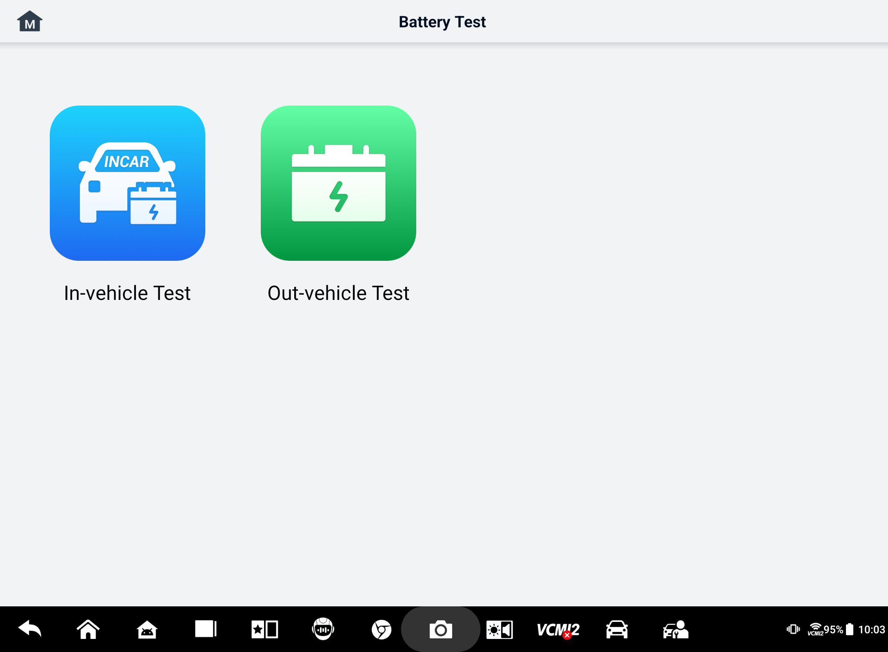
Figure 11-1 Battery Test Screen

MaxiBAS BT506 Battery Tester

Function Description
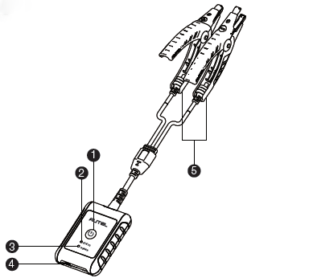
Figure 11-2 MaxiBAS BT506 Tester
      - Power Button
      - Status LED
      - Power LED
      - USB Port
      - Battery Clamp Cable
Table 11-1 LED Description
LED | Color | Description
Status LED | Flashing Green | The tester is communicating via USB cable.
Status LED | Flashing Blue | The tester is communicating via Bluetooth.
Status LED | Flashing Red | Battery clamps are connected to the wrong battery terminals.
Power LED | Solid Green | The tester is powered on and the battery is sufficiently charged.
Power LED | Flashing Green | The tester is charging. (Turns solid green when battery is fully charged.)
Power LED | Solid Red | The device is in boot mode.
Power LED | Flashing Red | The battery level is low. Please charge.

Power Sources
The MaxiBAS BT506 tester can receive power from the following sources:
- Internal Battery Pack
- AC/DC Power Supply
IMPORTANT
Do not charge the tester when the temperature is below 0 °C (32 °F) or above 45 °C (113 °F).

Internal Battery Pack
The MaxiBAS BT506 battery tester can be powered with the internal rechargeable battery.

AC/DC Power Supply — Using Power Adapter
The MaxiBAS BT506 battery tester can be powered from an electrical outlet using the AC/DC power adapter. The AC/DC power supply also charges the internal battery pack.

Technical Specifications
Table 11-2 Technical specifications
Item | Description
Connectivity | - USB 2.0, Type C  - Bluetooth 4.2
Input Voltage | 5 V DC
Working Current | < 150 mA at 12 V DC
Internal Battery | 3.7 V/800 mAh Lithium-ion Polymer battery
CCA Range | 100 to 2000 A
Voltage Range | 1.5 to 16 V
Working Temp. | －10 °C to 50 °C (14 °F to 122 °F)
Storage Temp. | －20 °C to 60 °C (－4 °F to 140 °F)
Dimension (L x W x H) | 107 mm (4.21”) x 75 mm (2.95”) x 26 mm (1.02”) (clamp cable not included)
Weight | 320 g (0.7 lbs.)

Test Preparation

Inspect the Battery
Before starting a test, inspect the battery for:
- Cracking, buckling or leaking. If you see any of these defects, replace the battery.
- Corroded, loosen or damaged cables and connections. Repair or replace as needed.
- Corrosion on the battery terminals, and dirt or acid on the case top. Clean the case and terminals using a wire brush and a mixture of water and baking soda.

Connect the Battery Tester
- To pair with the MaxiSys tablet
- Turn on both the MaxiSys tablet and the BT506 battery tester. Ensure that the units are sufficiently charged before you begin.
- Enable Bluetooth on the tablet by tapping VCI Manager > BAS BT. Tap Scan at the top-right corner. The device will start to search for available pairing units.
- Depending on the type of battery tester, the device name may display as “Maxi” suffixed with a serial number. Select the appropriate device for pairing.
- When paired successfully, the connection status will read “Connected.”
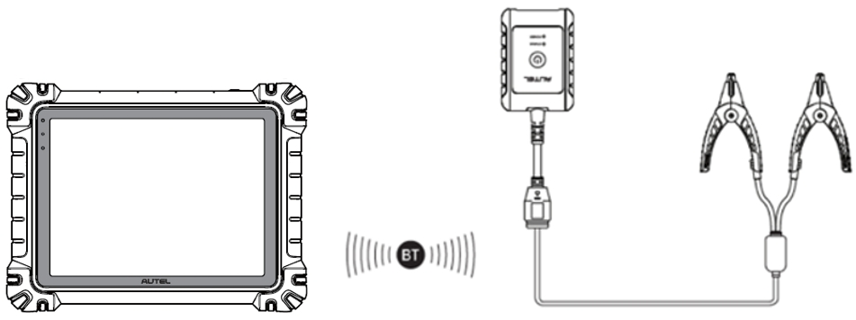
Figure 11-3 Battery Tester Connection Example 1

- To connect to a battery
  - Connect the red clamp to the positive (+) terminal of the battery.
  - Connect the black clamp to the negative (−) terminal of the battery.
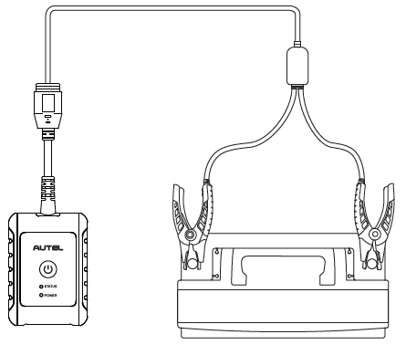
Figure 11-4 Battery Tester Connection Example 2

In-vehicle Test
The In-vehicle Test is used for testing batteries that are installed in a vehicle. An in-vehicle test includes the Battery Test, Starter Test, and Generator Test. These tests help determine the health of the battery, the starter, and the generator.
IMPORTANT
A disclaimer will appear when first accessing any function on the Home screen. Please read the end-user agreement and tap Accept to continue. If you tap Decline, you will not be able to use the features properly.
Prior to testing any battery, ensure that the battery tester is paired with the tablet via Bluetooth and connected properly to a battery.
- To start the in-vehicle test
- Tap the Battery Test application button on the MaxiSys Job Menu. Select In-vehicle Test.
- Confirm the vehicle information on the left side of the screen. Make sure the VIN is entered.
- Confirm your battery information, including voltage, type, standard, and capacity. Tap Next to continue in-vehicle test functions.
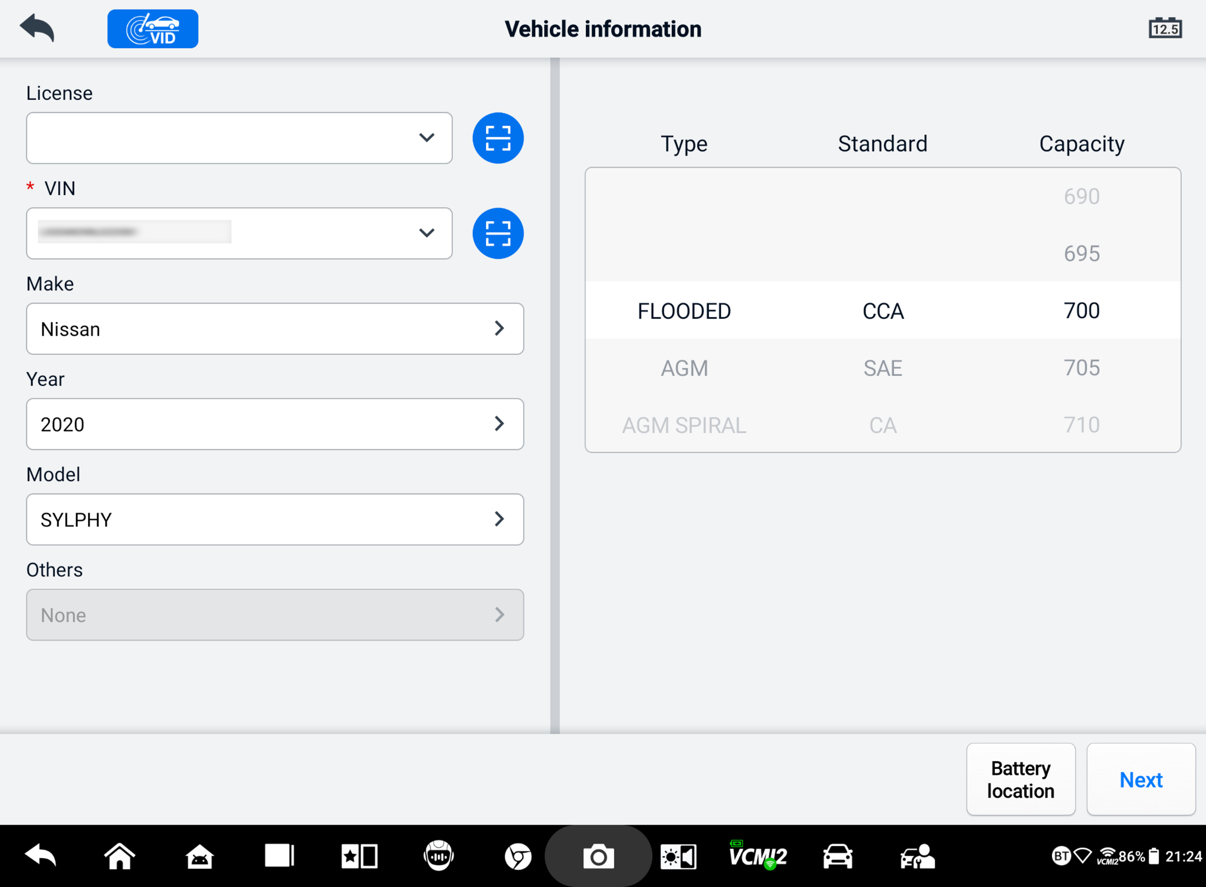
Figure 11-5 Battery Information Screen
NOTE
In the Settings application, the Battery Test option allows you to change the requirement for entering the VIN information. If the setting is enabled, supplying the VIN is no longer mandatory.
Refer to the table below for a list of buttons that may appear when accessing the functions:
Table 11-3 Top Toolbar Buttons
Button | Name | Description
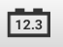 | Battery Connection | The value on the icon indicates the real-time voltage of the tested battery. In the battery test, the button will turn green if the battery is good; otherwise, it will turn red.
 | Exit | Returns to the Job Menu.
 | Back | Returns to the previous screen.
 | Next | Tap to proceed.

Battery Test
- Follow the on-screen instructions. Check the boxes once all required tasks are completed, and tap Start Testing.
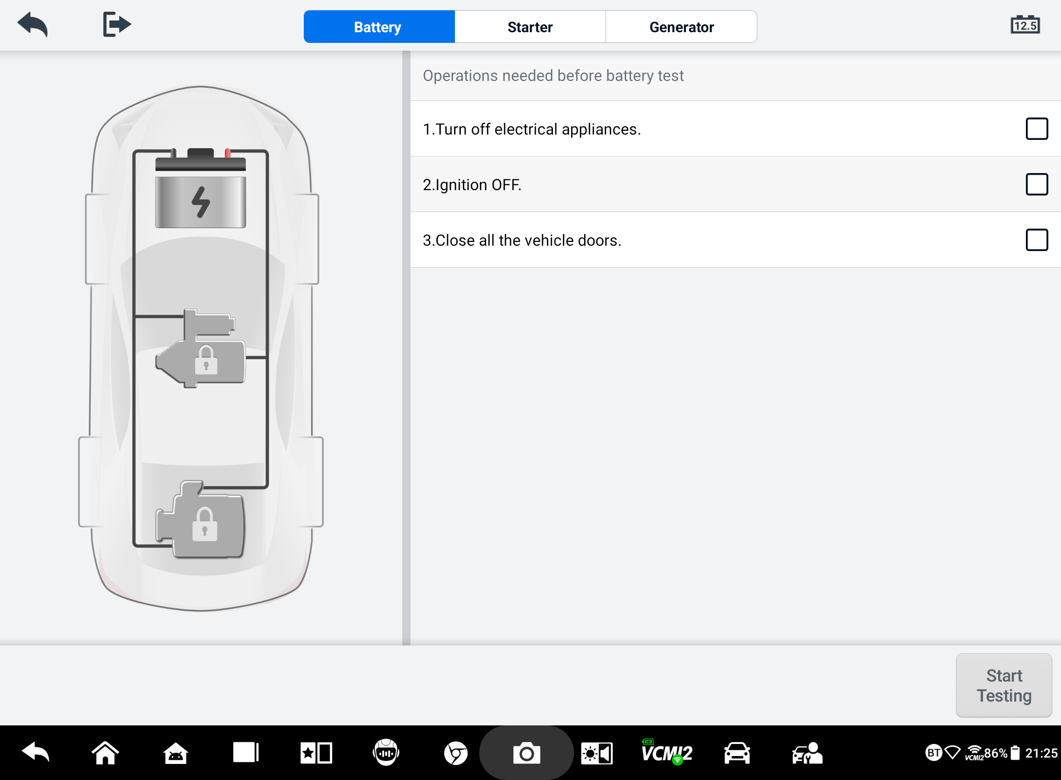
Figure 11-6 Battery Screen
- Wait until the test is completed. The test results will be displayed on the tool.
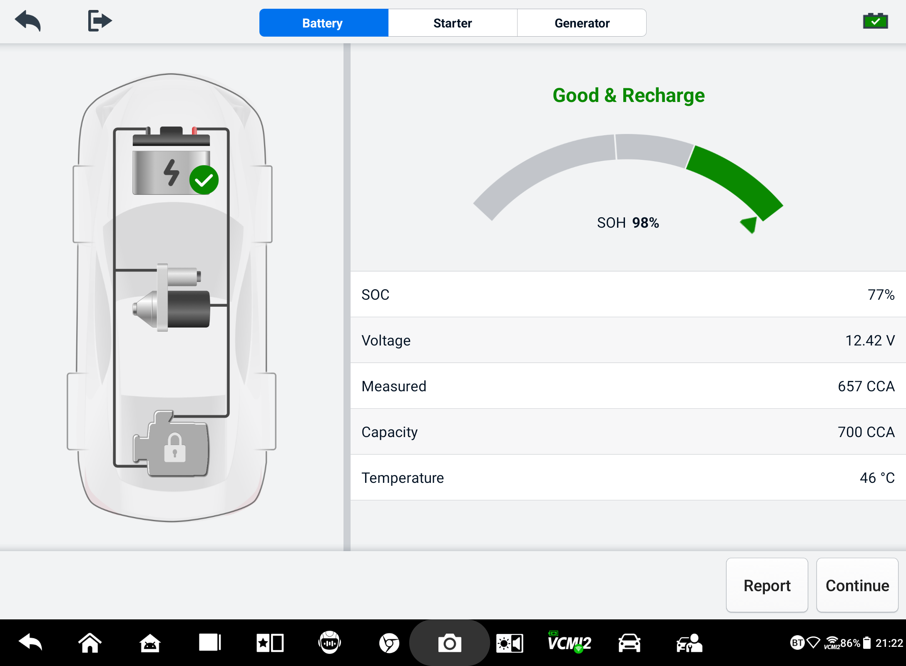
Figure 11-7 Battery Test Results Screen
Table 11-4 Test Results
Result | Description
Good Battery | Battery is good.
Good & Recharge | Battery is good but insufficiently charged. Recharge the battery.
Charge & Retest | Battery requires charge to determine its condition.
Bad Cell | Replace the battery.
Replace Battery | Replace the battery.

NOTE
Please always complete the battery test before you proceed to the starter and generator tests.

Starter Test
Follow the on-screen instructions to complete the test. Start the engine and let it idle. The test results will appear as follows:
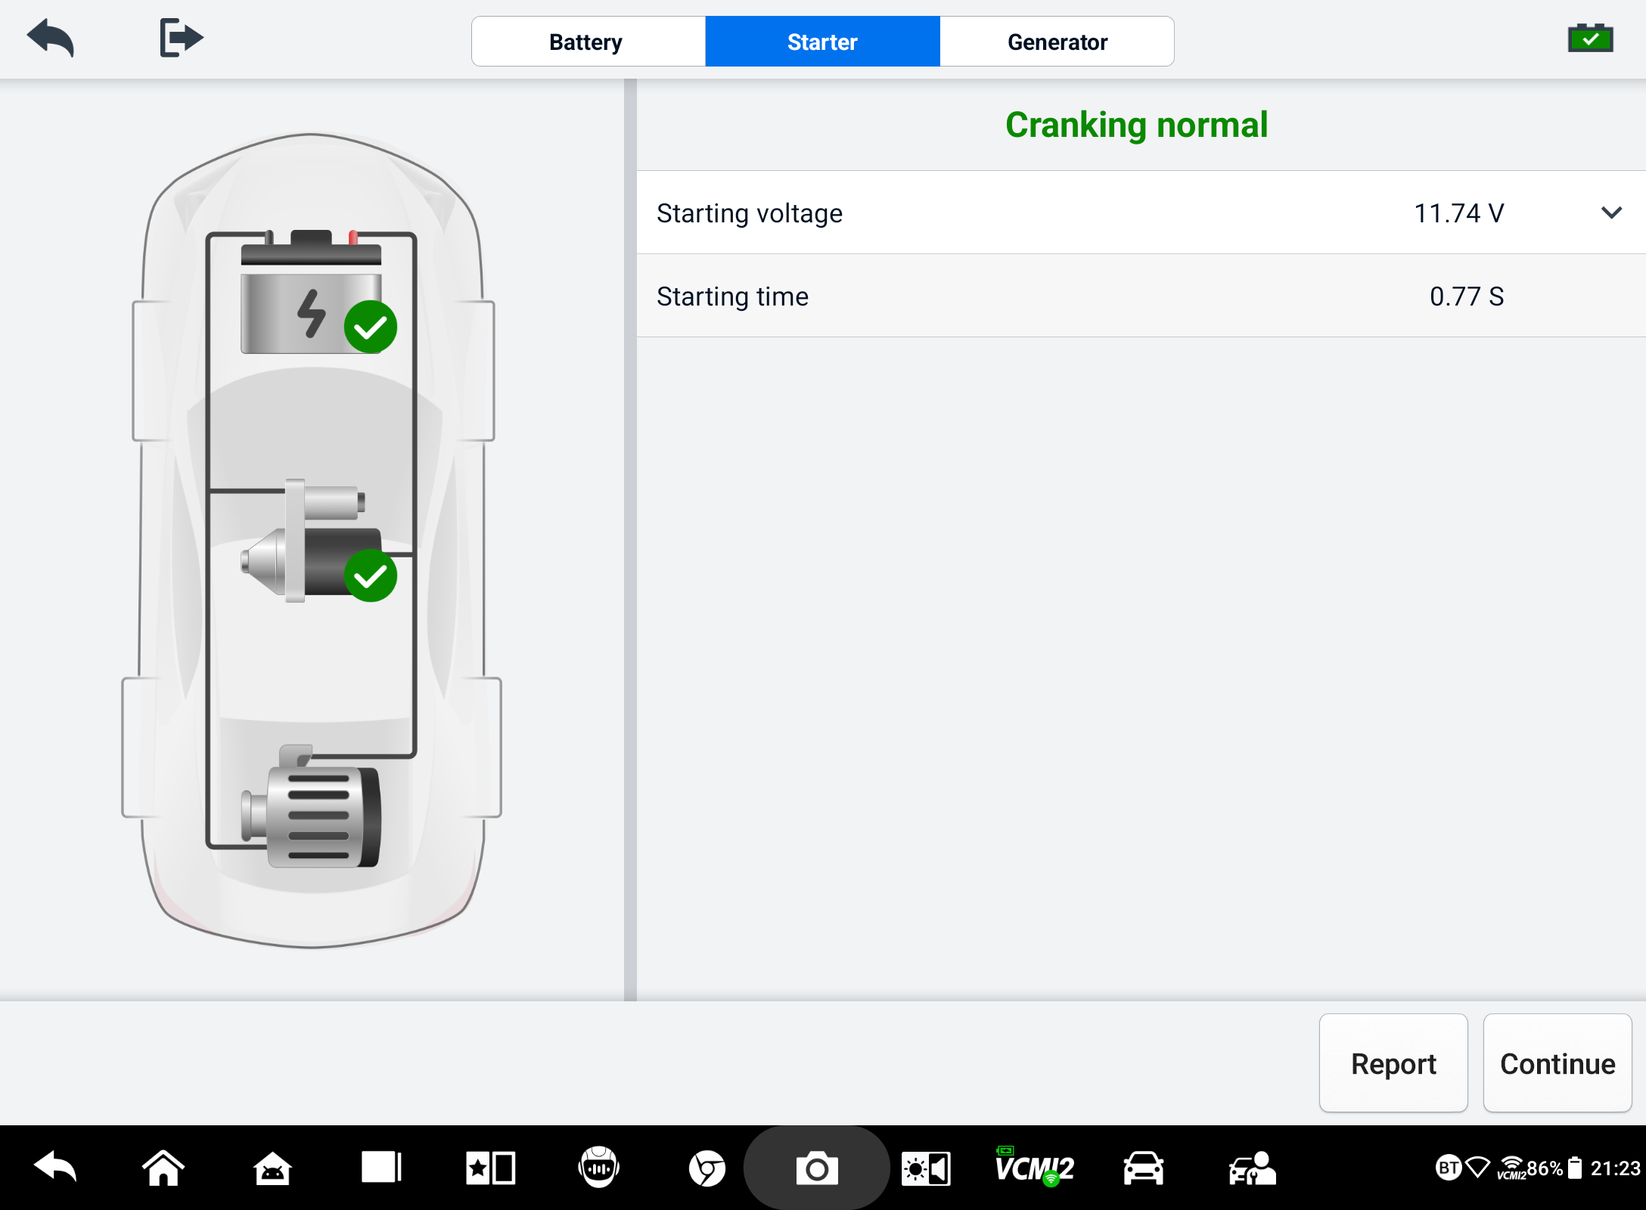
Figure 11-8 Starter Test Result Screen
Table 11-5 Starter Test Results
Result | Description
Cranking Normal | The starter is good.
Current Too Low | Low momentary discharge capacity.
Voltage Too Low | Low battery storage capacity.
Not Started | The starter is not detected for starting.

Generator Test
Follow the on-screen instructions to complete the test. The test results will appear as follows:
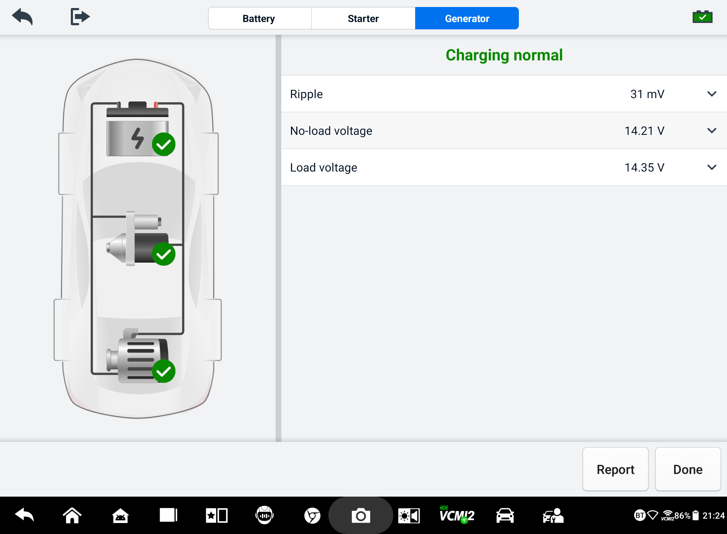
Figure 11-9 Generator Test Results Screen
Table 11-6 Generator Test Results
Result | Description
Charging Normal | The generator is functioning normally.
Output Too Low | - The belt linking the starter and the generator is loose.  - The cable linking the starter and battery is loose or corroded.
Output Too High | - The generator is not properly connected to the ground.  - The voltage adjuster is broken and needs replacement.
Ripple Too Large | The commutation diode is broken.
No Output | - The cable is loose.  - Some vehicles with power management systems do not provide path for charging due to the sufficient load capacity of the battery.  - The generator or the voltage adjuster is broken and needs replacement.

Out-vehicle Test
Out-vehicle Test is used to test the condition of batteries that are not connected to a vehicle. This function aims to check the health status of the battery.

Test Procedure
- To start the out-vehicle test
- Connect the tester clamps to the battery terminals.
- Tap Battery Test on the MaxiSys Job Menu. Select Out-vehicle Test.
- Select the appropriate battery type, rating standard, and CCA value. Tap Start Testing to start the test.
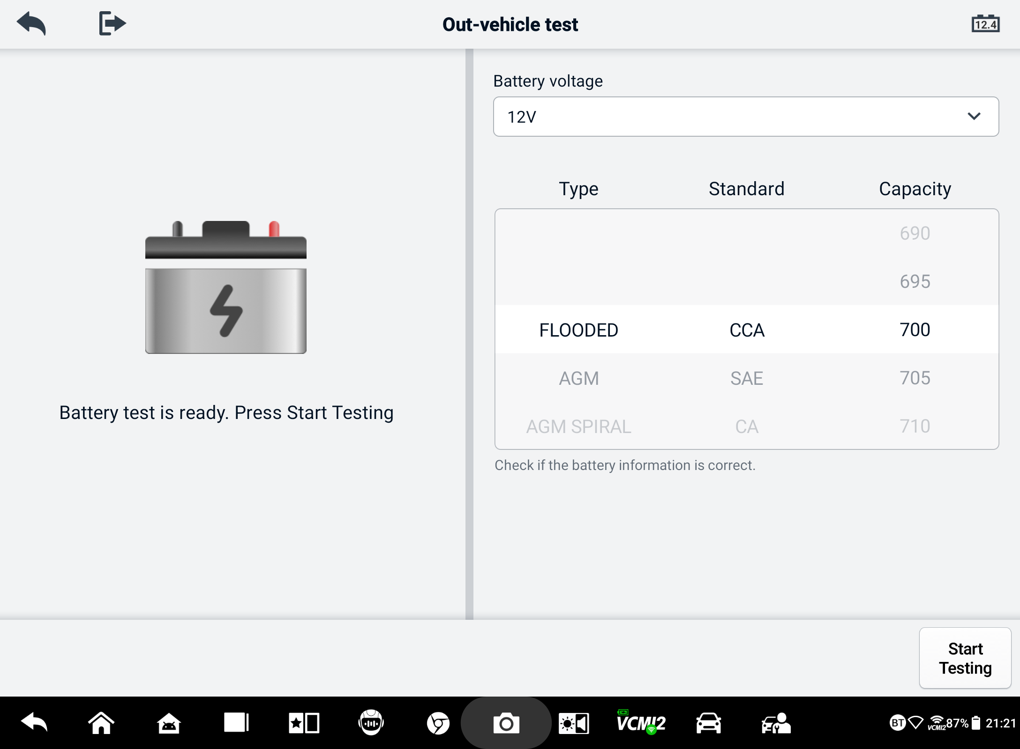
Figure 11-10 Out-vehicle Test Screen
- The test results will display in a few seconds.
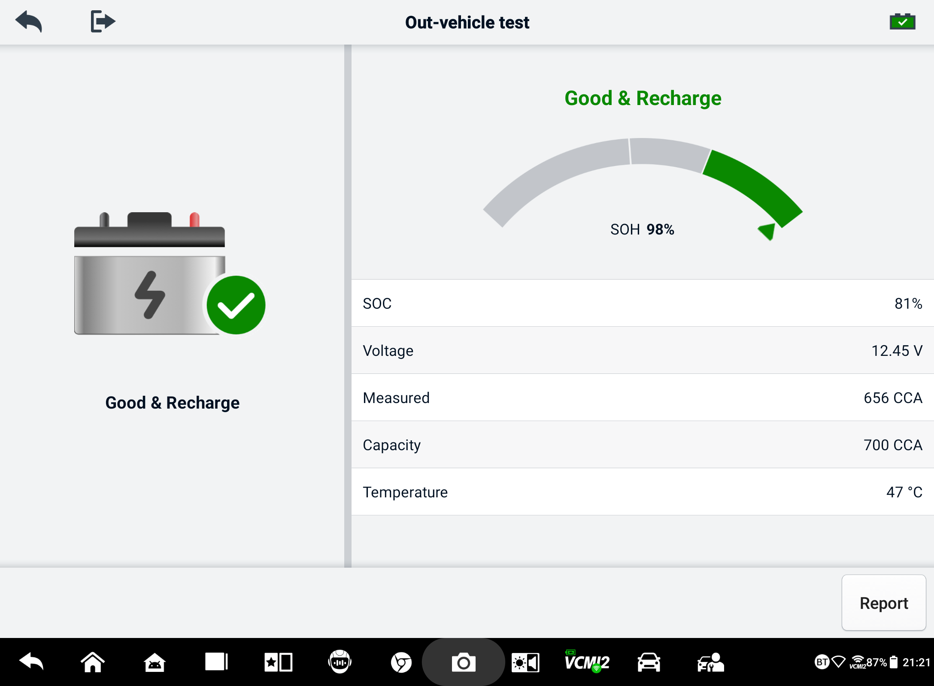
Figure 11-11 Out-vehicle Test Results Screen

Test Results
Table 11-7 Out-Vehicle Test Results
Result | Description
Good Battery | Battery meets required standards.
Good & Recharge | Battery is good, but low on charge. Fully charge the battery. Check for causes of low charge.
Charge & Retest | Battery requires charge to determine its condition.
Replace Battery | Battery fails to meet industry-accepted standards.
Bad Cell | Battery fails to meet industry-accepted standards.

Settings
Access the Settings menu to adjust default settings and view information about the MaxiSys system. The following options are available for the MaxiSys system settings:
- Unit
- Language
- Printing Settings
- Report Settings
- Push Notifications
- Auto Update
- ADAS Settings
- OBFCM Upload
- Vehicle List
- App Sorting
- Battery Test
- Country/Region Code
- Laws and Regulations
- System Settings
- About

Unit
This option allows you to change the measurement unit for the diagnostic system.
- To adjust the unit setting
- Tap the Settings application button on the MaxiSys Job Menu.
- Tap the Unit option on the left column.
- Select the appropriate measurement unit. A check mark will display to the right of the selected unit.
- Tap the Home button on the top-left corner to return to the MaxiSys Job Menu, or select another settings option for system setup.

Language
This option allows you to adjust the display language for the MaxiSys system.
- To adjust the language setting
- Tap the Settings application button on the MaxiSys Job Menu.
- Tap the Language option on the left column.
- Select the appropriate language. A check mark will display to the right of the selected language.
- Tap the Home button on the top-left corner to return to the MaxiSys Job Menu, or select another settings option for system setup.

Printing Settings
This option allows you to print from the tablet to a network printer via a computer.
- To setup the printer connection
- Tap the Settings application button on the MaxiSys Job Menu.
- Tap the Printing Settings option on the left column.
- Tap Print via PC-link or Print via Wi-Fi to activate the printing function, which enables the device to send files to the printer through the PC via Wi-Fi or Ethernet connection.
- Tap the Home button on the top-left corner to return to the MaxiSys Job Menu, or select another settings option for system setup.

Printing Operations
- To install the MaxiSys Printer driver
- Download Maxi PC Suite from www.autel.com > Support > Downloads > Autel Update Tools, and install it to a Windows-based PC.
- Double click on Setup.exe.
- Select the installation language and the wizard will load.
- Follow the instructions on the screen and Click on Next to continue.
- Click Install and the printer driver program will be installed onto the computer.
- Click Finish to complete the installation.

NOTE
The MaxiSys printer runs automatically after the installation. The PC, printer and the tablet must be connected to the same network.
This section describes how to receive file from the MaxiSys tablet and perform printing through the PC.
NOTE
- Make sure the tablet is connected to the same network with your computer, either via Wi-Fi or LAN, before printing.
- Make sure the computer installed with the Printing Services program is connected to a printer.
- To perform printing through the computer
- Ensure the tablet is connected to the computer network, either via Wi-Fi or LAN, before printing.
- Run the PC Link program on the computer.
- Select the MaxiSys Printer tab.
- Tap the Print button in the tablet top toolbar. A document will be sent to the computer.
    - If the Auto Print option in the MaxiSys Printer is selected, the MaxiSys Printer will print the received document automatically.
    - If the Auto Print option is not selected, click Open PDF File button to view files. Select the file(s) to print and click Print.
NOTE
To confirm that the printer is functioning normally, you can click Test Print in the PC Link program to test.

Report Settings
The options, such as Scan Report, Report Upload to Cloud, Insurance Information, and OBD Ready Status, are available in the Report Settings function. Toggle the ON/OFF button to enable/disable the required function. If the button displays blue, it indicates the selected function is enabled. If the button displays gray, it indicates the selected function is disabled.
- To enable the Report Upload to Cloud function
- Tap the Settings application button on the MaxiSys Job Menu.
- Tap the Report Settings option on the left column.
- Locate the Report upload to Cloud function, and then toggle the button to ON. Select Manual or Automatic based on the actual situation.
- Tap the Home button on the top-left corner to return to the MaxiSys Job Menu, or select another settings option for system setup.
The OBD Ready Status is disabled by default. The OBD ready status will be automatically read in the Auto Scan function once the OBD Ready Status button is enabled.

Push Notification
This option allows you to manage notifications. The Notification Preferences is turned on by default and cannot be turned off by users so that certain system notifications such as system security warnings won’t be blocked. Internet access is required for receiving on-line messages.
- To manage other notifications
- Tap the Settings application button on the MaxiSys Job Menu.
- Tap the Push Notifications option on the left column.
- Tap the button on the right to open a drop-down list.
- There are four options: Enable all notifications, Limit to 3 notifications or less per week, Limit to 1 notification per week, and Disable all notifications. Select whichever you want.
- Tap Home on the top-left corner to return to the MaxiSys Job Menu. Or select another settings option for the system setup.
NOTE
- Notifications will display on the screen. Slide the screen from top to check the received messages. If the message list covers more than one screen, slide the list up or down to view them.
- Tapping a specific message launches the corresponding application. For example, if you tap on an Update notification, the Update application will be launched.

Auto Update
The Auto Update allows the tool to automatically update the OS, the MaxiSys system, and the vehicle coverage software. Each can be configured to update automatically at a specified time. Tap the ON/OFF button to enable/disable the desired automatic update time.

- To set auto system or vehicle update
- Tap the Settings application button on the MaxiSys Job Menu.
- Tap the Auto Update option on the left column. The three auto update items will display on the right of the screen.
- Select the update type to schedule. Toggle the button to ON.
- Tap on the time to set the time of the day for updating. If the update time is set and the device is connected to the Internet, the selected software will be automatically updated at the configured time.

ADAS Settings
- To activate the MaxiSys ADAS calibration
      - Confirm the registered MaxiSys tablet has available updates.
      - Tap the Settings application button on the MaxiSys Job Menu.
      - Tap the ADAS Settings option on the left column.
      - Scan the QR code on the ADAS frame to bind, or manually input frame serial number when QR code is not available.
      - Enter the validation code from the ADAS Calibration Card.
      - The system will be reset and the Job Menu will display once the registration has been completed.

OBFCM Upload
This option allows you to upload the carbon dioxide emissions-related data (OBFCM data) of passenger vehicles and light commercial vehicles to the monitoring background of the European country.
Toggle the button to ON to enable this function, and then select the corresponding country and fill in the OBFCM monitoring server address. When the setting is completed, select the EOBD software in the Diagnostics application. After reading the OBFCM data in Vehicle information, the data can be sent to the monitoring server in the corresponding country.
NOTE
Do not enable this function in non-European countries or when the OBFCM monitoring data is not needed to submit.

Vehicle List
This option allows you to sort the vehicles either by alphabetical order or by frequency of use.
- To adjust the vehicle list setting
- Tap the Settings application button on the MaxiSys Job Menu.
- Tap the Vehicle List option on the left column.
- Select the required sort type. A check mark will display to the right of the selected item.
- Tap the Home button in the top-left corner to return to the MaxiSys Job Menu, or select another settings option for system setup.

App Sorting
This option allows you to list the applications by want you need on each screen. Drag the apps up and down to keep frequently-used applications on the first or second screen of the MaxiSys Job Menu.

Battery Test
This function allows you to change the requirement for entering the VIN information. If the setting is enabled, supplying the VIN is no longer mandatory.

Country/Region Code
This function provides Wi-Fi channel options for different country regions to ensure reliable and stable Wi-Fi communication. Please connect the tablet with VCI2 before making adjustment.
- To adjust the country code setting
- Tap the Settings application on the MaxiSys Job Menu.
- Tap the Country/Region Code option on the left column.
- Select the appropriate country/region. A confirmation message will display.
- Tap the Home button on the top-left corner to return to the MaxiSys Job Menu, or select another settings option for the system setup.
NOTE
If the tablet cannot find the VCI2 via Wi-Fi connection after setting the country code, please connect the VCI2 with the tablet via USB cable or Bluetooth connection to retry.

Laws and Regulations
This function provides the law and regulation information, including the end-user license agreement, disclaimer for products, and privacy policy. Please read these laws and regulations carefully before using this product.

System Settings
This function provides you with direct access to the Android system settings interface, where you can adjust various system settings for the Android system platform, including wireless and networks settings, various device settings such as sound and display, as well as system security settings, and checking related information about the Android system. Refer to Android documentation for additional information.

About
The About function provides information of the MaxiSys diagnostic device including the product name, version, hardware, and serial number.
- To check the MaxiSys product information in About
- Tap the Settings application button on the MaxiSys Job Menu.
- Tap the About option on the left column. The product information screen displays on the right.
- Tap the Home button on the top-left corner to return to the MaxiSys Job Menu, or select another settings option for system setup.

Update
The Update application on the tablet downloads the latest version of the software. The updates improve the MaxiSys applications’ capabilities, typically by adding new tests, new model coverage or by adding new or enhanced applications.
The tablet automatically searches for available updates for all of the MaxiSys software when it is connected to the Internet. Any updates that are found can be downloaded and installed on the device.
NOTE
Ensure the tablet is registered before utilizing the Update application. See Autel User Center for a comprehensive registration guide.
- To update the software
- Power up the tablet, and ensure that it is connected to a power source and has a steady Internet connection.
- Tap the Update application button on the MaxiSys Job Menu. The Update application screen displays.
- On the Update screen, tap the Get button to update the specific item(s) or tap the Update All button to update all available items.
- Tap More to view the details of all the available updates. You can also tap the Get or Update All button for update.
- During the update, tap the  icon to suspend the updating process. Tap the icon to resume the update and the process will continue from the pause point.
- When the updating process is completed, the software will be installed automatically. The new version will replace the older version.
NOTE
For the account management, proceed to the Member Center tab.

VCI Manager
The VCI Manager is an application for connecting the MaxiSys tablet with VCI2. This application allows you to pair the tablet with the VCI2 and to check the communication status. You can either build the connection via Bluetooth or Wi-Fi, of which the latter is more stable and faster in speed for module operation.
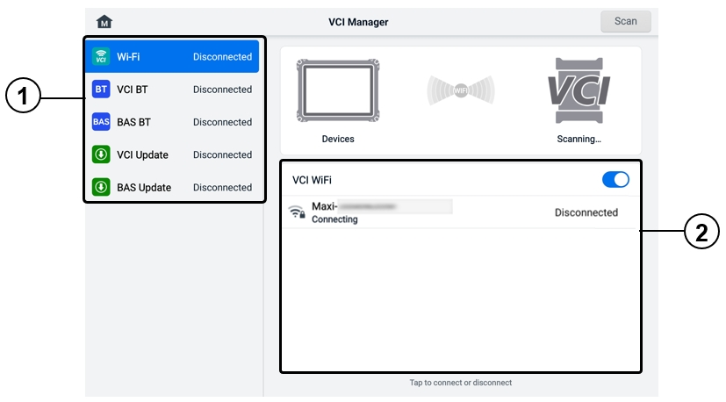
Figure 14-1 VCI Manager Screen
- Connection Mode: five connection modes are available. The connection status displays adjacent to each mode.
- Wi-Fi Connection — when connected to a wireless device, the connection state displays as “Connected.” Otherwise, it displays as “Disconnected.”
- VCI Bluetooth Pairing — when the VCI2 is paired to the tablet via Bluetooth, the connection status displays as “Connected.” Otherwise, it displays as “Disconnected.”
- BAS Bluetooth Pairing— when paired to a battery tester via Bluetooth, the connection status displays as “Connected.” Otherwise, it displays as “Disconnected.”
- VCI Update — connects the VCI2 to the diagnostic tablet, and then updates the VCI2 firmware through the tablet.
- BAS Update — connects the battery tester to the diagnostic tablet, and then updates the battery tester’s firmware through the tablet.
- Settings: this section allows you to manage wireless pairing or set up network connection. Toggle the ON/OFF button to ON. The available devices for pairing will display. Tap the needed one to start pairing.

Wi-Fi Connection
Wi-Fi Connection is an advanced function for quick linkage with VCI2. Since Wi-Fi connection supports 5G, the MaxiSys tablet and VCI2 share a faster and more stable connection when using this communication method.
- To connect the VCI2 to the tablet via Wi-Fi
- Power on the tablet.
- Connect the 26-pin end of the main cable to the VCI2's vehicle data connector.
- Connect the 16-pin end of the main cable to the vehicle data link connector (DLC).
- Tap the VCI Manager application button on the MaxiSys Job Menu of the tablet.
- Tap the Wi-Fi option on the left column.
- Toggle the ON/OFF button to ON. Tap Scan at the top-right corner. The device will start to search for available units.
- Depending on the VCI2 type you use, the device name may display as “Maxi” suffixed with a serial number. Select the appropriate device for connection.
- When the connection is established, the connection status displays as “Connected”.
- The VCI2 button on the system navigation bar at the bottom of the screen displays a green Wi-Fi icon, indicating the tablet is connected to the VCI2.
- Tap the connected device again to disconnect the device.
NOTE
To ensure a quick connection, please connect in a steady network environment.

VCI Bluetooth Pairing
Bluetooth Paring is the basic way for wireless connection. The VCI2 needs to be either connected to a vehicle or to an available power source, so that it is powered up during the synchronization procedure. Make sure the tablet has a charged battery or is connected to an AC/DC power supply.
- To pair the VCI2 with the tablet
- Power on the tablet.
- Connect the 26-pin end of the main cable to the VCI2's vehicle data connector.
- Connect the 16-pin end of the main cable to the vehicle data link connector (DLC).
- Tap the VCI Manager application button on the MaxiSys Job Menu of the tablet.
- Tap the VCI BT option on the left column.
- Toggle the ON/OFF button to ON. Tap Scan at the top-right corner. The device will start to search for available pairing units.
- Depending on the VCI2 type you use, the device name may display as “Maxi” suffixed with a serial number. Select the appropriate device for pairing.
- When paired successfully, the connection status displays as “Connected.”
- Wait a few seconds, and the VCI2 button on the system navigation bar at the bottom of the screen will display a green BT icon, indicating the tablet is connected to the VCI2.
- Tap the connected device again to disconnect the device.
NOTE
A VCI2 device can be paired to only one tablet at a time, and once it's been paired, the device will not be discoverable for any other unit.

BAS Bluetooth Pairing
The BT506 battery tester device can be connected with the tablet via Bluetooth. Ensure that the BT506 battery tester is sufficiently charged or is connected to the external power supply before use.
- To pair the Battery Tester with the tablet
- Power on the tablet and the battery tester.
- Tap the VCI Manager application button on the MaxiSys Job Menu of the tablet.
- Tap the BAS BT option on the left column.
- Toggle the ON/OFF button to ON. Tap Scan at the top-right corner of the screen. The device will start to search for available units to pair with.
- Depending on the type of battery tester, the device name may appear as "Maxi" suffixed with the battery test’s serial number. Select the appropriate device for pairing.
- When paired successfully, the connection status reads “Connected.”

VCI Update
VCI Update provides the latest update for the connected VCI2. Before updating the VCI2 firmware, make sure the tablet network is stable, and do not leave the VCI Update page during upgrade.

- To update the VCI2
- Power on the tablet.
- Connect the VCI2 to the tablet via USB cable.
- Tap the VCI Manager application button on the MaxiSys Job Menu of the tablet.
- Tap the VCI Update option on the left column.
- If the installed version is not the latest one, the current version and the latest version will display on the screen after a few seconds. Tap Update Now to update the VCI2 if available.

BAS Update
Before updating the battery tester firmware, please make sure the network connection is stable.
- To update the battery tester firmware
- Power on the tablet and the battery tester.
- Connect the battery tester to the tablet via Bluetooth or USB cable.
- Tap the VCI Manager application button on the MaxiSys Job Menu of the tablet.
- Tap the BAS Update option on the left column.
- If the installed version is not the latest one, the current version and the latest version will display on the screen after a few seconds. Tap Update Now to update the BAS firmware if available.
NOTE
Do not leave the BAS Update page during upgrade.

Hand-held Inclinometer
By connecting the hand-held inclinometer to MaxiSys tablet and opening the Hand-held inclinometer application, you can accurately measure the Mercedes-Benz vehicles’ ride height, which is a data basis for adjusting the values of wheel camber, caster, and toe during the wheel alignment procedure.
- To measure the ride height of a Mercedes-Benz vehicle
- Connect the hand-held inclinometer to the USB port on the MaxiSys tablet using the supplied USB cable.
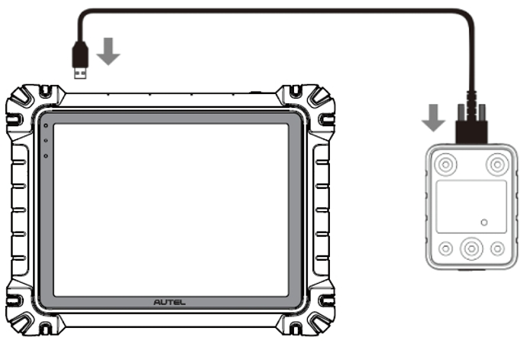
Figure 15-1 Connecting MaxiSys Tablet and Hand-held Inclinometer
- Tap the Hand-held Inclinometer application button on the MaxiSys Job Menu to open the vehicle series selection screen.
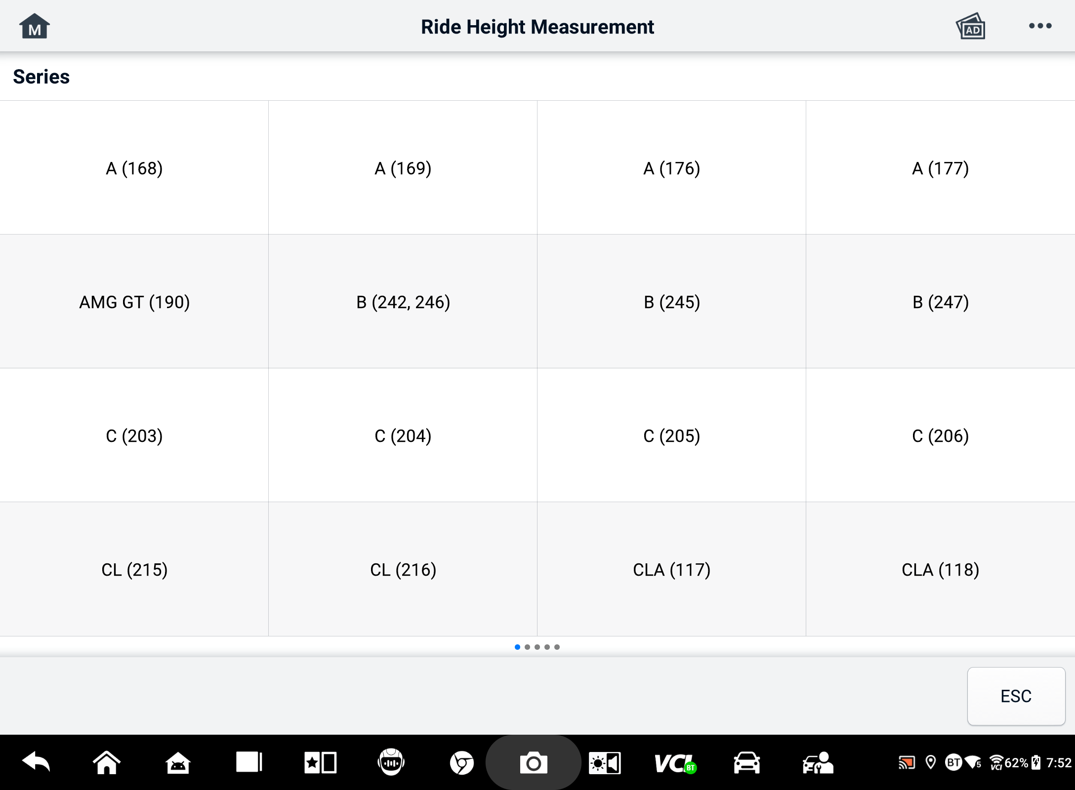
Figure 15-2 Vehicle Series Selection Screen
- Follow the on-screen instructions to measure the ride height. The measured results will be automatically uploaded to the tablet and displayed in the corresponding input box.
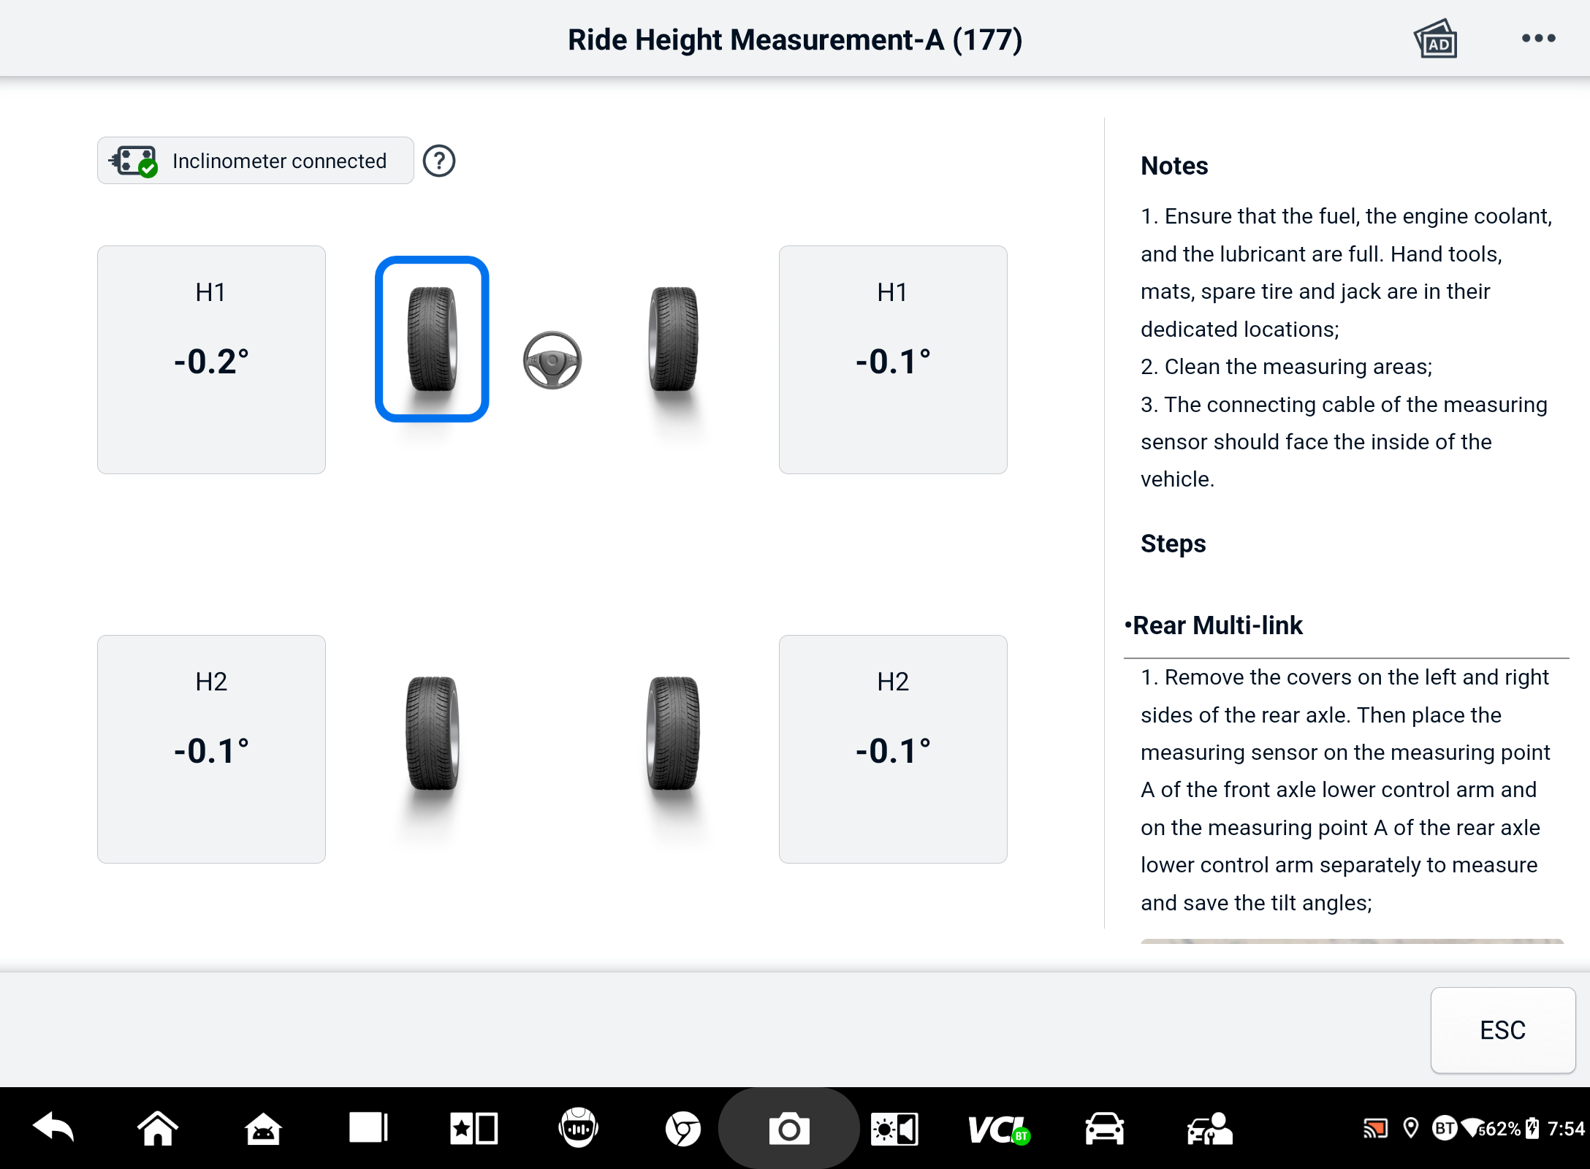
Figure 15-3 Ride Height Measurement Result Screen
NOTE
Tap the button on the upper-right corner of the screen to open the drop-down menu options: Calibrate, Update, Help. A quick reference guide on how to use the Autel hand-held inclinometer will display after tapping the Help option.

Support
This application launches the Support platform which synchronizes Autel’s online service base station with the MaxiSys tablet. Connected to Autel’s service channel and online communities, the Support application provides the quickest way for problem solutions, allowing you to send help requests to obtain direct service and support.

Support Screen Layout
The Support application interface is navigated by the Home button on the top toolbar. The main section of the Support screen is divided into two sections. The narrow column on the left is the main menu; you can select one subject from the main menu to display the corresponding function screen on the right.
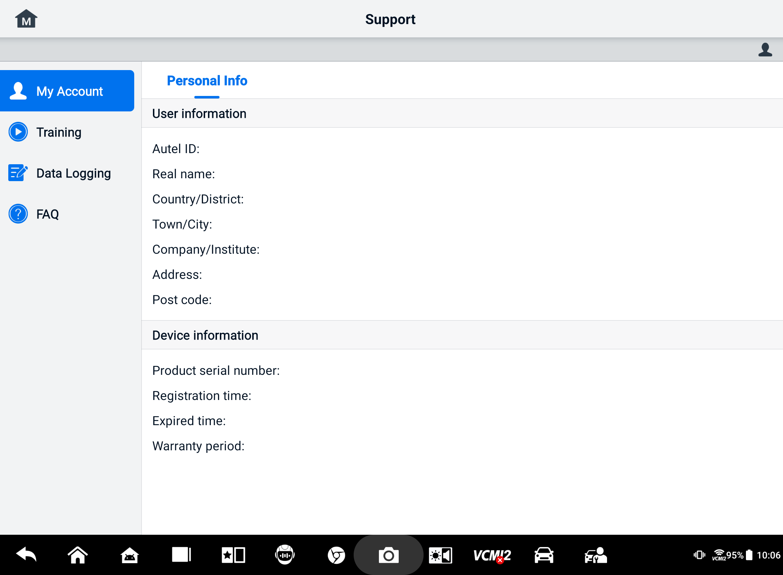
Figure 16-1 Support Application Screen

My Account
The My Account screen displays the comprehensive information of the user and the product, which is synchronized with the online registered account.
Personal Information
The User Information and Device Information are both included under the Personal Information section.
- User Information — displays detailed information of your registered online Autel account, such as your Autel ID, name, address, and other contact information.
- Device Information — displays the registered product information, including the product serial number, registration time, expired time, and warranty period.

Training
The Training section provides quick links to Autel’s online video accounts. Select a video channel by language to see all available Autel online tutorial videos on such topics as product usage techniques and vehicle diagnostics practices.

Data Logging
The Data Logging section keeps records of all Feedback (submitted), No feedback (not submitted but saved) or History (up to the latest 20 test records) data loggings on the diagnostic system. The support personnel will receive and process the submitted reports through the Support platform. The solution will be sent back as soon as possible. You may continue to correspond with the Support platform until the issue is resolved.
- To make a reply in a Data Logging session
- Tap on the Feedback tag to view the list of submitted data loggings.
- Select a specific item to view the latest update of the processing progress.
- Tap on the input field on the bottom of the screen and enter your reply. Additionally, you can add the attachment if needed.
- Tap Send to deliver your message to Autel Support.

FAQ
The FAQ section provides comprehensive references for all questions frequently asked and answered about the use of Autel’s online member account and shopping and payment procedures.
- Account — displays questions and answers about the use of Autel's online user account.
- Shopping — displays questions and answers about online product purchase methods or procedures.
- Payment — displays questions and answers about online product payment methods or procedures.

MaxiViewer
The MaxiViewer application allows you to search the functions supported by our tools and the version information. There are two ways for searching, either by searching the tool and the vehicle or searching the functions.
  - To search by the vehicle
- Tap the MaxiViewer application button on the MaxiSys Job Menu. The MaxiViewer application screen displays.
- Select a product model from the first dropdown list on the top-left corner.
- Select the vehicle brand, model, and year from the second drop-down list.
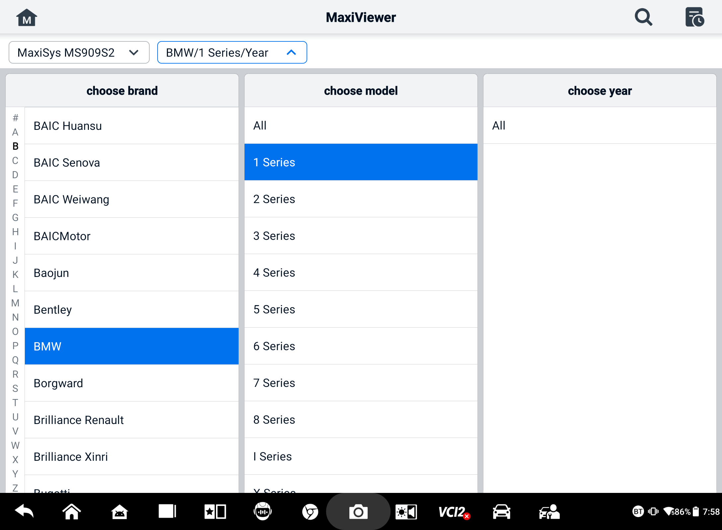
Figure 17-1 MaxiViewer Screen 1
- All the functions supported by the selected product model for the selected vehicle display as several columns.
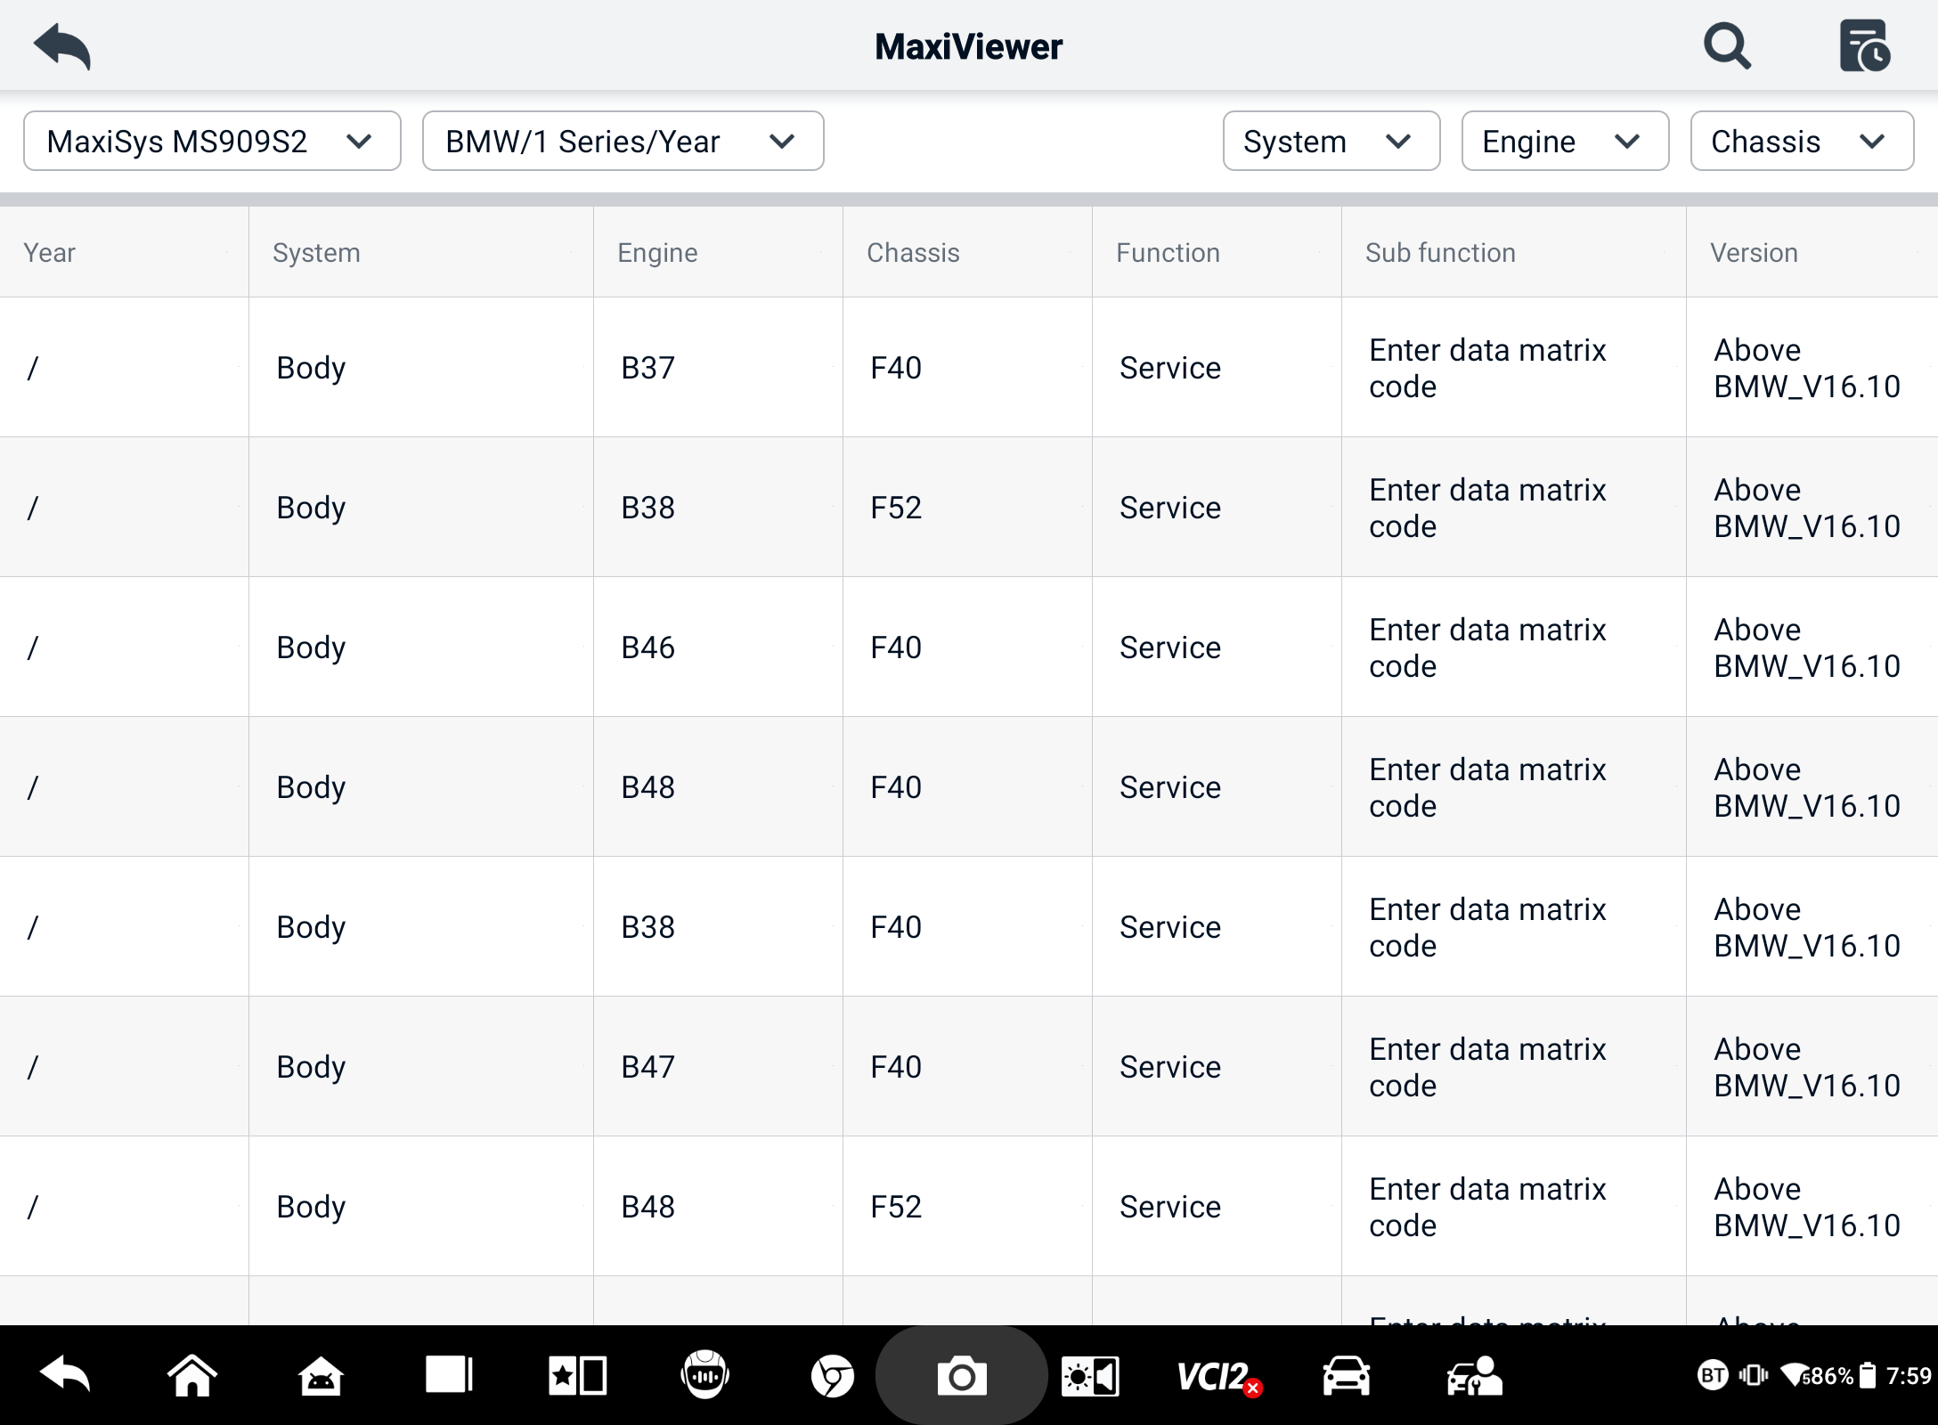
Figure 17-2 MaxiViewer Screen 2
  - To search by the functions
- Tap the MaxiViewer application button on the MaxiSys Job Menu. The MaxiViewer application screen displays.
- Select a product model from the first dropdown list on the top-left corner.
- Tap the search icon in the top-right corner and enter the function you want to search in the search box. The screen will display all vehicles that support this function, along with information such as the vehicles' year, system, function, sub-function, and version.
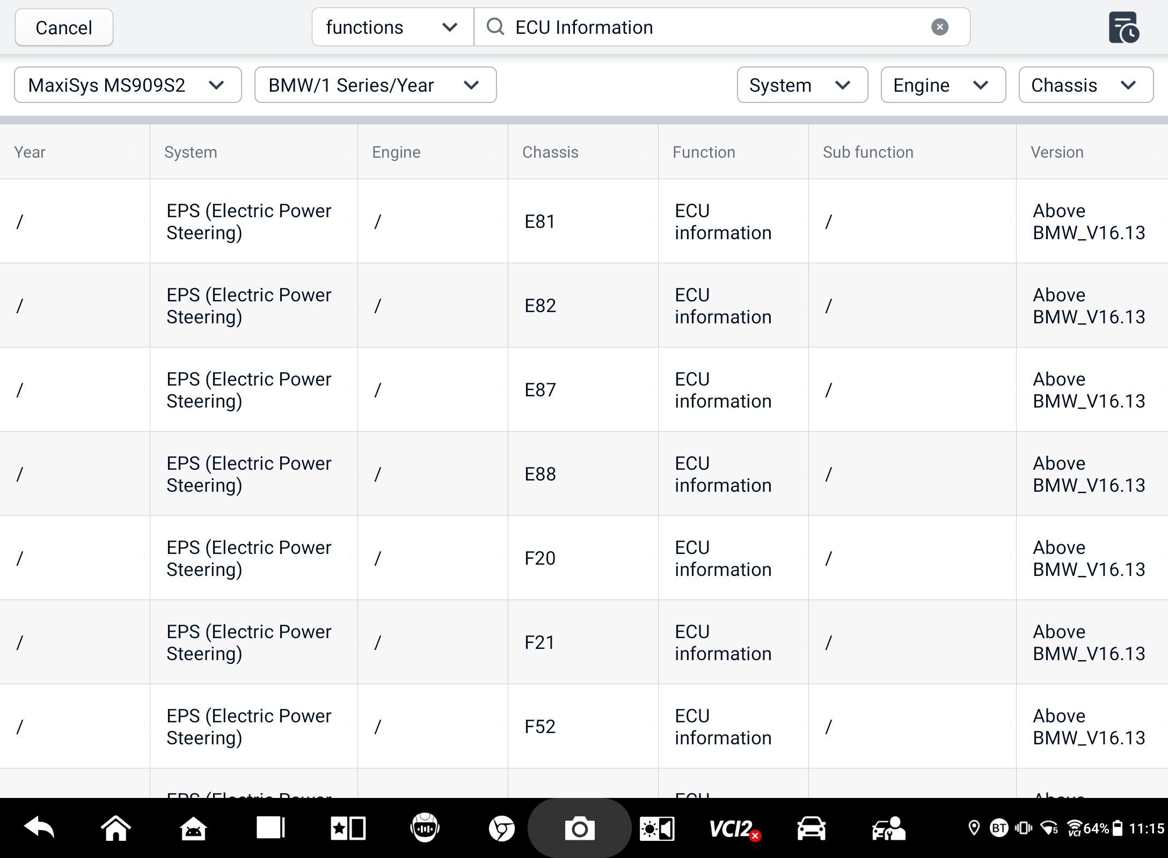
Figure 17-3 MaxiViewer Screen 3
NOTE
Fuzzy search is supported. Type in some part of the function-related keywords to find all the available information.

MaxiVideo
The MaxiVideo application configures the MaxiSys tablet to operate as a digital video scope by simply connecting the tablet to a MaxiVideo Digital Inspection Camera. This function allows you to examine difficult-to-reach areas normally hidden from sight, with the ability to record digital still images and videos, which offers you an economical solution to inspect machinery, facilities, and infrastructure in a safe and quick way.
NOTE
      - The MaxiVideo Digital Inspection Camera and its fittings are additional accessories, and need to be purchased separately. Both sizes (8.5 mm and 5.5 mm) of the imager head are optional and available for purchase.
      - This function is compatible with the MaxiVideo Digital Inspection Camera in models MV105S, MV108S, MV105, and MV108.
      - Connect the tablet with MaxiVideo Digital Inspection Camera using the USB cable. For detailed operation instructions, please refer to the Quick Reference Guide for the MaxiVideo Digital Inspection Camera.

Quick Link
The Quick Link application provides you with convenient access to Autel’s official website and many other well-known sites in the automotive service industry to provide technical help, knowledge bases, forums, and training and expertise consultations.
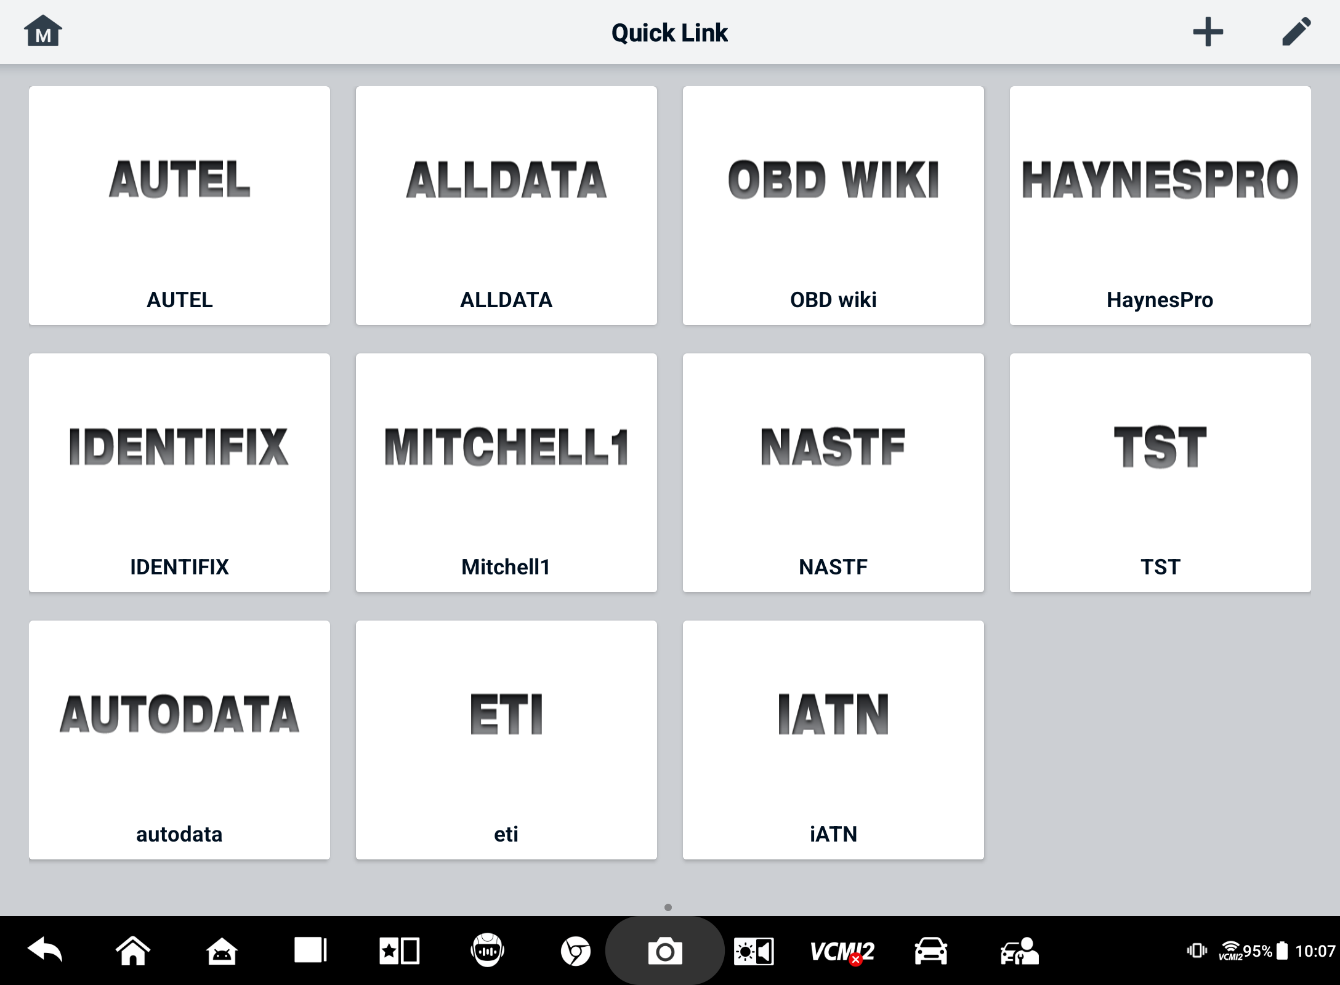
Figure 19-1 Quick Link Screen
- To open a quick link
- Tap the Quick Link application button on the MaxiSys Job Menu. The Quick Link application screen displays.
- Select a website thumbnail from the main section. The Chrome browser will launch and the selected website will open.
- To manage the quick links
- Tap the Quick Link application button on the MaxiSys Job Menu. The Quick Link application screen displays.
- Tap the  icon on the upper-right corner to add websites. Tap the  icon to delete websites.

Remote Desktop
The Remote Desktop application launches the TeamViewer Quick Support program, which is a simple, fast, and secure remote-control interface. You can use the application to receive ad-hoc remote support from Autel's support center, colleagues, or friends, by allowing them to control your MaxiSys tablet on their PC via the TeamViewer software.
If you think of a TeamViewer connection as a phone call, the TeamViewer ID would be the phone number under which all TeamViewer Clients can be reached separately. Computers and mobile devices that run TeamViewer are identified by a globally unique ID. The first time the Remote Desktop application is started, this ID is generated automatically based on the hardware characteristics and will not change.
Make sure the tablet is connected to the Internet before launching the Remote Desktop application, so that the tablet is able to receive remote support from a third party.
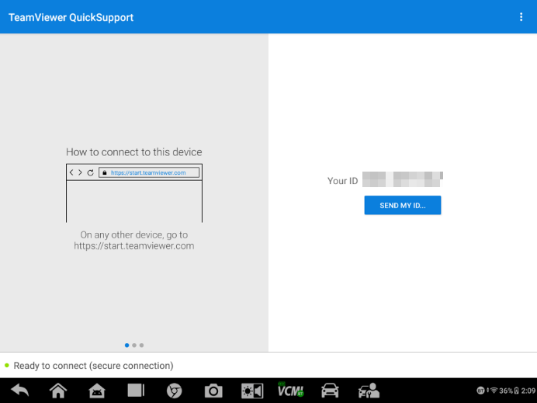
Figure 20-1 Remote Desktop Screen
- To receive remote support from a partner
- Power on the tablet.
- Tap the Remote Desktop application button on the MaxiSys Job Menu. The TeamViewer interface displays and the device ID is generated and shown.
- Your partner must install the Remote Control software to his/her computer by downloading the TeamViewer full version program online (http://www.teamviewer.com), and then launch the software.
- Provide your ID to the partner, and wait for him/her to send you a remote-control request.
- A message will appear asking for your confirmation to allow remote-control on your device.
- Tap Allow to accept, or tap Deny to reject.
Refer to the associated TeamViewer documents for additional information.

User Feedback
The User Feedback application allows you to submit questions related to this product.
- To send user feedback
- Tap the User Feedback application button on the MaxiSys Job Menu. The device information is automatically synchronized.
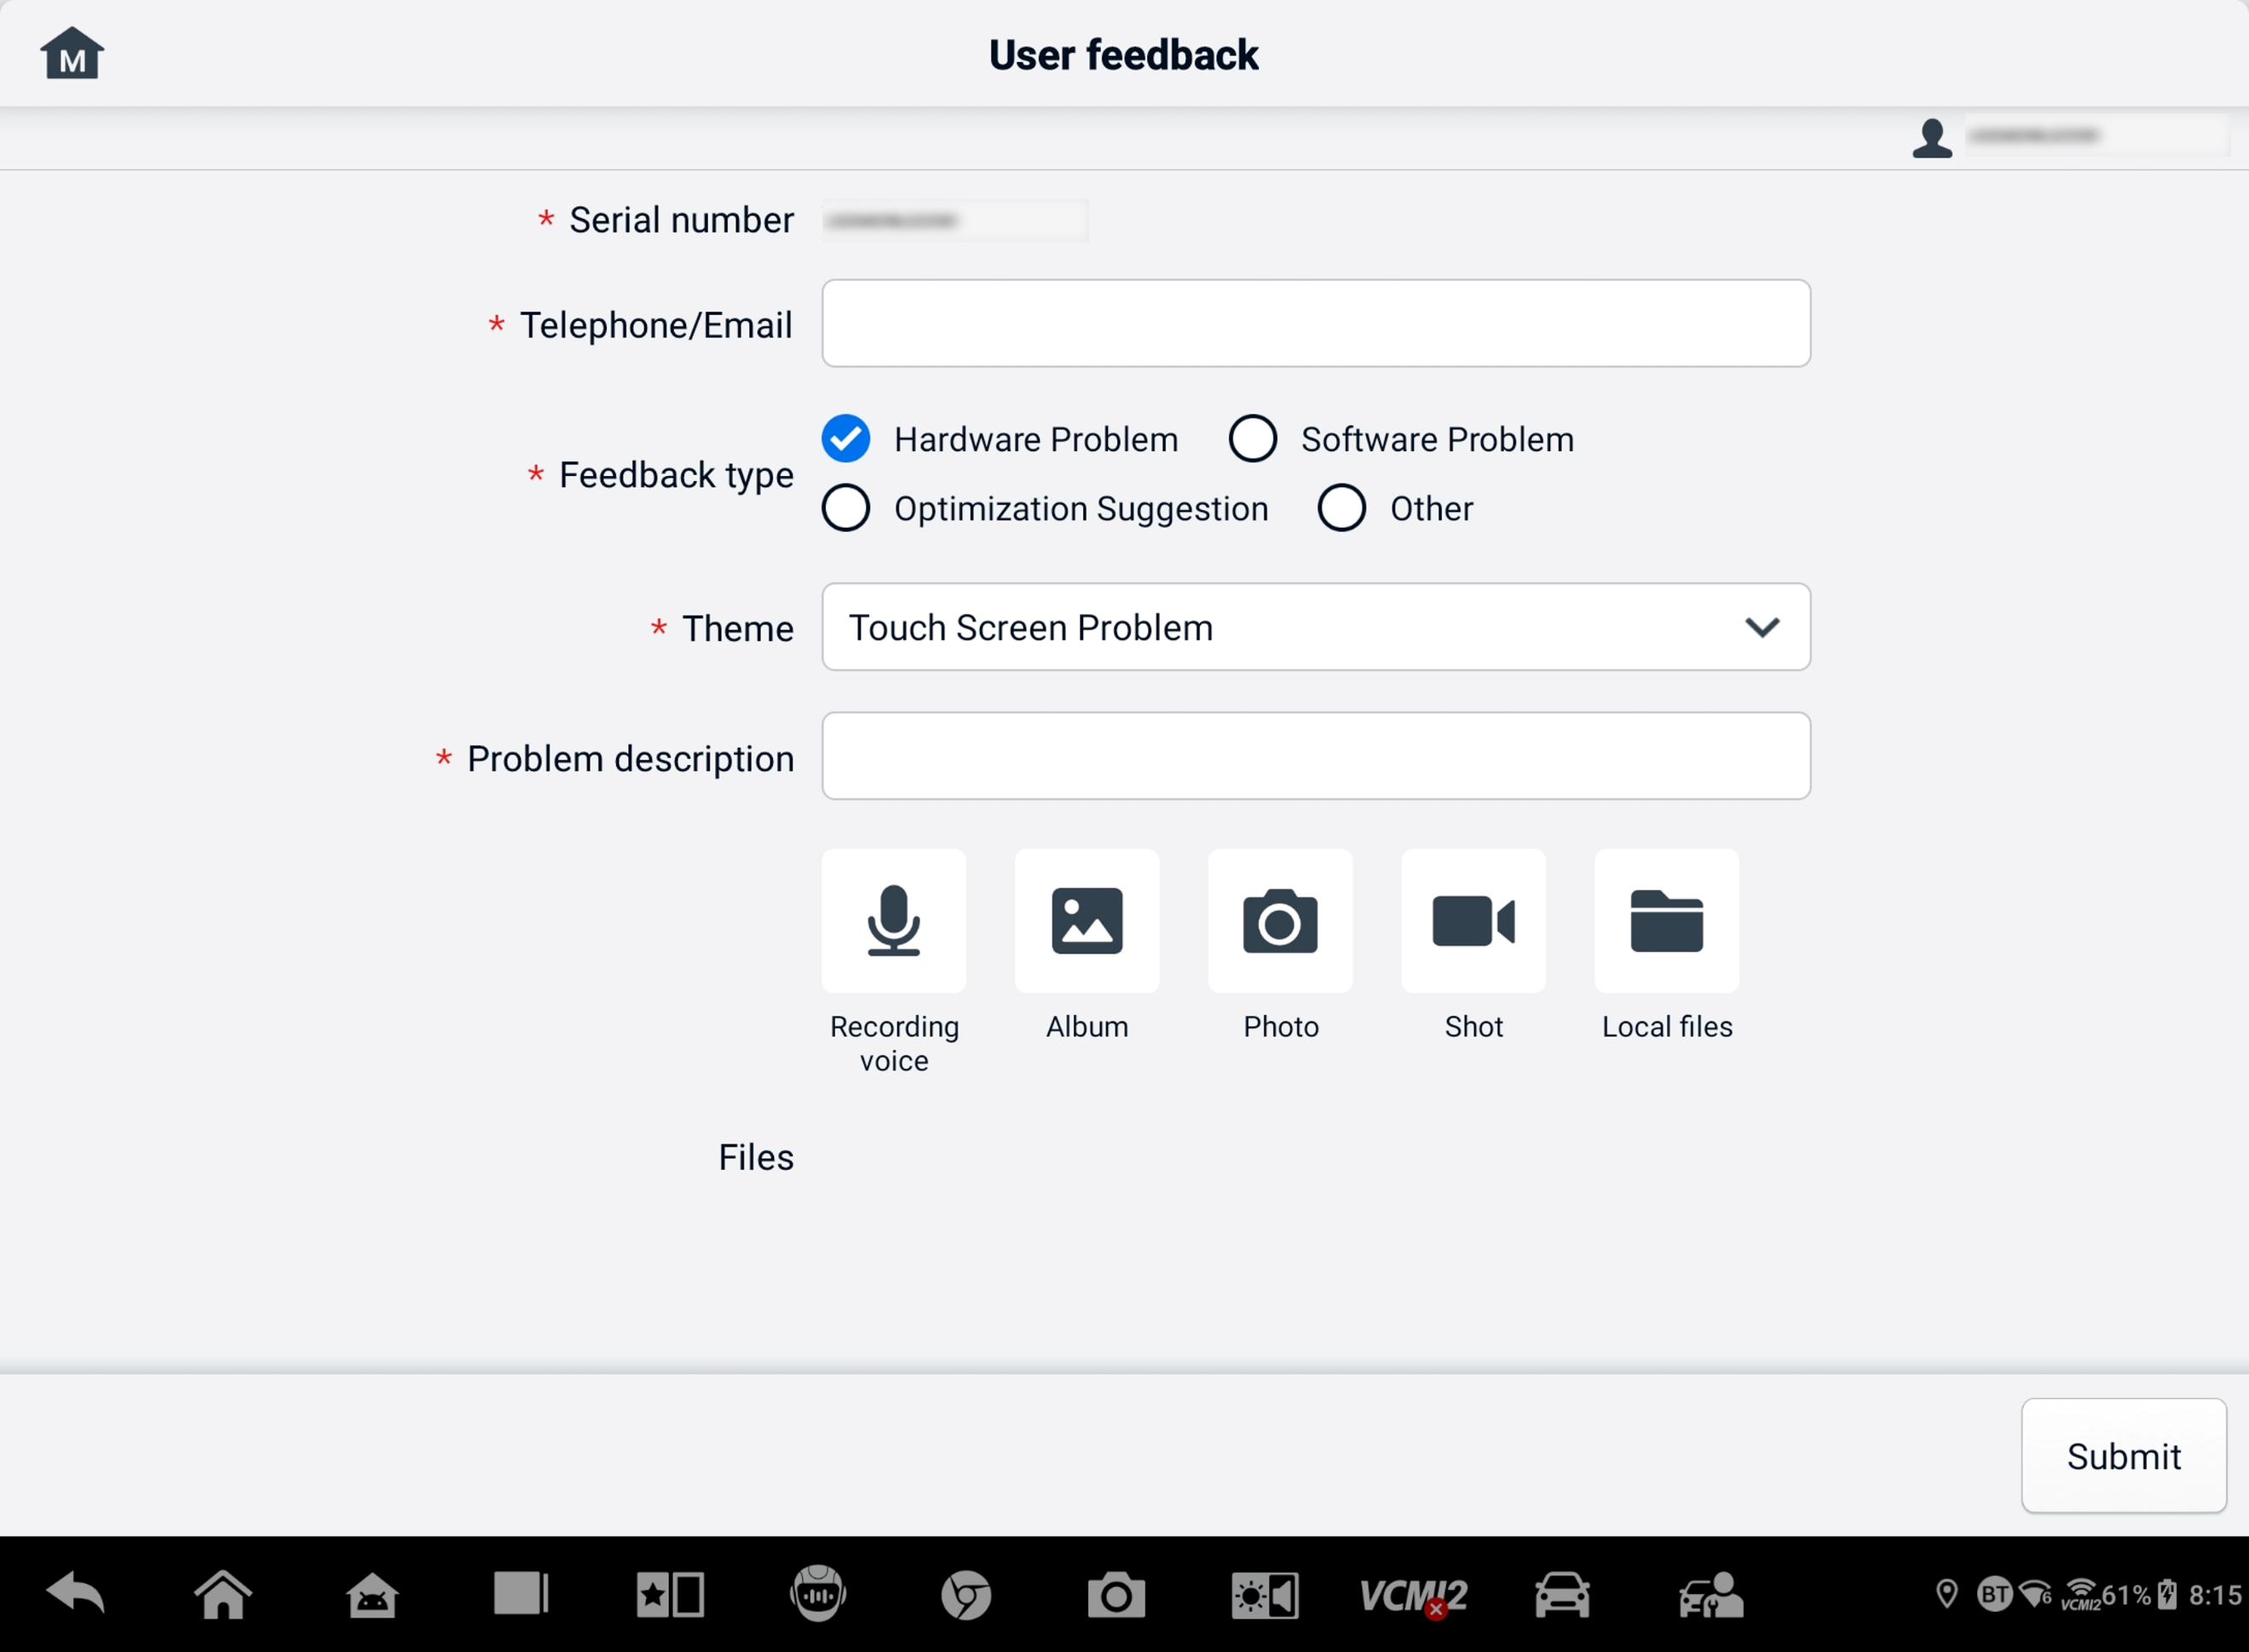
Figure 21-1 User Feedback Screen
- Set Telephone/Email, Feedback type, Theme, and Problem description. You can also attach voice recordings, photos, screenshots, images or PDF files. To resolve your issue more efficiently, we recommend you to complete the information with as many details as possible.
- Tap Submit to send the completed information to Autel's online service center. The submitted feedback will be carefully read and handled by our service personnel.

Autel User Center
Software updates are available for free for the first year from the date of purchase. The Autel User Center application allows you to register your tool to download the latest released software, thereby enhancing the functionality of the MaxiSys application by adding new vehicle models or enhanced applications to the database.
There are two ways for product registration:
- Via the MaxiSys tablet
- To log in with your account and register your Autel tool
  - Tap the Autel User Center application button on the MaxiSys Job Menu. The following screen displays.
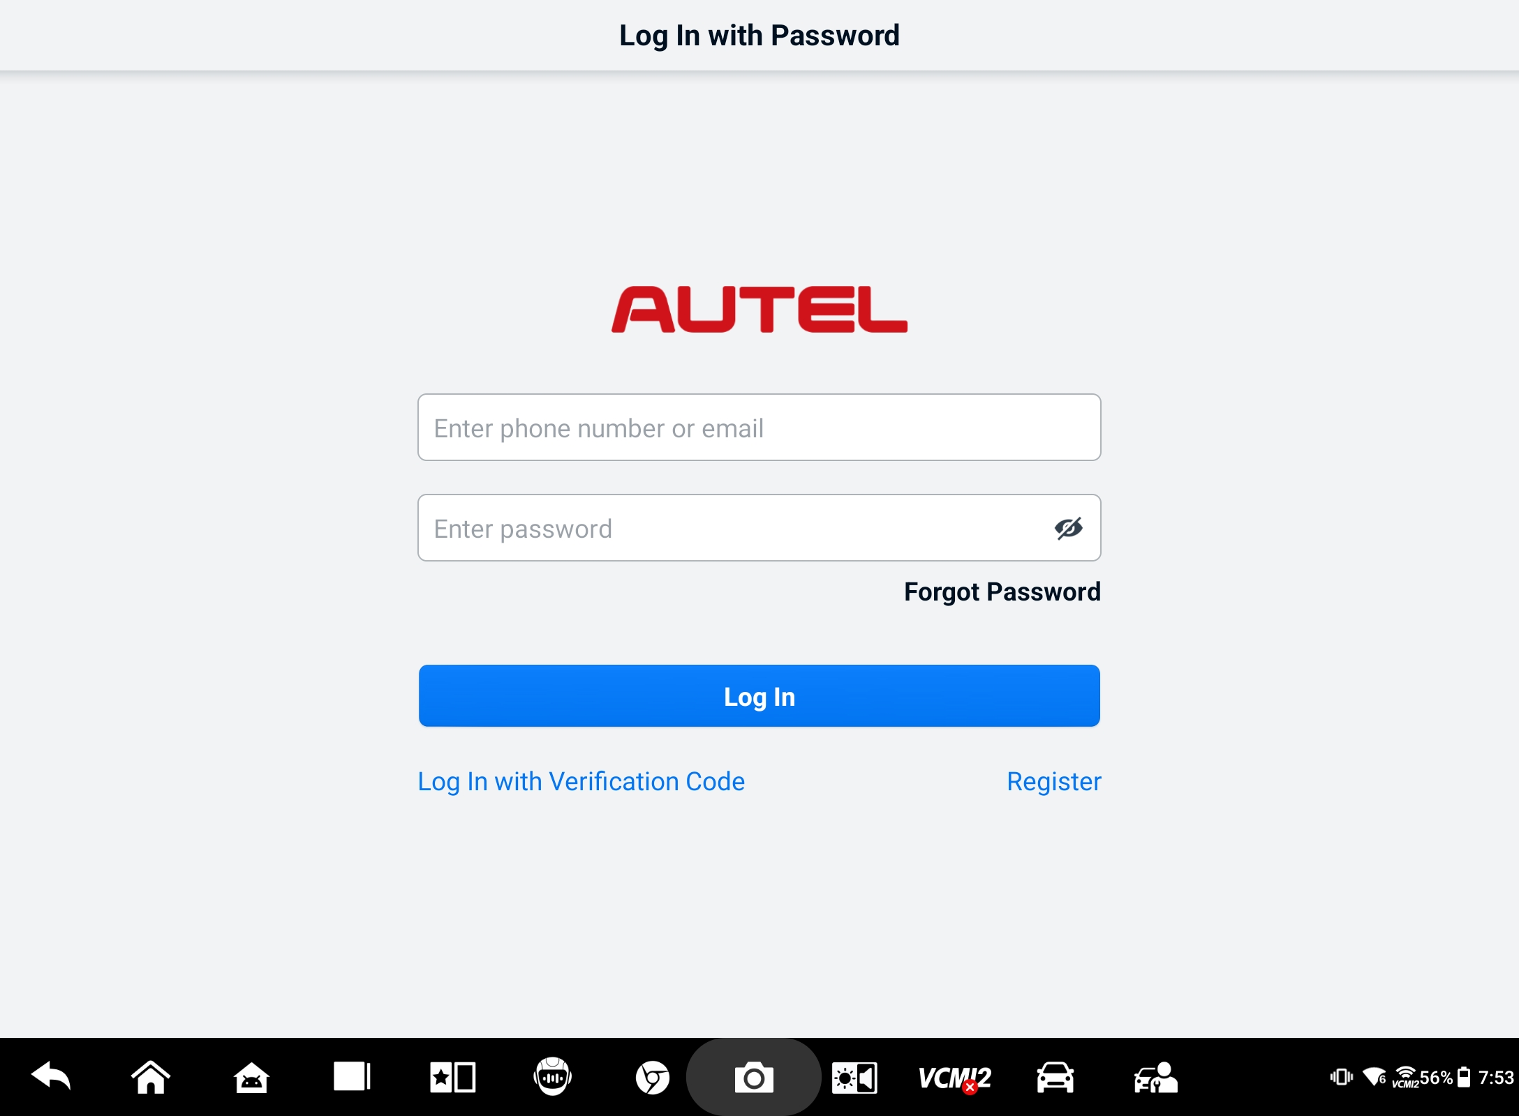
Figure 22-1 Autel User Center Screen
  - If you already have an Autel ID, you can log in with your Autel ID and password, or tap Log In with Verification Code to log in with your phone number and verification code. If you don't have an Autel ID yet, tap Register to create an Autel ID.
  - Once your account is successfully registered, you will enter the main menu of the Autel User Center.
  - Select Device Management on the main menu.
  - Tap the Link Device button on the upper-right corner of the Device Management screen. The serial number and password of the device will automatically appear on the Link Device screen.
  - Tap the Link button to complete the product registration.
- Via the Autel website
- To register your Autel tool
- Visit the website: pro.autel.com.
- If you have an Autel account, sign in with your account ID and password and skip to step 7.
- If you are a new member to Autel, click the Register button to create your Autel ID.
- Enter the required personal information in the input fields.
- Enter your email address, and then click Request. You will receive an email from Autel with your verification code. Open the email and copy the code into the proper input box.
- Set a password for your account and enter the password again to confirm. Read the Autel User Service Agreement and Autel Privacy Policy, and then check the box to accept the terms. After all the information is entered, click Register. A Product Registration screen will appear.
- Your product serial number and password are required to complete your registration. To find your serial number and password on the tool: go to Settings＞About.
- Enter your tool’s serial number and password on the Product Registration screen. Enter the CAPTCHA code and click Submit to complete your registration procedure.

Maintenance and Service
To ensure that the tablet and the combined VCI unit perform at their optimum level, we advise that the product maintenance instructions covered in this section are strictly followed.

Maintenance Instructions
The following includes how to maintain your devices, together with precautions to take.
- Use a soft cloth and alcohol or a mild window cleaner to clean the touchscreen of the tablet.
- Do not use any abrasive cleansers, detergent, or automotive chemicals to the tablet.
- Keep the devices in dry conditions and within the specified operating temperatures.
- Dry your hands before using the tablet. The touch screen of the tablet may not work if the touch screen is moist or if you tap the touch screen with wet hands.
- Do not store the devices in humid, dusty, or dirty areas.
- Check the housing, wiring, and connectors for dirt and damage before and after each use.
- Do not attempt to disassemble your tablet or the VCI unit.
- Do not drop or cause severe impact to the devices.
- Use only authorized battery chargers and accessories. Any malfunction or damage caused by the use of unauthorized battery chargers and accessories will void the limited product warranty.
- Ensure that the battery charger does not come in contact with conductive objects.
- Do not use the tablet beside microwave ovens, cordless phones, and some medical or scientific instruments to prevent signal interference.

Troubleshooting Checklist
- When the tablet does not work properly:
- Make sure the tablet has been registered online.
- Make sure the system software and diagnostic application software are properly updated.
- Make sure the tablet is connected to the Internet.
- Check all cables, connections, and indicators to see if the signal is being received.
- When battery life is shorter than usual:
- This may happen when you are in an area with low signal strength. Turn off your device if is not in use.
- When you cannot turn on the tablet:
- Make sure the tablet is connected to a power source or the battery is charged.
- When you are unable to charge the tablet:
- Your charger may be out of order. Contact your nearest dealer.
- You may be attempting to use the device in an overly hot/cold temperature. Charge the device in a cooler or warmer area.
- Your device may not have been connected to the charger properly. Check the connector.
NOTE
If the problems persist, please contact Autel's technical support personnel or your local selling agent.

About Battery Usage
Your tablet is powered by a built-in lithium-ion polymer battery, which enables you to recharge your battery when there is electricity left.

DANGER
The built-in Lithium-ion Polymer battery is factory replaceable only; incorrect replacement or tampering with the battery pack may cause an explosion.
- Do not use a damaged battery charger.
- Do not disassemble, open, crush, bend, deform, puncture, or shred the battery.
- Do not modify, remanufacture, or attempt to insert foreign objects into the battery, or expose the battery to fire, explosion, or other hazards.
- Only use the specified charger and USB cables. Use of non-Autel-authorized chargers or USB cables may lead to device malfunction or failure.
- Use of an unqualified battery or charger may present a risk of fire, explosion, leakage, or other hazards.
- Avoid dropping the tablet. If the tablet is dropped, especially on a hard surface, and you suspect damage, take the tablet to a service center for inspection.
- Try to keep closer to your wireless router to reduce battery usage.
- The time needed to recharge the battery varies depending on the remaining battery capacity.
- Battery life inevitably shortens over time.
- Unplug the charger once the tablet is fully charged since overcharging may shorten battery life.
- Keep the battery in temperate environments. Do not place it inside a car when it is too hot or too cold, which may reduce the capacity and life of the battery.

Service Procedures
This section provides information on technical support, repair service, and application for replacement or optional parts.

Technical Support
If you have any question or problem on the operation of the product, please contact us.
Autel China Headquarters
- Phone: +86 (0755) 8614-7779 (Monday-Friday, 9AM-6PM Beijing Time)
- Email: support@autel.com
- Address: Floor 2, Caihong Keji Building, 36 Hi-tech North Six Road, Songpingshan Community, Xili Sub-district, Nanshan District, Shenzhen City, China
- Web: www.autel.com
Autel North America
- Phone: 1-855-288-3587 (Monday-Friday, 9AM-6PM Eastern Time)
- Email: ussupport@autel.com
- Address: 36 Harbor Park Drive, Port Washington, New York, USA 11050
- Web: www.autel.com/us
Autel Europe
- Phone: +49(0)89 540299608 (Monday-Friday, 9AM-6PM Berlin Time)
- Email: support.eu@autel.com
- Address: Landsberger Str. 408, 81241 München, Germany
- Web: www.autel.eu
Autel APAC
Japan:
- Phone: +81-045-548-6282
- Email: support.jp@autel.com
- Address: 6th Floor, Ari-nadoribiru 3-7-7, Shinyokohama, Kohoku-ku, Yokohama-shi, Kanagawa-ken, 222-0033 Japan
- Web: www.autel.com/jp
Australia:
- Email: ausupport@autel.com
- Address: Unit 5, 25 Veronica Street, Capalaba
Autel IMEA
- Phone: +971 585 002709 (in UAE)
- Email: imea-support@autel.com
- Address: 906-17, Preatoni Tower (Cluster L), Jumeirah Lakes Tower, DMCC, Dubai, UAE
- Web: www.autel.com
Autel Latin America
Mexico:
- Phone: +52 33 1001 7880 (Spanish in Mexico)
- Email: latsupport@autel.com
- Address: Avenida Americas 1905, 6B, Colonia Aldrete, Guadalajara, Jalisco, Mexico
Brazil:
- Email: brsupport@autel.com
- Address: Avenida José de Souza Campos n° 900, sala 32 Nova Campinas Campinas – SP, Brazil
- Web: www.autel.com/br

Repair Service
If it becomes necessary to return your device for repair, please download the repair service form from www.autel.com, and fill in the form. The following information must be included:
- Contact name
- Return address
- Telephone number
- Product name
- Complete description of the problem
- Proof-of-purchase for warranty repairs
- Preferred method of payment for non-warranty repairs
NOTE
For non-warranty repairs, payment can be made with Visa, Master Card, or with approved credit terms.
Send the device to your local agent, or to the address below:
Floor 2, Caihong Keji Building, 36 Hi-tech North Six Road, Songpingshan Community, Xili Sub-district, Nanshan District, Shenzhen City, China

Other Services
You can purchase the optional accessories directly from Autel's authorized tool suppliers, and/or your local distributor or agent.
Your purchase order should include the following information:
- Contact information
- Product or part name
- Item description
- Purchase quantity

Compliance Information
FCC Compliance
This equipment has been tested and found to comply with the limits for a Class B digital device, pursuant to part 15 of the FCC Rules. These limits are designed to provide reasonable protection against harmful interference in a residential installation. This equipment generates, uses and can radiate radio frequency energy and, if not installed and used in accordance with the instructions, may cause harmful interference to radio communications. However, there is no guarantee that interference will not occur in a particular installation. If this equipment does cause harmful interference to radio or television reception, which can be determined by turning the equipment off and on, the user is encouraged to try to correct the interference by one or more of the following measures:
- Reorient or relocate the receiving antenna.
- Increase the separation between the equipment and receiver.
- Connect the equipment into an outlet on a circuit different from that to which the receiver is connected.
- Consult the dealer or an experienced radio/TV technician for help.

WARNING
Changes or modifications not expressly approved by the party responsible for compliance would void the user’s authority to operate the equipment.
This device complies with Part 15 of the FCC Rules. Operation is subject to the following two conditions:
- This device may not cause harmful interference.
- This device must accept any interference received, including interference that may cause undesired operation.
RF Exposure Information
FCC RF Exposure requirements: The highest SAR value reported under this standard during product certification for use next to the head with the minimum separation distance of 5mm. This transmitter must not be collocated or operating in conjunction with any other antenna or transmitter.

This product is in compliance with FCC RF Exposure requirements and refers to FCC website https://apps.fcc.gov/oetcf/eas/reports/GenericSearch.cfm. Search for FCC ID: WQ8-DV2379.
IC NOTICE TO CANADIAN USERS
This device contains licence-exempt transmitter(s)/receiver(s) that comply with Innovation, Science and Economic Development Canada’s licence-exempt RSS(s). Operation is subject to the following two conditions:
(1) This device may not cause interference.
(2) This device must accept any interference, including interference that may cause undesired operation of the device.
L’émetteur/récepteur exempt de licence contenu dans le présent appareil est conforme aux CNR d’Innovation, Sciences et Développement économique Canada applicables aux appareils radio exempts de licence. L’exploitation est autorisée aux deux conditions suivantes:
(1) l'appareil nedoit pas produire de brouillage;
(2) l'utilisateur de l'appareil doit accepter tout brouillage radioélectrique subi, même si le brouillage est susceptible d'en compromettre le fonctionnement.
Operation of this device is restricted to indoor use only. (5150-5250MHz)
Le fonctionnement de cet appareil est limité à une utilisation en intérieur uniquement. (5150-5250MHz)
This EUT is in compliance with SAR for general population/uncontrolled exposure limits in IC RSS-102 and had been tested in accordance with the measurement methods and procedures specified in IEEE 1528 and IEC 62209. This equipment should be installed and operated with minimum distance 5 mm between the radiator and your body. This device and its antenna(s) must not be co-located or operating in conjunction with any other antenna or transmitter.
Cet EST est conforme au SAR pour la population générale/limites d'exposition non contrôlées dans IC RSS-102 et a été testé conformément aux méthodes et procédures de mesure spécifiées dans IEEE 1528 et CEI 62209. Cet équipement doit être installé et utilisé à une distance minimale de 5 mm entre le radiateur et votre corps. Cet appareil et ses antennes ne doivent pas être situés ou fonctionner en conjonction avec une autre antenne ou un autre émetteur.

CE Compliance
RED Directive 2014/53/EU.
RoHS Compliance
This device is declared to be in compliance with the European RoHS Directive 2011/65/EU.

Warranty
12-Month Limited Warranty
Autel Intelligent Technology Corp., Ltd. (the Company) warrants to the original retail purchaser of this MaxiSys tablet that should this product or any part thereof during normal usage and under normal conditions be proven defective in material or workmanship that results in product failure within twelve (12) months period from the date of purchase, such defect(s) will be repaired, or replaced (with new or rebuilt parts) with Proof of Purchase, at the Company's option, without charge for parts or labor directly related to the defect(s).
NOTE
If the warranty period is inconsistent with local laws and regulations, please comply with the relevant local laws and regulations.
The Company shall not be liable for any incidental or consequential damages arising from the use, misuse, or mounting of the device. Some states do not allow limitation on how long an implied warranty lasts, so the above limitations may not apply to you.
This warranty does not apply to:
- Products subjected to abnormal use or conditions, accident, mishandling, neglect, unauthorized alteration, misuse, improper installation or repair or improper storage;
- Products whose mechanical serial number or electronic serial number has been removed, altered or defaced;
- Damage from exposure to excessive temperatures or extreme environmental conditions;
- Damage resulting from connection to, or use of any accessory or other product not approved or authorized by the Company;
- Defects in appearance, cosmetic, decorative or structural items such as framing and non-operative parts;
- Products damaged from external causes such as fire, dirt, sand, battery leakage, blown fuse, theft or improper usage of any electrical source.
IMPORTANT
All contents of the product may be deleted during the process of repair. You should create a back-up copy of any contents of your product before delivering the product for warranty service.

V1.1 | 2025.07

